Ride, Ride, Ride
By Nick Woods & Randy Sparks
Key of Am; 4/4 Time; “Solid Moving Beat.”
For Ukulele
GCEA  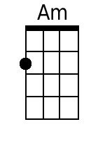  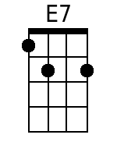  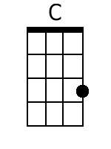  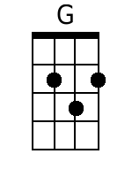  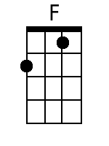  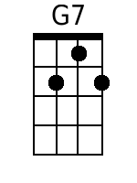  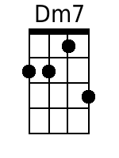  Bari  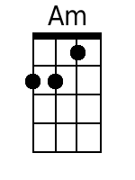  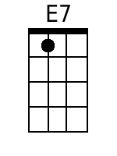  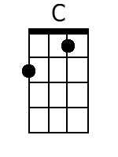  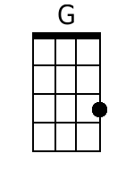  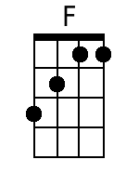  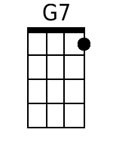  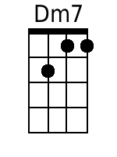 | Ride, Ride, Ride  By Nick Woods & Randy Sparks  Key of Am (Original Key of Bm - 2 Sharps); 4/4 Time; “Solid Moving Beat.” Ukulele.  Performed by The New Christy Minstrels on their 1963 LP, Ramblin'.  Introduction (2 Measures)  Am E7  Spoken: H'yah! C'mon. Yeah!  Am  1. A cowboy's life is a lonely road.  E7  Yer back gets bent and yer legs get bowed;  C G F C  Ridin' herd from town to town,  G7 C  Make your bed on the cold hard ground.  Am  2. North to the grass covered plains we go,  E7  South where the wild winter winds don't blow;  C G F C  Early morning till the day-light's gone,  G7 C E7  Round up strays and keep a movin' on. Just ...  Chorus.  Am E7 Am G7 C  Ride, ride, ride. Ride, ride, ride.  G F C  I'm been drivin' all over this land,  G7 C E7  Wide Missouri to the Rio Grande. Ah, oo.  Am  3. I'll work all day on a dusty trail,  E7  Spend my nights in a cow-town jail.  D G F C  Live on the cuff till I draw my pay;  G7 C  Drink and gamble and give it all away.  E7 Am  4. Now, all you cowboys, gather round.  E7  Don't spend your nights on the cold, hard ground.  C G F C  Life is short and the road is long;  G7 C  And only fools would sing this song. Just ...  Chorus.  Am E7 Am G7 C  Ride, ride, ride. Ride, ride, ride.  G F C  I'm been drivin' all over this land,  G7 C E7  Wide Missouri to the Rio Grande. Just...  Am E7 Am G7 C  Ride, ride, ride. Ride, ride, ride.  G F C  I'm been drivin' all over this land,  G7 Dm7♭5 G7 C  Wide Missouri to the Ri - o Grande.  Spoken: Yah!

