Ride, Ride, Ride
By Nick Woods & Randy Sparks
Key of Em; 4/4 Time; “Solid Moving Beat.”
For Ukulele
GCEA  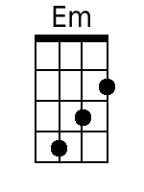  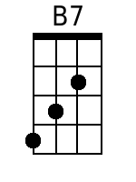  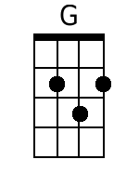  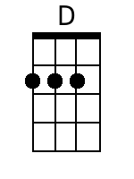  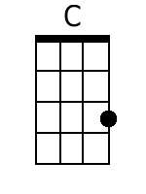  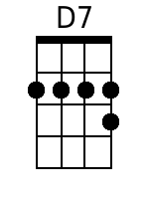  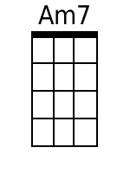  Bari  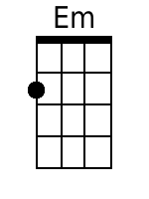  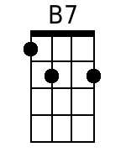  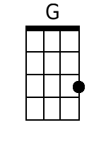  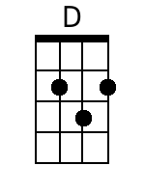  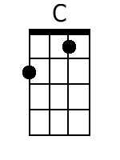  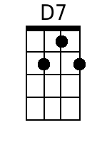  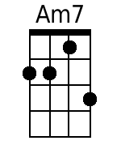 | Ride, Ride, Ride  By Nick Woods & Randy Sparks  Key of Em (Original Key of Bm - 2 Sharps); 4/4 Time; “Solid Moving Beat.” Ukulele.  Performed by The New Christy Minstrels on their 1963 LP, Ramblin'.  Introduction (2 Measures)  Em B7  Spoken: H'yah! C'mon. Yeah!  Em  1. A cowboy's life is a lonely road.  B7  Yer back gets bent and yer legs get bowed;  G D C G  Ridin' herd from town to town,  D7 G  Make your bed on the cold hard ground.  Em  2. North to the grass covered plains we go,  B7  South where the wild winter winds don't blow;  G D C G  Early morning till the day-light's gone,  D7 G B7  Round up strays and keep a movin' on. Just ...  Chorus.  Em B7 Em D7 G  Ride, ride, ride. Ride, ride, ride.  D C G  I'm been drivin' all over this land,  D7 G B7  Wide Missouri to the Rio Grande. Ah, oo.  Em  3. I'll work all day on a dusty trail,  B7  Spend my nights in a cow-town jail.  G D C G  Live on the cuff till I draw my pay;  D7 G  Drink and gamble and give it all away.  B7 Em  4. Now, all you cowboys, gather round.  B7  Don't spend your nights on the cold, hard ground.  G D C G  Life is short and the road is long;  D7 G  And only fools would sing this song. Just ...  Chorus.  Em B7 Em D7 G  Ride, ride, ride. Ride, ride, ride.  D C G  I'm been drivin' all over this land,  D7 G B7  Wide Missouri to the Rio Grande. Just...  Em B7 Em D7 G  Ride, ride, ride. Ride, ride, ride.  D C G  I'm been drivin' all over this land,  D7 Am7♭5 D7 G  Wide Missouri to the Ri - o Grande.  Spoken: Yah!

