**Riders On the Storm**

**(John Densmore / Robby Krieger / Ray Manzarek / Jim Morrison)**

**Em A Em A**

Riders on the storm

**Em A Em A**

Riders on the storm

**Am C D**

Into this house were born

**Em A Em A**

Into this world were thrown

**D**

Like a dog without a bone

**C**

An actor out on loan

**Em A Em A**

Riders on the storm

**Em A Em A**

There s a killer on the road

**Em A Em A**

His brain is squirming like a toad

**Am C D**

Take a long holiday

**Em A Em A**

Let your children play

**D**

If ya give this man a ride

**C**

Sweet memory will die

**Em A Em A**

Killer on the road, yeah



C

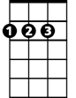

D

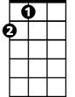

A

Em

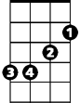

**BARITONE**



D

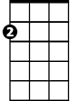

Em

C



A

**Em A Em A**

Girl ya gotta love your man

**Em A Em A**

Girl ya gotta love your man

**Am C D**

Take him by the hand

**Em A Em A**

Make him understand

**D**

The world on you depends

**C**

Our life will never end

**Em A Em A**

Gotta love your man, yeah

**Em A Em A**

Riders on the storm

**Em A Em A**

Riders on the storm

**Am C D**

Into this house were born

**Em A Em A**

Into this world were thrown

**D**

Like a dog without a bone

**C**

An actor out on loan

**Em A Em A**

Riders on the storm

**Em A Em**

Riders on the storm **x3**