Riders On the Storm (Am)
(John Densmore / Robby Krieger / Ray Manzarek / Jim Morrison)

Am D Am D  Riders on the storm  Am D Am D  Riders on the storm  Dm F G  Into this house were born  Am D Am D  Into this world were thrown  G  Like a dog without a bone  F  An actor out on loan  Am D Am D  Riders on the storm  Am D Am D  There s a killer on the road  Am D Am D  His brain is squirming like a toad  Dm F G  Take a long holiday  Am D Am D  Let your children play  G  If ya give this man a ride  F  Sweet memory will die  Am D Am D  Killer on the road, yeah |  |  |  |  | Am D Am D  Girl ya gotta love your man  Am D Am D  Girl ya gotta love your man  Dm F G  Take him by the hand  Am D Am D  Make him understand  G  The world on you depends  F  Our life will never end  Am D Am D  Gotta love your man, yeah  Am D Am D  Riders on the storm  Am D Am D  Riders on the storm  Dm F G  Into this house were born  Am D Am D  Into this world were thrown  G  Like a dog without a bone  F  An actor out on loan  Am D Am D  Riders on the storm  Am D Am  Riders on the storm x3
 |  |  |  |  | Bari
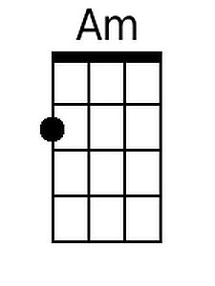 | 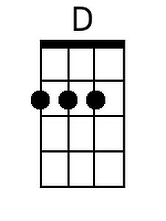 | 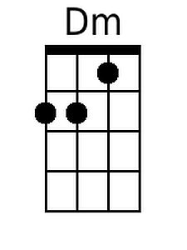 | 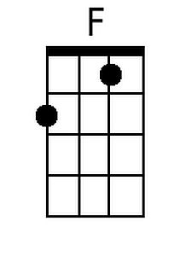 | 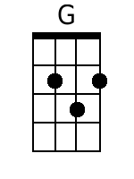 | 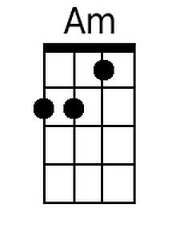 | 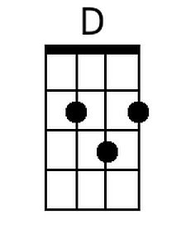 | 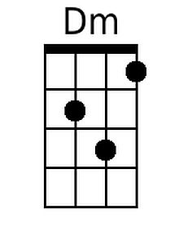 | 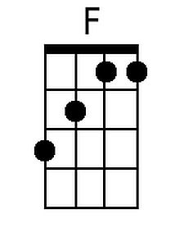 | 