Ring of Fire (June Carter & Merle Kilgore) (C)

Intro: C F C / C G7 C  C F C (C F C)  Love is a burning thing  G7 C (C G7 C)  And it makes a fiery ring  F C (C F C)  Bound by wild desire  G7 C  I fell into a ring of fire  Chorus  G7 F C  I fell into a burning ring of fire  G7  I went down, down, down  F C  And the flames went higher  G7  And it burns, burns, burns  C G7  The ring of fire  C  The ring of fire |  |  |  | (Intro 2X)  (Chorus)  C F C (C F C)  The taste of love is sweet  G7 C (C G7 C)  When hearts like ours meet  F C (C F C)  I fell for you like a child  G7 C  Oh, but the fire went wild  (Chorus 2X)  Ending:  C G7  And it burns, burns, burns  C G7  The ring of fire  C  The ring of fire  (Intro 2X) |  |  |  | 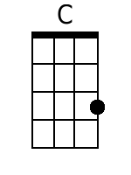
 |  |  |  |  |  |  |  | 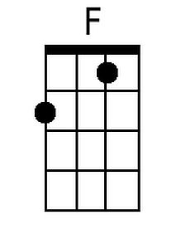
 |  |  |  |  |  |  |  | 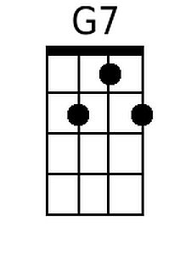
Bari
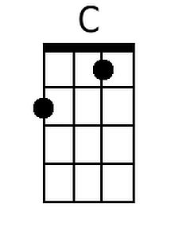 | 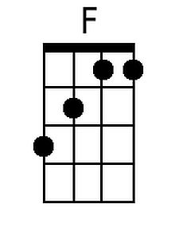 | 