**Ring of Fire (June Carter & Merle Kilgore)**

**INTRO: G C G / G D7 G**

**G C G (G C G)**

Love is a burning thing

**D7 G (G D7 G)**

And it makes a fiery ring

**C G (G C G)**

Bound by wild desire

**D7 G**

I fell into a ring of fire

**CHORUS:**

**D7 C G**

I fell into a burning ring of fire

**D7**

I went down, down, down

**C G**

And the flames went higher

**D7**

And it burns, burns, burns

**G D7**

The ring of fire

**G**

The ring of fire

**(INTRO 2X)**

**(CHORUS)**

**G C G (G C G)**

The taste of love is sweet

**D7 G (G D7 G)**

When hearts like ours meet

**C G (G C G)**

I fell for you like a child

**D7 G**

Oh, but the fire went wild

**(CHORUS 2X)**

**Ending:**

**G D7**

And it burns, burns, burns

**G D7**

The ring of fire

**G**

The ring of fire

**(INTRO 2X)**

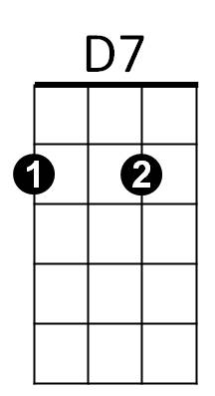

**BARITONE**

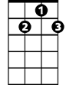

D7

C



G



C



G