Ring of Fire
Written by June Carter Cash and Merle Kilgore, 1963
Recorded by Johnny Cash, 1963
https://www.youtube.com/watch?reload=9&v=It7107ELQvY

GCEA  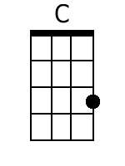  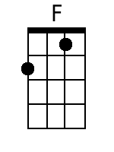  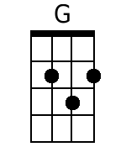 | Intro: C C C C C C C C  C F C  Love is a burnin' thing,  F C  And it makes a fiery ring  C F C  Love is a burnin' thing,  F C  And it makes a fiery ring  C F C  Love is a burnin' thing,  F C  And it makes a fiery ring  F C  Bound by wild de-sire  G C  I fell into a ring of fire.  Chorus  G F C  I fell into a burnin' ring of fire  G  I went down, down, down  F C  And the flames went higher,  And it burns, burn, burns,  F C G C  The ring of fire, the ring of fire.  Last Time Through:  G C C  The ring of fire.  C F C  Love is a burnin' thing,  F C  And it makes a fiery ring  C F C  Love is a burnin' thing,  F C  And it makes a fiery ring  C F C  The taste of love is sweet  F C  When hearts like ours meet.  F C  I fell for you like a child  G C  Oh, but the fire ran wild. Chorus (2x) | Bari  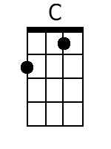  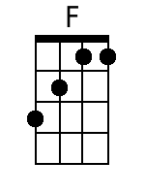  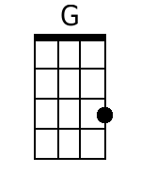

Ring of Fire
Written by June Carter Cash and Merle Kilgore, 1963
Recorded by Johnny Cash, 1963
https://www.youtube.com/watch?reload=9&v=It7107ELQvY

GCEA  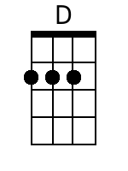 | Intro: G G G G G G G G  G C G  Love is a burnin' thing,  C G  And it makes a fiery ring  G C G  Love is a burnin' thing,  C G  And it makes a fiery ring  G C G  Love is a burnin' thing,  C G  And it makes a fiery ring  C G  Bound by wild de-sire  D G  I fell into a ring of fire.  Chorus  D C G  I fell into a burnin' ring of fire  D  I went down, down, down  C G  And the flames went higher,  And it burns, burn, burns,  C G D G  The ring of fire, the ring of fire.  Last Time Through:  D G G  The ring of fire.  G C G  Love is a burnin' thing,  C G  And it makes a fiery ring  G C G  Love is a burnin' thing,  C G  And it makes a fiery ring  G C G  The taste of love is sweet  C G  When hearts like ours meet.  C G  I fell for youlike a child  D G  Oh, but the fire ran wild. Chorus. 2x | Bari  