
Ripple (Robert Hunter & Jerry Garcia, 1970) (G)
Ripple by the Grateful Dead (2015 Remaster)
Ripple by the Grateful Dead (Official Music Video)
Tempo: 127 bpm
Intro  Instrumental verse (sing with “La-la-la”)  G C  If my words did glow with the gold of sunshine,  G  And my tunes were played on the harp unstrung  Would you hear my voice  C  Come through the music?  G D C G  Would you hold it near, as it were your own?  G C  It's a hand-me-down, the thoughts are broken.  G  Perhaps they're better left un-sung.  C  I don't know, don't really ca-re.  G D C G | G  Let there be songs to fill the air .  Chorus  Am D  Ri - pple in still water,  G C  When there is no pebble tossed,  A7 D  Nor wind to blow. |  |  |  | G C  Reach out your hand if your cup be empty.  G  If your cup is full, may it be a-gain.  C  Let it be known, there is a fountain,  G D C G  That was not made by the hands of man.  G C  There is a road, no simple highway,  G  Between the dawn and the dark of night.  C  And if you go, no one may follow,  G D C G | G  That path is for your steps a-lone. Chorus  G C  You who choose to lead must follow  G  But if you fall, you fall a-lone.  C  If you should stand, then who's to guide you?  G D C G  If I knew the way, I would take you home.  Outro  Instrumental verse (sing “la-la-la” along)  End on G [Hold]
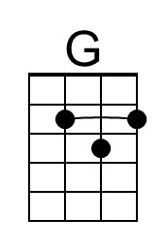 | 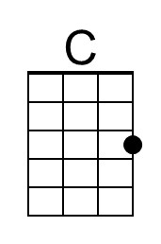 | 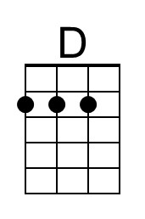 |  | Bari | 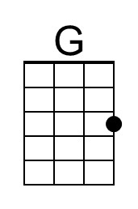 | 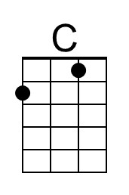 | 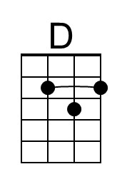
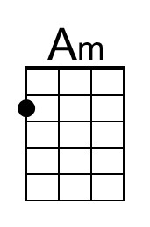 | 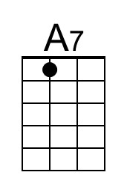 |  |  |  | 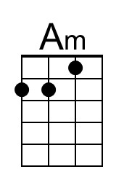 | 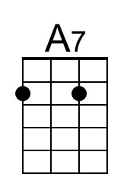

Ripple (Robert Hunter & Jerry Garcia, 1970) (C)
Ripple by the Grateful Dead (2015 Remaster)
Ripple by the Grateful Dead (Official Music Video)
Tempo: 127 bpm
Intro  Instrumental verse (sing with “La-la-la”)  C F  If my words did glow with the gold of sunshine,  C  And my tunes were played on the harp unstrung  C  Would you hear my voice  F  Come through the music?  C G F C  Would you hold it near, as it were your own?  C F  It's a hand-me-down, the thoughts are broken.  C  Perhaps they're better left un-sung.  F  I don't know, don't really ca-re.  C G F C | C  Let there be songs to fill the air .  Chorus  Dm G  Ri - pple in still water,  C F  When there is no pebble tossed,  D7 G  Nor wind to blow. |  |  |  | C F  Reach out your hand if your cup be empty.  C  If your cup is full, may it be a-gain.  F  Let it be known, there is a fountain,  C G F C  That was not made by the hands of man.  C F  There is a road, no simple highway,  C  Between the dawn and the dark of night.  F  And if you go, no one may follow,  C G F C | C  That path is for your steps a-lone. Chorus  C F  You who choose to lead must follow  C  But if you fall, you fall a-lone.  F  If you should stand, then who's to guide you?  C G F C  If I knew the way, I would take you home.  Outro  Instrumental verse (sing “la-la-la” along)  End on C [Hold]
 | 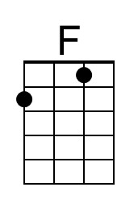 |  |  | Bari |  | 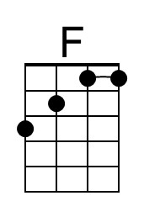
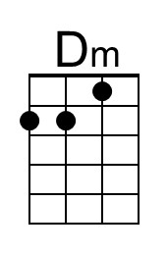 | 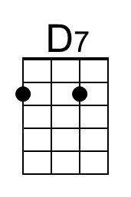 |  |  |  | 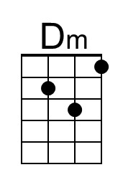 | 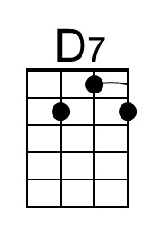

Ripple (Robert Hunter & Jerry Garcia, 1970) (D)
Ripple by the Grateful Dead (2015 Remaster)
Ripple by the Grateful Dead (Official Music Video)
Tempo: 127 bpm
Intro  Instrumental verse (sing with “La-la-la”)  D G  If my words did glow with the gold of sunshine,  D  And my tunes were played on the harp unstrung  D  Would you hear my voice  G  Come through the music?  D A G D  Would you hold it near, as it were your own?  D G  It's a hand-me-down, the thoughts are broken.  D  Perhaps they're better left un-sung.  G  I don't know, don't really ca-re.  D A G D | D  Let there be songs to fill the air .  Chorus  Em A  Ri - pple in still water,  D G  When there is no pebble tossed,  E7 A  Nor wind to blow. |  |  |  | D G  Reach out your hand if your cup be empty.  D  If your cup is full, may it be a-gain.  G  Let it be known, there is a fountain,  D A G D  That was not made by the hands of man.  D G  There is a road, no simple highway,  D  Between the dawn and the dark of night.  G  And if you go, no one may follow,  D A G D | D  That path is for your steps a-lone. Chorus  D G  You who choose to lead must follow  D  But if you fall, you fall a-lone.  G  If you should stand, then who's to guide you?  D A G D  If I knew the way, I would take you home.  Outro  Instrumental verse (sing “la-la-la” along)  End on D [Hold]
 |  | 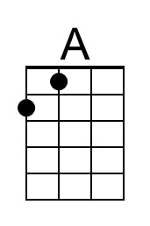 |  | Bari |  |  | 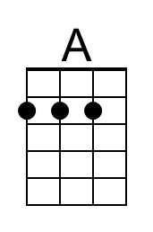
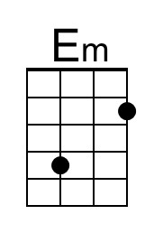 | 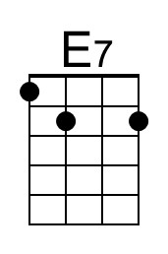 |  |  |  | 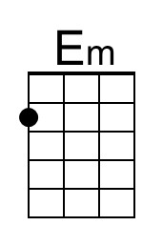 | 