
River (Bill Staines, circa 1979) (D)
¾ Time
Intro D | G | D | G  D G D  I was born in the path of the winter wind.  A7  I was raised where the mountains are old.  D G D  Their springtime waters came dancing down  A7 D | D  And I remember the tales they told.  D G D  The whistling ways of my younger days  A7  Too quickly have faded on by.  D G D  But all of their memories linger on  A7 D | D  Like the light in a fading sky.  Chorus  D G A7 D  Ri-ver, take me a-long in your sun-shine,  G A7  sing me your song.  G D  Ever mo-ving and winding and free.  G D G D  You rolling old river, you changing old river  G A7  Let's you and me, river,  G D | D | D | D  run down to the sea.  D G D  I've been to the city and back again.  I've been moved by some things  A7  that I've learned.  D  Met a lot of good people  G D  an’ I called them friends,  A7 D | D  Felt the change when the seasons turned. | D G D  I've heard all the songs that the children sing  A7  And listened to love's melo-dies.  D G D  I've felt my own music within me rise  A7 D | D  Like the wind in the autumn trees. Chorus  D G D  Some-day when the flowers are blooming still,  A7  Someday when the grass is still green,  D G D  My rolling waters will round the bend,  A7 D | D  Flow into the open sea.  D  So, here's to the rainbow  G D  that's followed me here.  A7  And here's to the friends that I know.  D G D  And here's to the song that's within me now  A7 D | D  I will sing it wherever I go. Chorus (2x)  Outro The 2nd time through, retard the last line of the Chorus:  G A7  Let's you and me, river, ___  A7 G D A7 D | D | G | A7 | D [Hold]  run down to the sea.
 | 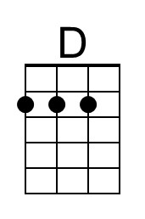 | 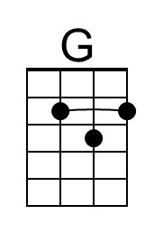 | 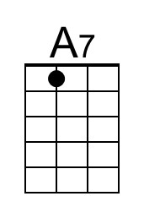
 | Bari | 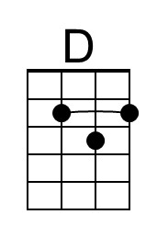 | 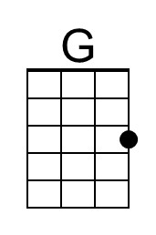 | 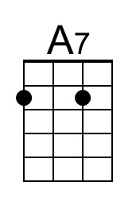

River (Bill Staines, circa 1979) (C)
¾ Time
Intro C | F | C | F  C F C  I was born in the path of the winter wind  G7  I was raised where the mountains are old  C F C  Their springtime waters came dancing down  G7 C | C  And I remember the tales they told  C F C  The whistling ways of my younger days  G7  Too quickly have faded on by  C F C  But all of their memories linger on  G7 C | C  Like the light in a fading sky.  Chorus:  C F G7 C  Ri-ver, take me a-long in your sun-shine,  F G7  sing me your song  F C  Ever mo-ving and winding and free  F C F C  You rolling old river, you changing old river  F G7  Let's you and me, river,  F C | C | C | C  run down to the sea.  C F C  I've been to the city and back again  I've been moved by some things  G7  that I've learned  C  Met a lot of good people  F C  an’ I called them friends,  G7 C | C  Felt the change when the seasons turned. | C F C  I've heard all the songs that the children sing  G7  And listened to love's melo-dies  C F C  I've felt my own music within me rise  G7 C | C  Like the wind in the autumn trees. Chorus  C F C  Some-day when the flowers are blooming still  G7  Someday when the grass is still green  C F C  My rolling waters will round the bend,  G7 C | C  Flow into the open sea.  C  So, here's to the rainbow  F C  that's followed me here  G7  And here's to the friends that I know  C F C  And here's to the song that's within me now  G7 C | C  I will sing it wher-e’er I go. Chorus (2x)  Outro The 2nd time through, retard the last line of the Chorus:  F G7  Let's you and me, river, ___  G7 F G7 F C | C | F | G7 | C [Hold]  run down to the sea.
 | 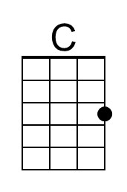 | 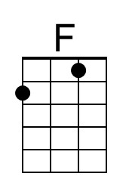 | 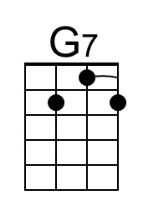
 | Bari | 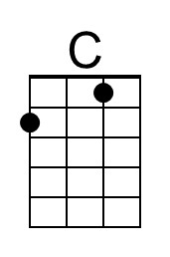 | 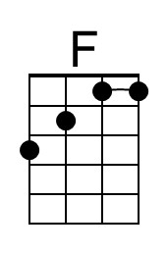 | 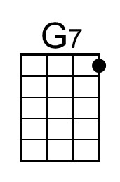

River (Bill Staines, circa 1979) (G)
¾ Time
Intro G | C | G | C  G C G  I was born in the path of the winter wind  D7  I was raised where the mountains are old  G C G  Their springtime waters came dancing down  D7 G | G  And I remember the tales they told.  G C G  The whistling ways of my younger days  D7  Too quickly have faded on by  G C G  But all of their memories linger on  D7 G | G  Like the light in a fading sky.  Chorus  G C D7 G  Ri-ver, take me along in your sun-shine,  C D7  sing me your song  C G  Ever mo-ving and winding and free  C G C G  You rolling old river, you changing old river  C D7  Let's you and me, river,  C G | G | G | G  run down to the sea.  G C G  I've been to the city and back again  I've been moved by  D7  some things that I've learned  G  Met a lot of good people  C G  an’ I called them friends,  D7 G | G  Felt the change when the seasons turned. | G C G  I've heard all the songs that the children sing  D7  And listened to love's melo-dies  G C G  I've felt my own music within me rise  D7 G | G  Like the wind in the autumn trees. Chorus  G C G  Someday when the flowers are blooming still  D7  Someday when the grass is still green  G C G  My rolling waters will round the bend,  D7 G | G  Flow into the open sea.  G  So, here's to the rainbow  C G  that's followed me here  D7  And here's to the friends that I know  G C G  And here's to the song that's within me now  D7 G | G  I will sing it wher-ever I go. Chorus (2x)  Outro The 2nd time through, retard the last line of the Chorus:  C D7  Let's you and me, river, ___  D7 C G D7 G | G | C | D7 | G [Hold]  run down to the sea.
 |  |  | 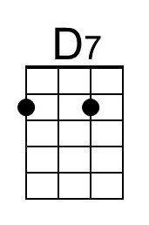
 | Bari |  |  | 