River (Bill Staines, circa 1979) (D)
River by Bill Staines from "The Whistle of the Jay" (E)
¾ Time – Tempo 150 bpm

Intro D | G | D | G

D G D
I was born in the path of the winter wind.
A7
I was raised where the mountains are old.
D G D A7 D | D
Their springtime waters came dancing down, and I remember the tales they told.

D G D
The whistling ways of my younger days
A7
Too quickly have faded on by.
D G D A7 D | D
But all of their memories linger on, like the light in a fading sky.

Chorus
D G A7 D G A7
River, take me a-long in your sun-shine, sing me your song.
G D
Ever moving and winding and free.
G D G D
You rolling old river, you changing old river,
G A7 G D | D | D | D
Let's you and me, river, run down to the sea.

D G D
I've been to the city and back again.
A7
I've been moved by some things that I've learned.
D G D
Met a lot of good people an’ I called them friends,
A7 D | D
Felt the change when the seasons turned.

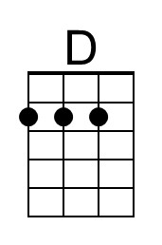 | 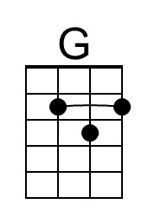 | 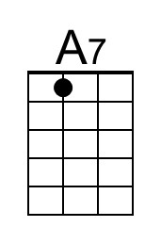 |  | Bari | 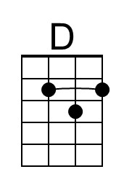 | 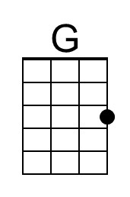 | 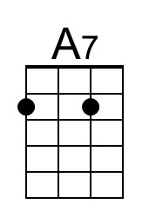
River (D) – Page 2
D G D
I've heard all the songs that the children sing
A7
And listened to love's melo-dies.
D G D A7 D | D
I've felt my own music within me rise, like the wind in the autumn trees.

Chorus
D G A7 D G A7
River, take me a-long in your sun-shine, sing me your song.
G D
Ever moving and winding and free.
G D G D
You rolling old river, you changing old river,
G A7 G D | D | D | D
Let's you and me, river, run down to the sea.

D G D
Some-day when the flowers are blooming still,
A7
Someday when the grass is still green,
D G D A7 D | D
My rolling waters will round the bend, flow into the open sea.

D G D
So, here's to the rainbow that's followed me here.
A7
And here's to the friends that I know.
D G D A7 D | D
And here's to the song that's within me now, I will sing it wher-e’er I go. Chorus

Outro
D G A7 D G A7
River, take me a-long in your sun-shine, sing me your song.
G D G D G D
Ever moving and winding and free. You rolling old river, you changing old river
G A7 | A7
Let's you and me, river,
G A7 G D | D | G | A7 | D [Hold]
Run down to the sea.
River (Bill Staines, circa 1979) (E)
River by Bill Staines from "The Whistle of the Jay" (E)
¾ Time – Tempo 150 bpm

Intro E | A | E | A

E A E B7
I was born in the path of the winter wind. I was raised where the mountains are old.
E A E B7 E | E
Their springtime waters came dancing down, and I remember the tales they told.

E A E B7
The whistling ways of my younger days, Too quickly have faded on by.
E A E B7 E | E |
But all of their memories linger on, like the light in a fading sky.

Chorus
E A B7 E A B7
River, take me a-long in your sun-shine, sing me your song.
A E
Ever moving and winding and free.
A E A E
You rolling old river, you changing old river,
A B7 A E | E | E | E
Let's you and me, river, run down to the sea.

E A E
I've been to the city and back again.
B7
I've been moved by some things that I've learned.
E A E
Met a lot of good people an’ I called them friends,
B7 E | E
Felt the change when the seasons turned.

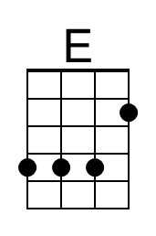 | 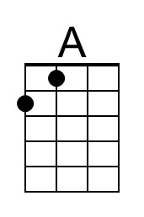 | 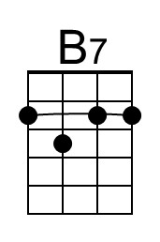 |  | Bari | 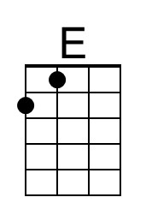 | 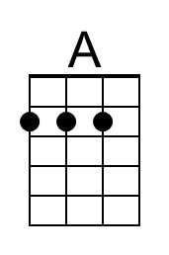 | 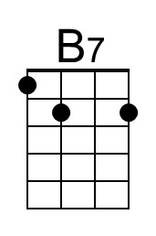
River (E) – Page 2

E A E B7
I've heard all the songs that the children sing, And listened to love's melo-dies.
E A E B7 E | E |
I've felt my own music within me rise, like the wind in the autumn trees.

Chorus
E A B7 E A B7
River, take me a-long in your sun-shine, sing me your song.
A E
Ever moving and winding and free.
A E A E
You rolling old river, you changing old river,
A B7 A E | E | E | E
Let's you and me, river, run down to the sea.

E A E
Some-day when the flowers are blooming still,
B7
Someday when the grass is still green,
E A E B7 E | E
My rolling waters will round the bend, flow into the open sea.

E A E
So, here's to the rainbow that's followed me here.
B7
And here's to the friends that I know.
E A E B7 | E
And here's to the song that's within me now, I will sing it wher-e’er I go. Chorus

Outro
E A B7 E A B7
River, take me a-long in your sun-shine, sing me your song.
A E A E A E
Ever moving and winding and free. You rolling old river, you changing old river
A B7 | B7
Let's you and me, river,
B7 A B7 A E | E | A | B7 | D
Run down to the sea. [Hold]
River (Bill Staines, circa 1979) (G)
River by Bill Staines from "The Whistle of the Jay" (E)
¾ Time – Tempo 150 bpm

Intro G | C | G | C

G C G D7
I was born in the path of the winter wind. I was raised where the mountains are old.
G C G D7 G | G
Their springtime waters came dancing down, and I remember the tales they told.

G C G D7
The whistling ways of my younger days, Too quickly have faded on by.
G C G D7 G | G |
But all of their memories linger on, like the light in a fading sky.

Chorus
G C D7 G C D7
River, take me a-long in your sun-shine, sing me your song.
C G
Ever moving and winding and free.
C G C G
You rolling old river, you changing old river,
C D7 C G | G | G | G
Let's you and me, river, run down to the sea.

G C G
I've been to the city and back again.
D7
I've been moved by some things that I've learned.
G C G
Met a lot of good people an’ I called them friends,
D7 G | G
Felt the change when the seasons turned.

 | 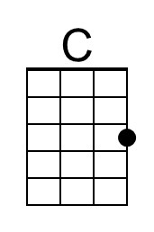 | 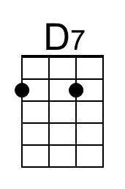 |  | Bari |  | 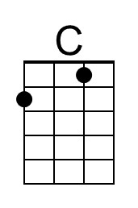 | 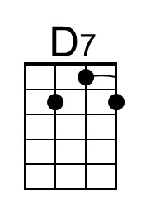
River (G) – Page 2

G C G D7
I've heard all the songs that the children sing, And listened to love's melo-dies.
G C G D7 G | G |
I've felt my own music within me rise, like the wind in the autumn trees.

Chorus
G C D7 G C D7
River, take me a-long in your sun-shine, sing me your song.
C G
Ever moving and winding and free.
C G C G
You rolling old river, you changing old river,
C D7 C G | G | G | G
Let's you and me, river, run down to the sea.

G C G
Some-day when the flowers are blooming still,
D7
Someday when the grass is still green,
G C G D7 G | G
My rolling waters will round the bend, flow into the open sea.

G C G
So, here's to the rainbow that's followed me here.
D7
And here's to the friends that I know.
G C G D7 | G
And here's to the song that's within me now, I will sing it wher-e’er I go. Chorus

Outro
G C D7 G C D7
River, take me a-long in your sun-shine, sing me your song.
C G C G C G
Ever moving and winding and free. You rolling old river, you changing old river
C D7 | D7
Let's you and me, river,
D7 C D7 C G | G | C | D7 | F
Run down to the sea. [Hold]

