**River (Bill Staines) Key C**

**C F C**

I was born in the path of the winter wind

**G7**

I was raised where the mountains are old

**C F C**

Their springtime waters came dancing down

**G7 C**

And I remember the tales they told

**C F C**

The whistling ways of my younger days

**G7**

Too quickly have faded on by

**C F C**

But all of their memories linger on

**G7 C**

Like the light in a fading sky

**Chorus:**

**C F G7 C**

Ri-ver, take me along in your sun-shine,

**F G7**

sing me your song

**F C**

Ever mo-ving and winding and free

**F C F C**

You rolling old river, you changing old river

**F G7 F C**

Let's you and me, river, run down to the sea

**C F C**

I've been to the city and back again

**G7**

I've been moved by some things that I've learned

**C F**

Met a lot of good people and I've called them

**C**

friends

**G7 C**

Felt the change when the seasons turned

**C F C**

I've heard all the songs that the children sing

**G7**

And listened to love's melodies

**C F C**

I've felt my own music within me rise

**G7 C**

Like the wind in the autumn trees

**(Chorus)**

**C F C**

Someday when the flowers are blooming still

**G7**

Someday when the grass is still green

**C F C**

My rolling waters will round the bend

**G7 C**

And flow into the open sea

**C F C**

So, here's to the rainbow that's followed me here

**G7**

And here's to the friends that I know

**C F C**

And here's to the song that's within me now

**G7 C**

I will sing it wherever I go

**(Chorus) 2x**



C

F

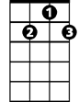

G7

**BARITONE**

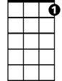

G7



F

C



**River (Bill Staines) Key G**

**G C G**

I was born in the path of the winter wind

**D7**

I was raised where the mountains are old

**G C G**

Their springtime waters came dancing down

**D7 G**

And I remember the tales they told

**G C G**

The whistling ways of my younger days

**D7**

Too quickly have faded on by

**G C G**

But all of their memories linger on

**D** **7 G**

Like the light in a fading sky

**Chorus:**

**G C D7 G**

Ri-ver, take me along in your sun-shine,

**C D7**

sing me your song

**C G**

Ever mo-ving and winding and free

**C G C G**

You rolling old river, you changing old river

**C D7 C G**

Let's you and me, river, run down to the sea

**G C G**

I've been to the city and back again

**D7**

I've been moved by some things that I've learned

**G C**

Met a lot of good people and I've called them

**G**

friends

**D7 G**

Felt the change when the seasons turned

**G C G**

I've heard all the songs that the children sing

**D7**

And listened to love's melodies

**G C G**

I've felt my own music within me rise

**D7 G**

Like the wind in the autumn trees

**(Chorus)**

**G C G**

Someday when the flowers are blooming still

**D7**

Someday when the grass is still green

**G C G**

My rolling waters will round the bend

**D7 G**

And flow into the open sea

**G C G**

So, here's to the rainbow that's followed me here

**D7**

And here's to the friends that I know

**G C G**

And here's to the song that's within me now

**D7 G**

I will sing it wherever I go

**(Chorus) 2x**

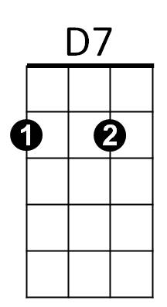



G



C

**BARITONE**

C



D7



G

**River (Bill Staines) Key D**

**D G D**

I was born in the path of the winter wind

**A7**

I was raised where the mountains are old

**D G D**

Their springtime waters came dancing down

**A7 D**

And I remember the tales they told

**D G D**

The whistling ways of my younger days

**A7**

Too quickly have faded on by

**D G D**

But all of their memories linger on

**A7 D**

Like the light in a fading sky

**Chorus:**

**D G A7 D**

Ri-ver, take me along in your sun-shine,

**G A7**

sing me your song

**G D**

Ever mo-ving and winding and free

**G D G D**

You rolling old river, you changing old river

**G A7 G D**

Let's you and me, river, run down to the sea

**D G D**

I've been to the city and back again

**A7**

I've been moved by some things that I've learned

**D G**

Met a lot of good people and I've called them

**D**

friends

**A7 D**

Felt the change when the seasons turned

**D G D**

I've heard all the songs that the children sing

**A7**

And listened to love's melodies

**D G D**

I've felt my own music within me rise

**A7 D**

Like the wind in the autumn trees

**(Chorus)**

**D G D**

Someday when the flowers are blooming still

**A7**

Someday when the grass is still green

**D G D**

My rolling waters will round the bend

**A7 D**

And flow into the open sea

**D G D**

So, here's to the rainbow that's followed me here

**A7**

And here's to the friends that I know

**D G D**

And here's to the song that's within me now

**A7 D**

I will sing it wherever I go

**(Chorus) 2x**



G

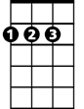

D

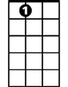

A7

**BARITONE**

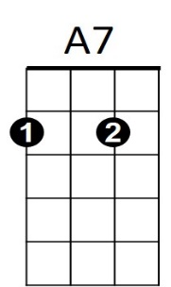



D



G