Rock and Roll Music
Chuck Berry (1957) – At YouTube Rock And Roll Music
"Rock and Roll Music" is a 1957 hit single written and recorded by rock and roll star Chuck Berry in a 12-bar blues style ( I I I I IV IV I I V V I I ), a form he would frequently use in his song writing. The song has been widely covered and is recognized as one of Berry's most popular and enduring compositions. In the fall of 1957, his recording reached number 6 on Billboard magazine's R&B Singles chart and number 8 on its Hot 100 chart.
The song has been recorded by many well-known artists. The Beatles' 1964 recording topped singles charts in Europe and in Australia, and the Beach Boys had a U.S. top ten hit with the song in 1976. Other artists who have cover the song include Bill Haley & His Comets, Dickie Rock and the Miami Showband, REO Speedwagon, Mental As Anything, Humble Pie, Manic Street Preachers, and Bryan Adams. Berry performed it on December 16, 1957, on ABC's short-lived variety program ”The Guy Mitchell Show.”
In 2004, Rolling Stone magazine ranked Berry's version number 128 on its list of the "500 Greatest Songs of All Time". The song is also included in the Rock and Roll Hall of Fame's “500 Songs That Shaped Rock and Roll.”
The sessions for "Rock and Roll Music" took place on either May 6 or May 21, 1957, in Chicago, Illinois. The session was produced by Leonard Chess and Phil Chess. Backing Berry were Lafayette Leake (piano), Willie Dixon (bass), and Fred Below (drums).
Sometime after the single was released in September 1957, "Rock and Roll Music" reached #6 on Billboard magazine's R&B Singles chart and #8 on the Billboard Top 100 chart before the year's end.
The Beatles Version, Rock and Roll Music (1964)
The Beatles performed the song in many of their early Hamburg shows, and also played it on the BBC show “Pop Go The Beatles.” In late 1964, exhausted from non-stop touring and recording and short of original material, they decided to record several of their old rock and rhythm and blues favorites to fill out their LP release “Beatles for Sale.” Among these was a version of Berry's tune that eventually became as well known as the original. The lead vocal in the Beatles' version was performed by John Lennon. In contrast to Berry's even-toned rendition, Lennon sang it as loudly and dynamically as his voice would permit. In the United States, it was released on the LP “Beatles '65.” The song was part of the set list for the group's final tour in 1966 – the performance from their June 30 show at the Nippon Budokan was included in 1996's “Anthology 2” – and was also performed during the Get Back/Let It Be Sessions in January 1969. It also served as the title song to the Beatles' 1976 compilation album “Rock 'n' Roll Music.”
The Beach Boys Version, Rock And Roll Music (1976)
The Beach Boys' version is notable for the use of backing vocals which repeat the phrase "Rock, roll, rockin' and roll," as well as the expanded orchestration. There is a difference between the LP version and the single version in that the LP version has more synthesizer. Their version reached No. 5 on the US chart and No. 11 in Canada during the summer of 1976.
Chuck Berry died at his home in St. Charles County, Missouri, near the town of Wentzville, at the age of 90 on March 18, 2017.
Source: Wikipedia, https://en.wikipedia.org/wiki/Rock_and_Roll_Music
Rock and Roll Music
Chuck Berry (1957) – At YouTube Rock And Roll Music
The Beatles, Rock and Roll Music (1964)
Key of C

GCEA  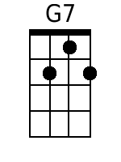  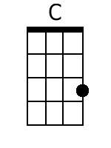  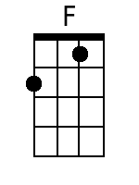  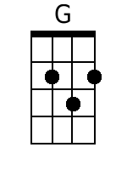 | Intro: (G7) | | | [STOP]  Just let me hear some of that …  Chorus  C  Rock and roll music, any old way you choose it,  F  It's got a back beat, you can't lose it,  C  Any old time you use it,  G7  It's gotta be rock and roll music,  C  If you wanna dance with me,  G7 C [STOP]  If you wanna dance with me.  [N.C.] G  1. I have no kick against modern jazz,  G7 C  Unless they try to play it too darn fast,  F  And change the beauty of a melody,  G7 [STOP]  Until it sounds just like a symphony.  That's why I go for that … Chorus  [N.C.] G  2. I took my love on over 'cross the tracks,  G7 C  So she could hear my man a wail a sax,  F  I must admit they have a rockin' band,  G7 [STOP]  And they were blowin' like a hurrican'.  That's why I go for that … Chorus  [N.C.] G  3. Way down south they gave a jubilee,  G7 C  And Georgia folks, they had a jamboree,  F  They're drinkin' home brew from a wooden cup,  G7 [STOP]  The folks dancin' got all shook up.  And started playin' that … Chorus  [N.C.] G  4. Don't get to hear 'em play a tango,  G7 C  I'm in no mood to take a mambo,  F  It's way too early for the congo,,  G7 [STOP]  So keep on rockin' that piano.  So I can hear some of that …  C  Rock and roll music, any old way you choose it,  F  It's got a back beat, you can't lose it,  C  Any old time you use it,  G7  It's gotta be rock and roll music,  C  If you wanna dance with me,  G7 C | | | [STOP]  If you wanna dance with me. | Bari  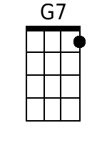  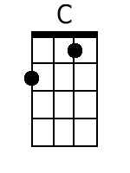  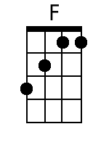  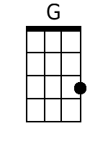

Notes:
- The “ | “ indicates single strokes, stopped.
- “N.C.” = “No Chord;” do not strum until next Chord indicated.
- [STOP] means to stop strumming until next Chord indicated.

Rock and Roll Music
Chuck Berry (1957) – At YouTube Rock And Roll Music
The Beatles, Rock and Roll Music (1964)
Key of G

GCEA  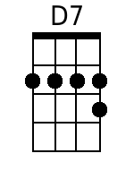  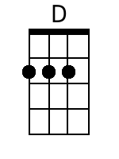 | Intro: (D7) | | | (STOP)  Just let me hear some of that ...  Chorus:  G  Rock and roll music, any old way you choose it,  C  It's got a back beat, you can't lose it,  G  Any old time you use it,  D7  It's gotta be rock and roll music,  G  If you wanna dance with me,  D7 G [STOP]  If you wanna dance with me.  [N.C.] D  1. I have no kick against modern jazz,  D7 G  Unless they try to play it too darn fast,  C  And change the beauty of a melody,  D7 [STOP]  Until it sounds just like a symphony.  That's why I go for that … Chorus  [N.C.] D  2. I took my love on over 'cross the tracks,  D7 G  So she could hear my man a wail a sax,  C  I must admit they have a rockin' band,  D7 [STOP]  And they were blowin' like a hurrican'.  That's why I go for that … Chorus  [N.C.] D  3. Way down south they gave a jubilee,  D7 G  And Georgia folks, they had a jamboree,  C  They're drinkin' home brew from a wooden cup,  D7 [STOP]  The folks dancin' got all shook up.  And started playin' that … Chorus  [N.C.] D  4. Don't get to hear 'em play a tango,  D7 G  I'm in no mood to take a mambo,  C  It's way too early for the congo,  D7 [STOP]  So keep on rockin' that piano.  So I can hear some of that …  G  Rock and roll music, any old way you choose it,  C  It's got a back beat, you can't lose it,  G  Any old time you use it,  D7  It's gotta be rock and roll music,  G  If you wanna dance with me,  D7 G | | | [STOP]  If you wanna dance with me. | Bari  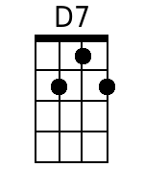  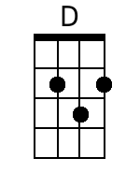

Notes:
- The “ | “ indicates single strokes, stopped.
- [N.C.] = “No Chord;” do not strum until next Chord indicated.
- [STOP] means to stop strumming until next Chord indicated.

