**Rocket Man (Elton John / Bernie Taupin) Key C**

**Am D7**

She packed my bags last night, pre-flight

**Am D7**

Zero hour; nine A - M

**F C F G G7**

And I'm gonna be hi - gh - as a kite by then

**Am D7**

I miss the earth so much I mi ss my wife

**Am D7**

It's lonely out in space

**F C F G G7**

On such a ti – i-meless flight

**Chorus:**

**C F**

And I think it's gonna be a long long time

**C**

'Till touch down brings me round again to find

**F**

I'm not the man they think I am at home

**C D D7**

Oh no no no - I'm a rocket man

**F C F**

Rocket man burning out his fuse up here alone

**C F**

And I think it's gonna be a long long time

**C**

'Till touch down brings me round again to find

**F**

I'm not the man they think I am at home

**C D D7**

Oh no no no - I'm a rocket man

**F C F**

Rocket man burning out his fuse up here alone

**BARITONE**

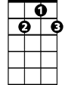

D7

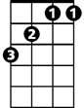

F

C

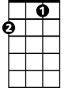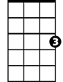

G

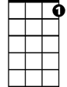

G7

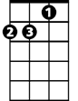

Am



D

**Am D7**

Mars ain't the kind of place to raise your kids

**Am D7**

In fact it's cold as hell

**F C F G G7**

And there's no one there to raise them if you did

**Am D7**

And all this science I don't understand

**Am D7**

It's just my job five days a week

**F C F G G7**

A rocket ma - an, a rocket man

**(Chorus)**

**Repeat 3x to fade**

**C F**

And I think it's gonna be a long long time

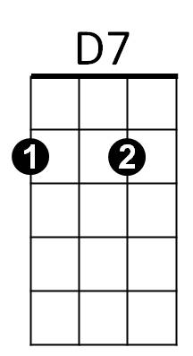



C

F

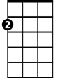

Am

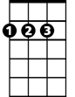

D



G



G7

**Rocket Man (Elton John / Bernie Taupin) Key F**

**Dm G7**

She packed my bags last night, pre-flight

**Dm G7**

Zero hour; nine A - M

**Bb F Bb C C7**

And I'm gonna be hi - gh - as a kite by then

**Dm G7**

I miss the earth so much I miss my wife

**Dm G7**

It's lonely out in space

**Bb F Bb C C7**

On such a ti – i-meless flight

**Chorus:**

**F Bb**

And I think it's gonna be a long long time

**F**

'Till touch down brings me round again to find

**Bb**

I'm not the man they think I am at home

**F G G7**

Oh no no no - I'm a rocket man

**Bb F Bb**

Rocket man burning out his fuse up here alone

**F Bb**

And I think it's gonna be a long long time

**F**

'Till touch down brings me round again to find

**Bb**

I'm not the man they think I am at home

**F G G7**

Oh no no no - I'm a rocket man

**Bb F Bb**

Rocket man burning out his fuse up here alone

**BARITONE**



G



G7

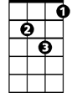

Dm

C



F

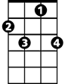

C7

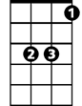

Bb

**Dm G7**

Mars ain't the kind of place to raise your kids

**Dm G7**

In fact it's cold as hell

**Bb F Bb C C7**

And there's no one there to raise them if you did

**Dm G7**

And all this science I don't understand

**Dm G7**

It's just my job five days a week

**Bb F Bb C C7**

A rocket ma - an, a rocket man

**(Chorus)**

**Repeat 3x to fade**

**F Bb**

And I think it's gonna be a long long time



Bb

F



G7



Dm



C



C7



G

**Rocket Man (Elton John / Bernie Taupin) Key C**

**Em A7**

She packed my bags last night, pre-flight

**Em A7**

Zero hour; nine A - M

**C G C D D7**

And I'm gonna be hi - gh - as a kite by then

**Em A7**

I miss the earth so much I miss my wife

**Em A7**

It's lonely out in space

**C G C D D7**

On such a ti – i-meless flight

**Chorus:**

**G C**

And I think it's gonna be a long long time

**G**

'Till touch down brings me round again to find

**C**

I'm not the man they think I am at home

**G A A7**

Oh no no no - I'm a rocket man

**C G C**

Rocket man burning out his fuse up here alone

**G C**

And I think it's gonna be a long long time

**G**

'Till touch down brings me round again to find

**C**

I'm not the man they think I am at home

**G A A7**

Oh no no no - I'm a rocket man

**C G C**

Rocket man burning out his fuse up here alone

**BARITONE**

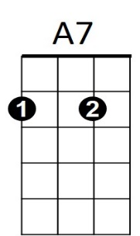



D7



G



D



A



Em

C



**Em A7**

Mars ain't the kind of place to raise your kids

**Em A7**

In fact it's cold as hell

**C G C D D7**

And there's no one there to raise them if you did

**Em A7**

And all this science I don't understand

**Em A7**

It's just my job five days a week

**C G C D D7**

A rocket ma - an, a rocket man

**(Chorus)**

**Repeat 3x to fade**

**G C**

And I think it's gonna be a long long time



G



C

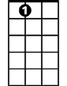

A7

Em

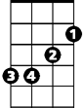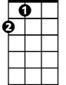

A





D