**Rocket Man (Elton John / Bernie Taupin)**

**Dm G7**

She packed my bags last night, pre-flight

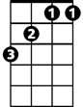

Bb

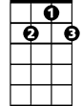

G7

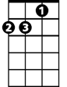

Dm

**Dm G7**

Zero hour - nine A - M

**Bb F Bb C C7**

And I'm gonna be hi-gh - as a kite by then

**Dm G7**

I miss the earth so much I miss m y wife

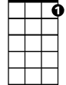

C7

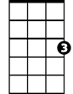

C

F

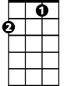

**Dm G7**

It's lonely out in space

**Bb F Bb C C7**

On such a ti – i-meless flight

**Chorus: 2X**



G

**F Bb**

And I think it's gonna be a long long time

**F**

'Till touch down brings me round again to find

**Bb**

I'm not the man they think I am at home

**F G**

Oh no no no I'm a rocket man

**BARITONE**

**Bb F Bb**

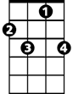

C7

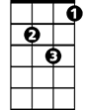

Dm



G7

Rocket man burning out his fuse up here alone

**Dm G7**

Mars ain't the kind of place to raise your kids

**Dm G7**

In fact it's cold as hell

**Bb F Bb C C7**



F

C

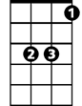

Bb

And there's no one there to raise them if you did

**Dm G7**

And all this science I don't understand

**Dm G7**

It's just my job five days a week

**Bb F Bb C C7**



G

A rocket ma - an, a rocket man

**(Chorus)**

**Repeat 3X to fade**

**Bb F**

And I think it's gonna be a long long time