**Rocking Around the Christmas Tree (Johnny Marks)**

C26

**Intro (Four Measures): C | Am | F | G7 |**

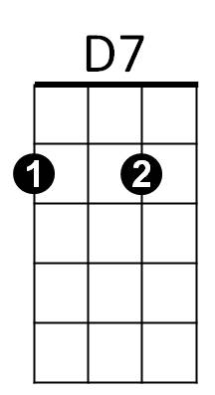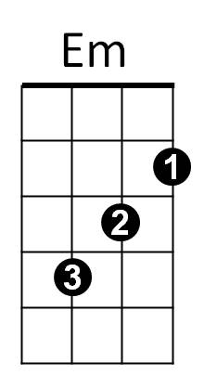



C

F

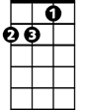

Dm

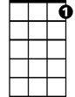

C7

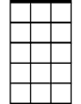

Am7

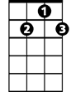

G7

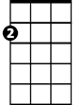

Am

**C**

Rocking around the Christmas tree

**G7**

At the Christmas party hop

**Dm G7 Dm G7**

Mistletoe hung where you can see

**Dm C**

Every couple tries to stop

**C**

Rocking around the Christmas tree

**G7**

Let the Christmas spirit ring

**Dm G7 Dm G7**

Later we'll have some pumpkin pie

**Dm C C7**

And we'll do some carol-ing

**Bridge:**

**BARITONE**



F



Am

C



**F Em**

You will get a sentimental feeling when you hear

**Am Am7**

Voices singing, "Let's be jolly

**D7 G7**

Deck - the halls with boughs of holly!"

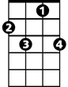

C7

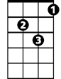

Dm



G7

**C**

Rocking around the Christmas tree

**G7**

Have a happy holiday

**Dm G7 Dm G7**

Everyone dancing merri-ly



D7



Em

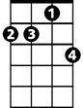

Am7

**F G7 C**

In the new old-fashioned way! **Repeat from Bridge**

**Outro**

**G7 F G7 C C F G7 C**

In the new – old – fash - ioned - way!