Rovin' Gambler
Randy Sparks
Original Key of G. 2/2 Time.
"Moderately Bright."
Note.

The first verse of the Sparks version is the same as most of the other versions, but the similarity stops there. By way of comparison, here are the lyrics to the Bob Dylan version, which are substantially similar to most of the other versions (Tennessee Ernie Ford, Hank Thompson, the Country Gentlemen, and others).

Bob Dylan's Version

I am a rovin' gambler, I've gambled all around
Wherever I meet with a deck of cards
I lay my money down
(I Lay my money down, lay my money down.)

I gambled up in Washington, gambled over in Spain
I'm on my way to Frisco town
To knock down my last game
(knock down my last game; knock down my last game)

I had not been in 'Frisco, many more days than three
I fell in love with a pretty little girl
And she fell in love with me
(Fell in love with me, fell in love with me.)

She took me in her parlor, she cooled me with a fan
She whispered low in her mama's ear
"I love this gamblin' man."
("Love this gamelin' man." "Love this gamblin' man.")

"Daughter, Oh! dear daughter, how could you treat me so?
And leave your dear old mother
And with a gambler go?"
(With a gambler go? with a gambler go?)

"Mother, Oh dear mother, I'll tell you if I can
If you ever see my face again
I'll be with the gamblin' man"
(be with the gamblin' man" be with the gamblin' man)

Finally, there's a really good commentary by Tom Adams, "High Five: Roving Gambler."
www.adamscountybanjo.com
https://banjonews.com/2017-10/roving_gambler.html
Rovin' Gambler
Randy Sparks
Original Key of G. Ukulele Tabs. 2/2 Time. "Moderately Bright."
Recorded by the New Christy Minstrels on their 1963 Album Ramblin'.

GCEA  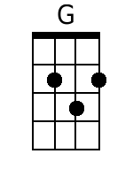  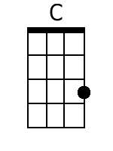  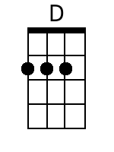  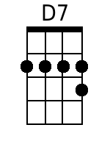  Bari  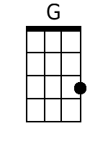  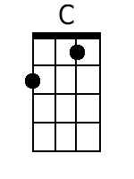  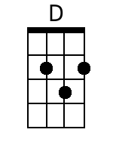  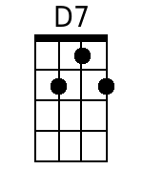 | Intro: 4/4 Time  G  I'm a rambler, I'm a gambler,  [3/4] C [4/4] D - D7  Lady For-tune's my trade.  Chorus.  G  I am a rovin' gambler, I've gambled all around;  Whenever I meet with a deck of cards,  C G  I lay my money down.  D7 G  Lay my money down, Lord, lay my money down.  G  1. Got a pretty little girl in New Orleans,  Her name is Mary Lou.  Though I ain't been to see her in fourteen years,  C G  She promised she'd be true.  (Whistle ... measure and a half.)  D7 G  Hey, Poor ol' Mary Lou.  G  2. There's an old maid livin' in Abilene,  Her name is Polly Ann;  She claims if she ever gets wedded up,  C G  It's gonna be to a gamblin man.  (Instrumental ... measure and a half)  D7 G  So long, Polly Ann.  Chorus.  G  I am a rovin' gambler, I've gambled all around;  Whenever I meet with a deck of cards,  C G  I lay my money down.  D7 G  Lay my money down, Lord, lay my money down.  (12 Measure Instrumental.)  (Bridge)  G  Well I never cheat a gamblin'  'Cause it makes some people sore.  (Spoken) (But just in case I got an extra ace  C G  And a big long forty four.)  (Whistle ... measure and a half.)  D7 G  A red hot forty four.  G  3. Well, the preacher said that a gamblin' man  Is walking the road of sin;  (Spoken) (But every time that I start to quit,  C G  That's when I start to win.)  (Two Measure Instrumental)  D7 G  Lord, I rake that money in.  Chorus  G  I am a rovin' gambler, I've gambled all around;  Whenever I meet with a deck of cards,  C G  I lay my money down.  D7 G  Lay my money down, Lord, lay my money down.  (Instrumental ... 1 & ½ verses): C ... G ...  D7 G ... G ... G ... G .  Lay my money down.
  G | G | G  Get her, Larry! | G
  G  Pick at it! | G  Pick your little heart out! | C | G
  G | G | D7 | G

