Ruby Tuesday (Mick Jagger & Keith Richards, 1966) (Am)
Ruby Tuesday by the Rolling Stones (1966)
Key: Am – Tempo: 105 BPM – Melanie: Ab Major / 90 BPM

Intro (TBD)  Am G F G C - Csus4 C  She would never say where she came from.  Am G F G7 - G7sus4 G7  Yester-day don't matter if it's gone.  Am D7 G Am D7 G  While the sun is bright; Or in the darkest night  C G - Gsus4 G  No one knows she comes and goes.  Chorus  C G C G C  Good-bye Ruby Tuesday who could hang a name on you  C G Bb F G F - G7  When you change with ev'ry new day, still I'm gonna miss you.  Am G F G C - Csus4 C  Don't question why she needs to be so free.  Am G F G7 – G7sus4 G7  She'll tell you it's the only way to be.  Am D7 G Am D7 G  She just can't be chained; To a life where nothing's gained  C G - Gsus4 G  And nothing's lost at such a cost. Chorus  Am G F G C - Csus4 C  There's no time to lose I heard her say.  Am G F G7 - G7sus4 G7  Catch your dreams be-fore they slip a-way.  Am D7 G Am D7 G  Dying all the time; Lose your dreams and you  C G - Gsus4 G  Will lose your mind ain't life un-kind. Chorus  Outro  G F - G7 Am G F G7 C  Still I'm gonna miss you. |  |  |  |  |  | 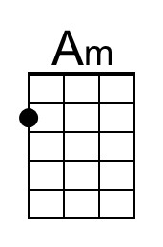 | 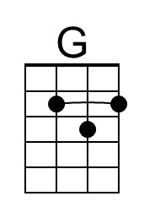
 |  |  |  |  |  | 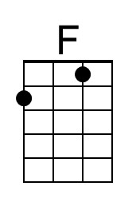 | 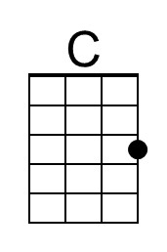
 |  |  |  |  |  | 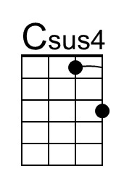 | 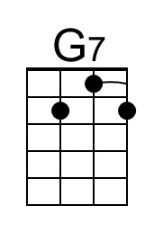
 |  |  |  |  |  | 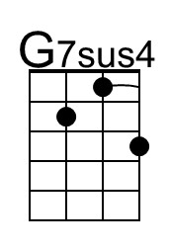 | 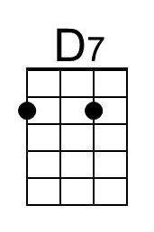
 |  |  |  |  |  | 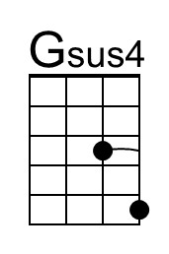 | 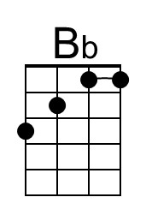
Bari | 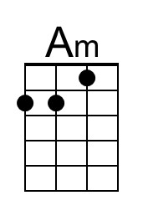 | 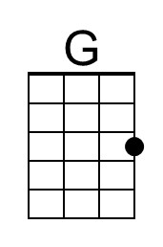 | 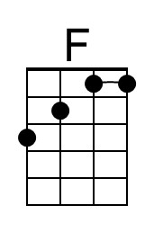 | 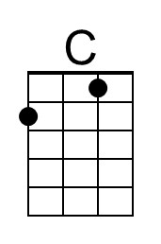 | 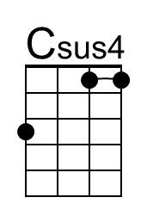
 | 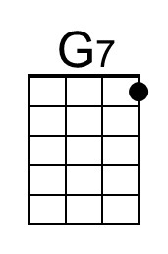 | 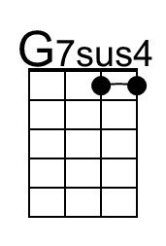 | 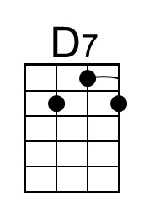 | 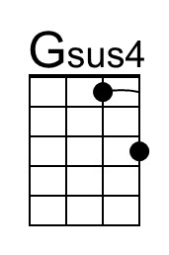 | 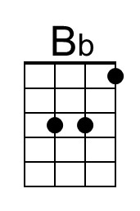

Ruby Tuesday (Mick Jagger & Keith Richards, 1966) (Em)
Ruby Tuesday by the Rolling Stones (1966)
Key: Em – Tempo: 105 BPM – Melanie: Ab Major / 90 BPM

Intro (TBD)  Em D C D G - Gsus4 G  She would never say where she came from.  Em D C D7 - D7sus4 D7  Yester-day don't matter if it's gone.  Em A7 D Em A7 D  While the sun is bright; Or in the darkest night  G D - Dsus4 D  No one knows she comes and goes.  Chorus  G D G D G  Good-bye Ruby Tuesday who could hang a name on you.  G D F C  When you change with ev'ry new day,  D C - D7  Still I'm gonna miss you.  Em D C D G - Gsus4 G  Don't question why she needs to be so free.  Em D C D7 – D7sus4 D7  She'll tell you it's the only way to be.  Em A7 D Em A7 D  She just can't be chained; To a life where nothing's gained  G D - Dsus4 D  And nothing's lost at such a cost. Chorus  Em D C D G - Gsus4 G  There's no time to lose I heard her say.  Em D C D7 - D7sus4 D7  Catch your dreams be-fore they slip a-way.  Em A7 D Em A7 D  Dying all the time; Lose your dreams and you  G D - Dsus4 D  Will lose your mind ain't life un-kind. Chorus  Outro  D C - D7 Em D C D7 G  Still I'm gonna miss you. |  |  |  |  |  | 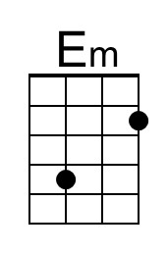 | 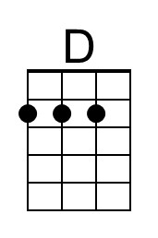
 |  |  |  |  |  | 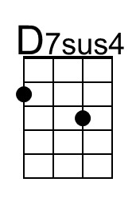 | 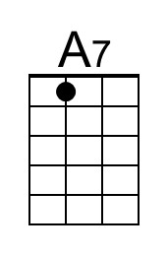
 |  |  |  |  |  | 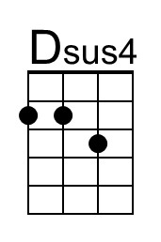
Bari | 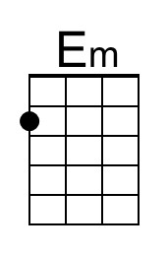 | 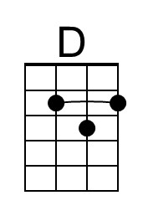
 |  | 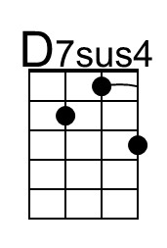 | 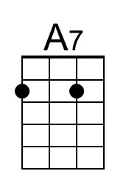 | 