
Rudolph the Red-Nosed Reindeer
C15 C
(Johnny Marks, ca. 1949)
Rudolph the Red-Nosed Reindeer by Gene Autry (1949)
Rudolph the Red-Nosed Reindeer by Burl Ives (1964)

Starting Note E  Intro F | F  F G F C  You know Dasher and Dancer and Prancer and Vixen,  F G F C  Comet and Cupid and Donner and Blitzen  Am D7 G G7  But do you recall the most famous reindeer of all?  C G7  Rudolph the red-nosed reindeer had a very shiny nose,  C  And if you ever saw it, you would even say it glows.  C G7  All of the other reindeer used to laugh and call him names,  C C7  They never let poor Rudolph join in any reindeer games.  Refrain  F C Dm G7 C  Then one foggy Christmas Eve, Santa came to say,  G  "Rudolph with your nose so bright,  D7 G7  Won't you guide my sleigh tonight?"  C G7  Then how the reindeer loved him, as they shouted out with glee,  _________________________________________________________  │ C C7  │ 1. "Rudolph the red-nosed reindeer, you'll go down in history."  (Repeat from Refrain)  _________________________________________________________  │ C G7 C  │ 2. "Rudolph the red-nosed reindeer, you'll go down in his – to – ry." |  |  |  |  |  |  |  | 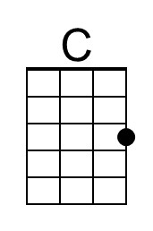
 |  |  |  |  |  |  |  | 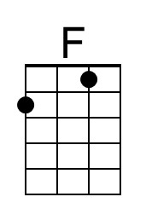
 |  |  |  |  |  |  |  | 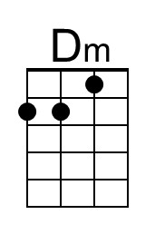
 |  |  |  |  |  |  |  | 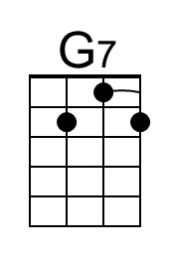
 |  |  |  |  |  |  |  | 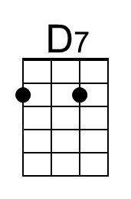
 |  |  |  |  |  |  |  | 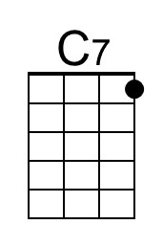
 |  |  |  |  |  |  |  | 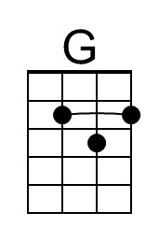
Baritone | 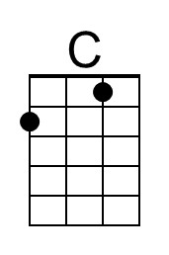 | 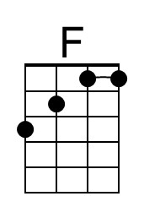 | 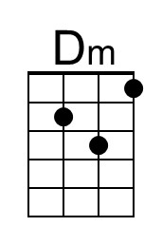 | 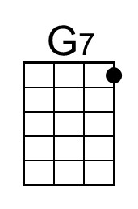 | 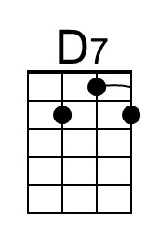 | 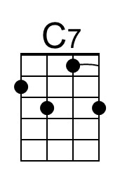 | 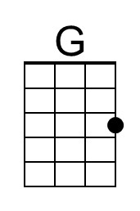

Rudolph the Red-Nosed Reindeer
C15 G
(Johnny Marks, ca. 1949)
Rudolph the Red-Nosed Reindeer by Gene Autry (1949)
Rudolph the Red-Nosed Reindeer by Burl Ives (1964)

Starting Note B

Intro C | C

C D C G
You know Dasher and Dancer and Prancer and Vixen,
C D C G
Comet and Cupid and Donner and Blitzen
Em A7 D D7
But do you recall the most famous reindeer of all?

G D7
Rudolph the red-nosed reindeer had a very shiny nose,
G
And if you ever saw it, you would even say it glows.
G D7
All of the other reindeer used to laugh and call him names,
G G7
They never let poor Rudolph join in any reindeer games.

Refrain
C G Am D7 G
Then one foggy Christmas Eve, Santa came to say,
D
"Rudolph with your nose so bright,
A7 D7
Won't you guide my sleigh tonight?"

G D7
Then how the reindeer loved him, as they shouted out with glee,
_________________________________________________________
│ G G7
│ 1. "Rudolph the red-nosed reindeer, you'll go down in history."
(Repeat from Refrain)
_________________________________________________________
│ G D7 G
│ 2. "Rudolph the red-nosed reindeer, you'll go down in his – to – ry."

 |  |  |  |  |  |  |  | 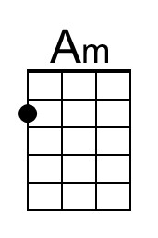
 |  |  |  |  |  |  |  | 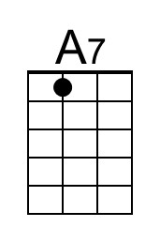
 |  |  |  |  |  |  |  | 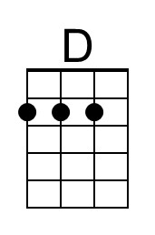
Baritone |  |  | 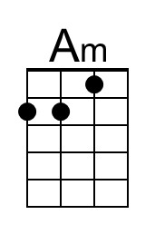 |  | 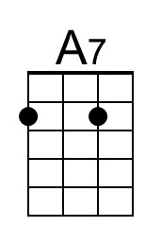 |  | 