**Rudolph the Red-Nosed Reindeer (Johnny Marks, 1964)**

C15

**F G F C**

F



C

F



You know Dasher and Dancer and Prancer and Vixen,



C

**F G F C**

Comet and Cupid and Donner and Blitzen

**Am D7 G G7**

But do you recall the most famous reindeer of all?

**C G7**

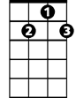

G7

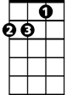

Dm

Rudolph the red-nosed reindeer had a very shiny nose,

**C**

And if you ever saw it, you would even say it glows.

**C G7**

All of the other reindeer used to laugh and call him names,

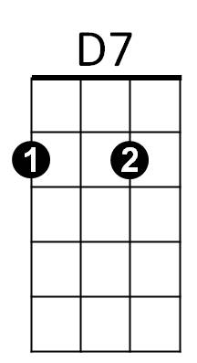 **C C7**

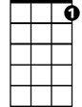

C7

They never let poor Rudolph join in any reindeer games.

**Refrain:**

**F C**

Then one foggy Christmas Eve,

**Dm G7 C**



G

Santa came to say,

**G**

"Rudolph with your nose so bright,

**D7 G7**

Won't you guide my sleigh tonight?"

**C G7**

Then how the reindeer loved him, as they shouted out with glee,

**C**

"Rudolph the red-nosed reindeer, you'll go down in history."

**(Repeat song from Refrain, draw out “his-to-ree”)**

C



G

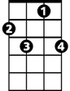

C7



D7



G7

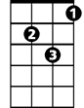

Dm

**BARITONE**



F