**Run To Me (Barry, Robin & Maurice Gibbs)**

**C Bb**

If ever you got rain in your heart,

**Am F Am Dm**

Someone has hurt you, and torn you apart,

**G C**

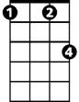

Fm

Em

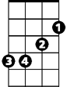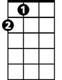

A

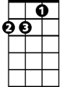

Dm

F



G

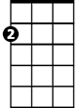

Am



C



Bb

Am I unwise to open up your eyes to love me?

**C Bb**

And let it be like they said it would be -

**Am F Am Dm**

Me loving you girl, and you loving me.

**G C**

Am I unwise to open up your eyes to love me?

**Chorus:**

**C Em**

Run to me whenever you're lonely

**F Fm**

Run to me if you need a shoulder

**C Bb A**

Now and then, you need someone older,

**Fm G C**

So darling, you run to me.



Em

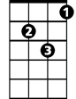

Dm



G

C



Am

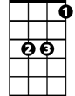

Bb

**BARITONE**

**C Bb**

And when you're out in the cold,

**Am F**  **Am Dm**

No one beside you, and no one to hold,

**G C**



F

Am I unwise to open up your eyes to love me?

**C Bb**

And when you've got nothing to lose,

**Am F Am Dm**

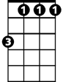

Fm

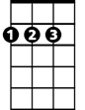

A

Nothing to pay for, nothing to choose,

**G C**

Am I unwise to open up your eyes to love me?

**(Chorus) (2X)**