Runaround Sue (Dion DiMucci & Ernie Maresca, 1961) (C)
Runaround Sue by Dion and the Del-Satins (D)
4/4 – 80 BPM
Intro  C Am  __ Here's my story, it's sad but true. __ It's about a girl that I once knew.  F G  __ She took my love, then ran around. __ With every single guy in town.  Chorus 1  C Am  Hey, hey, bum-da ha-dy ha-dy. Hey, hey, bum-da ha-dy ha-dy.  F G7  Hey, hey, bum-da ha-dy ha-dy. Hey, hey, bum-da ha-dy ha-dy. La, la, la, la.  C Am  Hey, hey, bum-da ha-dy ha-dy. Hey, hey, bum-da ha-dy ha-dy.  F G7  Hey, hey, bum-da ha-dy ha-dy. Hey. Aaahhh  C  __ Yea, I should have known it from the very start,  Am  __ This girl will leave me with a broken heart.  F  __ Now listen people, what I'm tellin’ you.  G  __ A-keep away from Runaround Sue.  C  __ I miss her lips and the smile from her face.  Am  __ The touch of her hair and this girl's warm embrace.  F  __ So if you don't wanna cry like I do,  G  __ A-keep away from Runaround Sue.  Chorus 2  C Am  Hey, hey, bum-da ha-dy ha-dy. Hey, hey, bum-da ha-dy ha-dy.  F G7  Hey, hey, bum-da ha-dy ha-dy. Hey. Aaahhh | 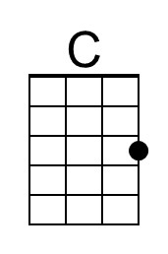
 | 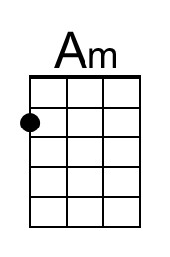
 | 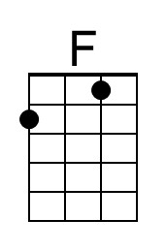
 | 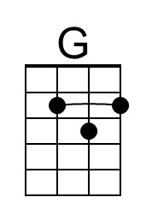
 | Bari
 | 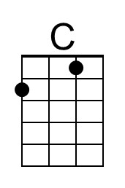
 | 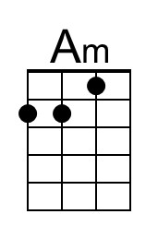
 | 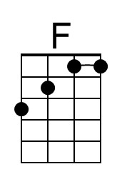
 | 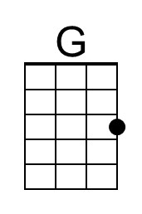

Runaround Sue (C) – Page 2
Bridge
F C
She like to travel around, yea. She'll love you, but she'll put you down.
F G (Tacet)
Now, people let me put you wise, Sue goes out with other guys

C
__ Here’s the moral and the story from the guy who knows.
Am
__ I fell in love and my love still grows.
F
Ask any fool that she ever knew,
G
They'll say: __ Keep away from Runaround Sue.

C Am
Hey, hey, bum-da ha-dy ha-dy. Hey, hey, bum-da ha-dy ha-dy.
F G7
Hey, hey, bum-da ha-dy ha-dy. Hey. Aaahhh

Repeat from Bridge

Outro
C Am
Hey, hey, bum-da ha-dy ha-dy. Hey, hey, bum-da ha-dy ha-dy.
F G7 | C
Hey, hey, bum-da ha-dy ha-dy. Hey, Hey.
Runaround Sue (Dion DiMucci & Ernie Maresca, 1961) (D)
Runaround Sue by Dion and the Del-Satins (D)
4/4 – 80 BPM
Intro  D Bm  __ Here's my story, it's sad but true. __ It's about a girl that I once knew.  G A  __ She took my love, then ran around. __ With every single guy in town.  Chorus 1  D Bm  Hey, hey, bum-da ha-dy ha-dy. Hey, hey, bum-da ha-dy ha-dy.  G A7  Hey, hey, bum-da ha-dy ha-dy. Hey, hey, bum-da ha-dy ha-dy. La, la, la, la.  D Bm  Hey, hey, bum-da ha-dy ha-dy. Hey, hey, bum-da ha-dy ha-dy.  G A7  Hey, hey, bum-da ha-dy ha-dy. Hey. Aaahhh  D  __ Yea, I should have known it from the very start,  Bm  __ This girl will leave me with a broken heart.  G  __ Now listen people, what I'm tellin’ you.  A  __ A-keep away from Runaround Sue.  D  __ I miss her lips and the smile from her face.  Bm  __ The touch of her hair and this girl's warm embrace.  G  __ So if you don't wanna cry like I do,  A  __ A-keep away from Runaround Sue.  Chorus 2  D Bm  Hey, hey, bum-da ha-dy ha-dy. Hey, hey, bum-da ha-dy ha-dy.  G A7  Hey, hey, bum-da ha-dy ha-dy. Hey. Aaahhh | 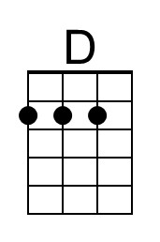
 | 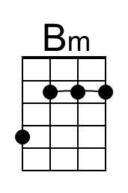
 | 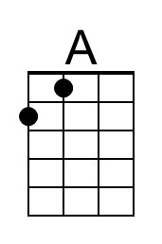
 | Bari
 | 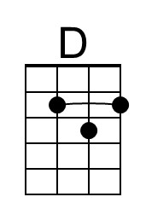
 | 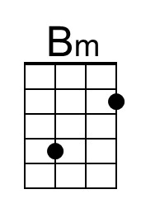
 | 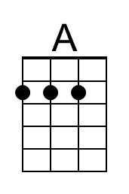

Runaround Sue (D) – Page 2
Bridge
G D
She like to travel around, yea. She'll love you, but she'll put you down.
G A (Tacet)
Now, people let me put you wise, Sue goes out with other guys

D
__ Here’s the moral and the story from the guy who knows.
Bm
__ I fell in love and my love still grows.
G
Ask any fool that she ever knew,
A
They'll say: __ Keep away from Runaround Sue.

D Bm
Hey, hey, bum-da ha-dy ha-dy. Hey, hey, bum-da ha-dy ha-dy.
G A7
Hey, hey, bum-da ha-dy ha-dy. Hey. Aaahhh

Repeat from Bridge

Outro
D Bm
Hey, hey, bum-da ha-dy ha-dy. Hey, hey, bum-da ha-dy ha-dy.
G A7 | D
Hey, hey, bum-da ha-dy ha-dy. Hey, Hey.

Runaround Sue (Dion DiMucci & Ernie Maresca, 1961) (G)
Runaround Sue by Dion and the Del-Satins (D)
4/4 – 80 BPM
Intro
G Em
__ Here's my story, it's sad but true. __ It's about a girl that I once knew.
C D
__ She took my love, then ran around. __ With every single guy in town.

Chorus 1
G Em
Hey, hey, bum-da ha-dy ha-dy. Hey, hey, bum-da ha-dy ha-dy.
C D7
Hey, hey, bum-da ha-dy ha-dy. Hey, hey, bum-da ha-dy ha-dy. La, la, la, la.
G Em
Hey, hey, bum-da ha-dy ha-dy. Hey, hey, bum-da ha-dy ha-dy.
C D7
Hey, hey, bum-da ha-dy ha-dy. Hey. Aaahhh

G
__ Yea, I should have known it from the very start,
Em
__ This girl will leave me with a broken heart.
C
__ Now listen people, what I'm tellin’ you.
D
__ A-keep away from Runaround Sue.

G
__ I miss her lips and the smile from her face.
Em
__ The touch of her hair and this girl's warm embrace.
C
__ So if you don't wanna cry like I do,
D
__ A-keep away from Runaround Sue.

Chorus 2
G Em
Hey, hey, bum-da ha-dy ha-dy. Hey, hey, bum-da ha-dy ha-dy.
C D7
Hey, hey, bum-da ha-dy ha-dy. Hey. Aaahhh
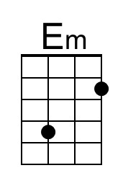
Bari
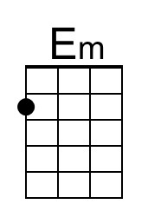

Runaround Sue (G) – Page 2
Bridge
C G
She like to travel around, yea. She'll love you, but she'll put you down.
C D (Tacet)
Now, people let me put you wise: Sue goes out with other guys!

G
__ Here’s the moral and the story from the guy who knows.
Em
__ I fell in love and my love still grows.
C
Ask any fool that she ever knew,
D
They'll say: __ Keep away from Runaround Sue.

G Em
Hey, hey, bum-da ha-dy ha-dy. Hey, hey, bum-da ha-dy ha-dy.
C D7
Hey, hey, bum-da ha-dy ha-dy. Hey. Aaahhh

Repeat from Bridge

Outro
G Em
Hey, hey, bum-da ha-dy ha-dy. Hey, hey, bum-da ha-dy ha-dy.
C D7 | G
Hey, hey, bum-da ha-dy ha-dy. Hey. Hey.

Dion and the Belmonts parted ways in October, 1960.

