
Santa Baby
C78 C
(Joan Javits, Philip Springer & Tony Springer, 1953) – Santa Baby by Eartha Kitt (1953)

Intro C A7 D7 G7  C A7 D7 G7 C  Santa Baby, slip a sable under the tree -  A7 D7 G7 C  - For me. I've been an awful good girl.  A7 D7 G7 C A7 D7 G7  Santa baby so hurry down the chimney tonight.  C A7 D7 G7 C A7  Santa Baby, a 54 con-vertible too, light blue.  D7 G7 C  Well I'll wait up for you dear.  A7 D7 G7 C A7 D7 G7  Santa Baby so hurry down the chimney tonight.  E7 A7  Think of all the fun I've missed. Think of all the boys I haven't kissed.  D7 G7 G  Next year I could be just as good, if you’ll check off my Christmas list.  C A7 D7 G7 C A7  Santa Baby, I want a yacht and really that’s not - a lot.  D7 G7 C  I've been an angel all year.  C A7 D7 G7 C A7 D7 G7  Santa Baby, so hurry down the chimney tonight.  C A7 D7 G7 C  Santa Honey, there’s one more thing I really do need.~  A7 D7 G7 C  - The deed - to a platinum mine.  A7 D7 G7 C A7 D7 G7  Santa Honey, so hurry down the chimney tonight.  E7 A7  Come and trim my Christmas tree with some decorations bought from  Tiffany’s  D7 G7 G  I really do believe in you, let’s see if you believe in me.  C A7 D7 G C A7  Santa Baby, forgot to mention one little thing - A RING,  D7 G7 C  - And I don’t mean on the phone.  A7 D7 G7 C A7  Santa Baby, So hurry down the chimney tonight.  D7 G7 C A7  So hurry down the chimney tonight. (4x) | 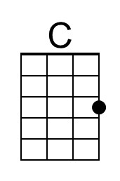 | 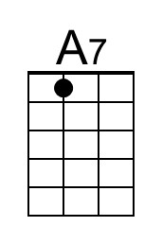
 | 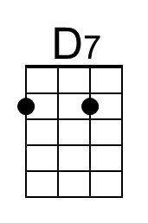 | 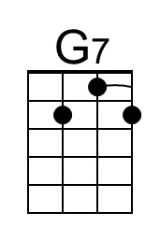
 | 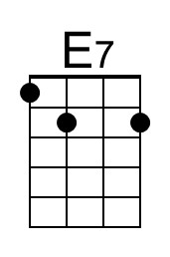 | 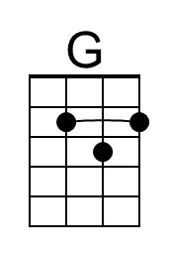
 | Baritone
 | 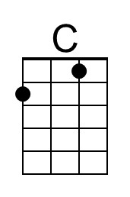 | 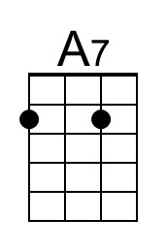
 | 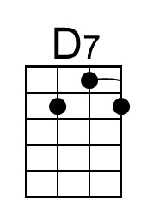 | 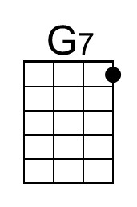
 | 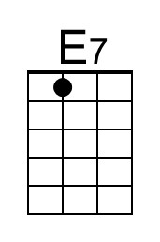 | 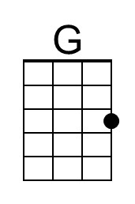

Santa Baby
C78 G
(Joan Javits, Philip Springer & Tony Springer, 1953) – Santa Baby by Eartha Kitt (1953)

Intro G E7 A7 D7

G E7 A7 D7 G
Santa Baby, slip a sable under the tree -
E7 A7 D7 G
- For me. I've been an awful good girl.
E7 A7 D7 G E7 A7 D7
Santa baby so hurry down the chimney tonight.

G E7 A7 D7 G E7
Santa Baby, a 54 con-vertible too, light blue.
A7 D7 G
Well I'll wait up for you dear.
E7 A7 D7 G E7 A7 D7
Santa Baby so hurry down the chimney tonight.

B7 E7
Think of all the fun I've missed. Think of all the boys I haven't kissed.
A7 D7 D
Next year I could be just as good, if you’ll check off my Christmas list.

G E7 A7 D7 G E7
Santa Baby, I want a yacht and really that’s not - a lot.
A7 D7 G
I've been an angel all year.
G E7 A7 D7 G E7 A7 D7
Santa Baby, so hurry down the chimney tonight.

G E7 A7 D7 G
Santa Honey, there’s one more thing I really do need.~
E7 A7 D7 G
- The deed - to a platinum mine.
E7 A7 D7 G E7 A7 D7
Santa Honey, so hurry down the chimney tonight.

B7 E7
Come and trim my Christmas tree with some decorations bought from
Tiffany’s
A7 D7 D
I really do believe in you, let’s see if you believe in me.

G E7 A7 D G E7
Santa Baby, forgot to mention one little thing - A RING,
A7 D7 G
- And I don’t mean on the phone.
E7 A7 D7 G E7
Santa Baby, So hurry down the chimney tonight.
A7 D7 G E7
So hurry down the chimney tonight. (4x)
 | 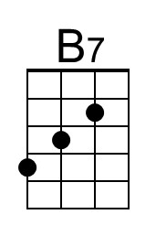 | 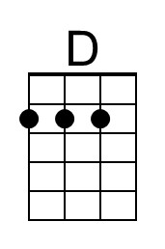
 | Baritone
 | 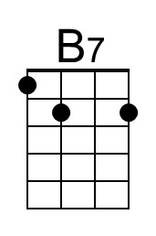 | 