
Santa Baby Ukulele
C96 C
( Adaptation by Theresa Miller, 2019)

Intro (Hawaiian vamp): Dm G7 C (2x)  C Am Dm G7 C Am Dm G7 C Am  _ Santa baby, a ukulele under the tree would be, _ such a thri-ill for me, Santa baby  Dm G7 C Am Dm G7  So hurry down the chimney to-night.  C Am Dm G7 C Am  _ Santa honey, fill my stocking with Aquila strings and things,  Dm G7 C Am  __ Maybe some Aloha shirts, too, Santa baby,  Dm G7 C Am Dm G7  So hurry down the chimney to-night  Dm G7 C Am Dm G7  So hurry down the chimney to-night  E7  __ Think of all the ukes I haven’t played,  A A7  One of each size and color, would just make my day, and  D  _ think of all those Christmas songs  G G7 Dm G7 C  I could practice every day and play them all year long. Ba-doo-bee-doo  C Am Dm G7 C Am  _ Santa baby, an amp and a music stand too, would do  Dm G7 C Am  For ukulele strum-alongs, too, Big Ka-huna,  Dm G7 C Am Dm G7  Please hurry down the chimney to-night  E7  __ Come and deck my Christmas tree  A A7  With capos, tuners, straps and draped with orchid leis.  D G G7 Dm G7  Daily Ukulele books under the tree, with lots of cool new songs for me  C Am Dm G7 C Am Dm G7  _ Santa baby, for-got to mention one little thing, I’d like __ to ring-in the New Year  C Am Dm G7 C Am  In Ha - wa - ii, so wiki-wiki down the chimney to-night  Dm G7 C A7 Dm G7 B ~ C  I’ll play Mele Kaliki-maka for you, mahalo nui, so hurry down the chimney to – night.  Vamp out: Dm G7 C (2x) Aloha! |  |  |  |  |  |  | 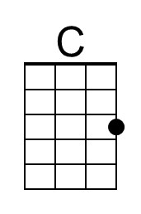 | 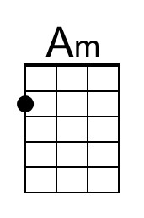
 |  |  |  |  |  |  | 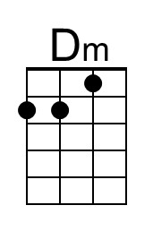 | 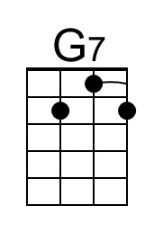
 |  |  |  |  |  |  | 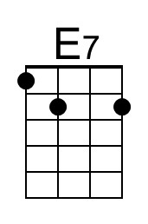 | 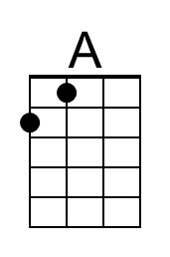
 |  |  |  |  |  |  | 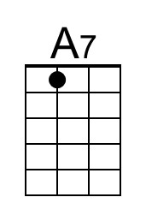 | 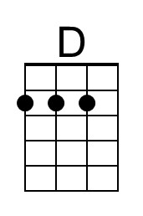
 |  |  |  |  |  |  | 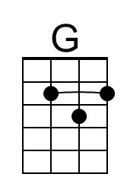
Baritone
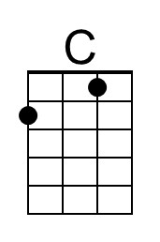 | 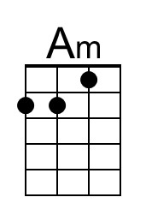 | 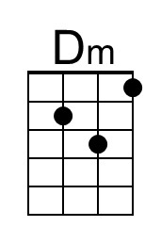 | 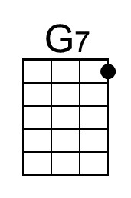 | 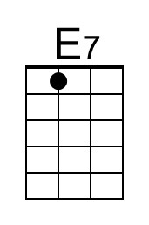 | 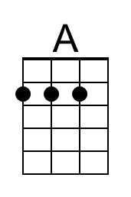 | 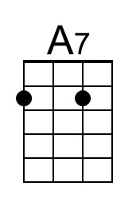 | 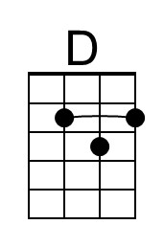 | 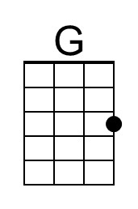

Santa Baby Ukulele
C96 G
(Adaptation by Theresa Miller, 2019)

Intro (Hawaiian vamp): Am D7 G (2x)  G Em Am D7 G Em Am D7 G Em  _ Santa baby, a ukulele under the tree would be, _ such a thri-ill for me, Santa baby  Am D7 G Em Am D7  So hurry down the chimney to-night.  G Em Am D7 G Em  _ Santa honey, fill my stocking with Aquila strings and things,  Am D7 G Em  __ Maybe some Aloha shirts, too, Santa baby,  Am D7 G Em Am D7  So hurry down the chimney to-night  Am D7 G Em Am D7  So hurry down the chimney to-night  B7  __ Think of all the ukes I haven’t played,  E E7  One of each size and color, would just make my day, and  A  _ think of all those Christmas songs  D D7 Am D7 G  I could practice every day and play them all year long. Ba-doo-bee-doo  G Em Am D7 G Em  _ Santa baby, an amp and a music stand too, would do  Am D7 G Em  For ukulele strum-alongs, too, Big Ka-huna,  Am D7 G Em Am D7  Please hurry down the chimney to-night  B7  __ Come and deck my Christmas tree  E E7  With capos, tuners, straps and draped with orchid leis.  A D D7 Am D7  Daily Ukulele books under the tree, with lots of cool new songs for me  G Em Am D7 G Em Am D7  _ Santa baby, for-got to mention one little thing, I’d like __ to ring-in the New Year  G Em Am D7 G Em  In Ha - wa - ii, so wiki-wiki down the chimney to-night  Am D7 G E7 Am D7 F# ~ G  I’ll play Mele Kaliki-maka for you, mahalo nui, so hurry down the chimney to – night.  Vamp out: Am D7 G (2x) Aloha! |  |  |  |  |  |  |  | 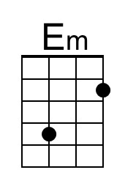
 |  |  |  |  |  |  |  | 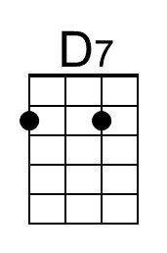
 |  |  |  |  |  |  | 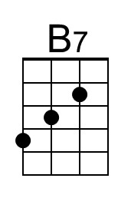 | 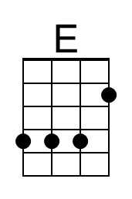
Baritone
 | 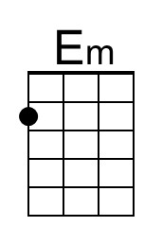 |  | 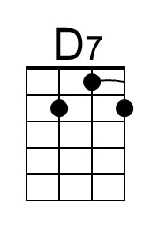 | 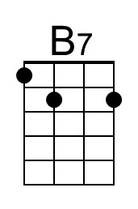 | 