**Santa Baby (Joan Javits, Philip Springer and Tony Springer)**

**Intro: C A7 D7 G7**

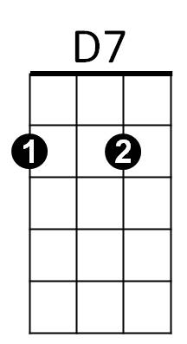

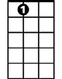

A7



C

**C A7 D7 G7 C**

Santa Baby, slip a sable under the tree -

**A7 D7 G7 C**

- For me. I've been an awful good girl.

**A7 D7 G7 C A7 D7 G7**

Santa baby so hurry down the chimney tonight.



G

E7

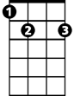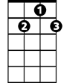

G7

**C A7 D7 G7 C A7**

Santa Baby, a 54 convertable too, light blue.

**D7 G7 C**

Well I'll wait up for you dear.

**A7 D7 G7 C A7 D7 G7**

Santa Baby so hurry down the chimney tonight.

**E7**

Think of all the fun I've missed.

**A7**

Think of all the boys I haven't kissed.

**D7**

Next year I could be just as good

**G7 G**

If you’ll check off my Christmas list.

**C A7 D7 G7 C A7**

Santa Baby, I want a yacht and really that’s not - a lot.

**D7 G7 C**

I've been an angel all year.

**C A7 D7 G7 C A7 D7 G7**

Santa Baby, so hurry down the chimney tonight.

**BARITONE**

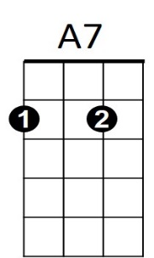**C A7 D7 G7 C**



G



E7

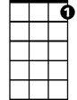

G7

C



D7

Santa Honey, there’s one more thing I really do need.~

**A7 D7 G7 C**

- The deed - to a platinum mine.

**A7 D7 G7 C A7 D7 G7**

Santa Honey, so hurry down the chimney tonight.

**E7**

Come and trim my Christmas tree

**A7**

With some decorations bought from Tiffany’s

**D7 G7 G**

I really do believe in you, let’s see if you believe in me.

**C A7 D7 G C** **A7**

Santa Baby, forgot to mention one little thing - A RING,

**D7 G7 C**

- And I don’t mean on the phone.

**A7 D7 G7 C A7**

Santa Baby, So hurry down the chimney tonight.

**D7 G7 C A7 (x4)**

So hurry down the chimney tonight.