
Santa Claus Is Coming to Town
C16 C
(J. Fred Coots / Henry Gillespie, 1934)
Santa Claus Is Coming to Town by Bing Crosby and the Andrews Sisters (1947)
Santa Claus Is Coming to Town by The Jackson Five (1970)
Santa Claus Is Coming to Town by Bruce Springsteen & The E Street Band (1975)

Intro (Last line of Chorus)  Chorus  C F  You'd better watch out, you'd better not cry,  C F  You'd better not pout, I'm telling you why  C Am F G7 C G7  Santa Claus is coming to town. [End on C]  C F C F  He's making a list, he's checkin' it twice, he's gonna find out who's naughty and nice.  C Am F G7 C  Santa Claus is coming to town.  Reprise  C7 F C7 F  He sees you when you're sleeping, He knows if you're awake,  D7 G7 D7 G7  He knows if you've been bad or good, So be good for goodness sake. Chorus  C F C F  With little tin horns and little toy drums, Rooty toot toots and rum-a tum tums  C Am F G7 C  Santa Claus is coming to town.  C F C F  With curly haired dolls that cuddle and coo, Elephants, boats and kiddie cars, too.  C Am F G7 C  Santa Claus is coming to town.  C7 F C7 F  The kids in girls and boy-land, will have a jubi-lee  D7 G7 D7 G7  They’re gonna build a toyland town, all a-round the Christmas tree.  ( Chorus / Reprise / Chorus) |  |  |  |  |  |  |  | 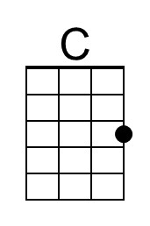
 |  |  |  |  |  |  |  | 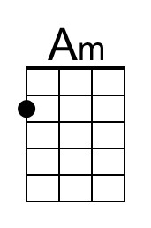
 |  |  |  |  |  |  |  | 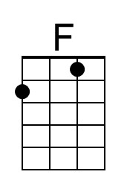
 |  |  |  |  |  |  |  | 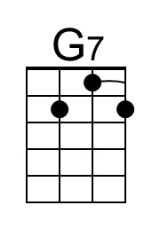
 |  |  |  |  |  |  |  | 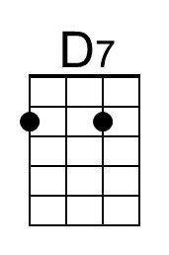
 |  |  |  |  |  |  |  | 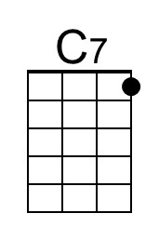
Baritone | 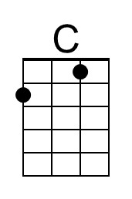 | 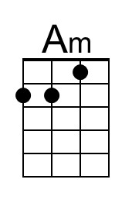 | 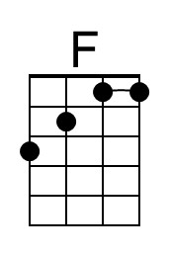 | 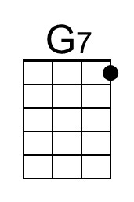 | 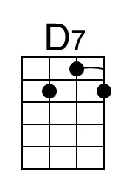 | 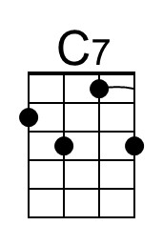

Santa Claus Is Coming to Town
C16 G
(J. Fred Coots / Henry Gillespie, 1934)
Santa Claus Is Coming to Town by Bing Crosby and the Andrews Sisters (1947)
Santa Claus Is Coming to Town by The Jackson Five (1970)
Santa Claus Is Coming to Town by Bruce Springsteen & The E Street Band (1975)

Intro (Last line of Chorus)  Chorus  G C  You'd better watch out, you'd better not cry,  G C  you'd better not pout, I'm telling you why  G Em C D7 G D7  Santa Claus is coming to town. [End on C]  G C G C  He's making a list, he's checkin' it twice, he's gonna find out who's naughty and nice.  G Em C D7 G  Santa Claus is coming to town.  Reprise  G7 C G7 C  He sees you when you're sleeping, He knows if you're awake,  A7 D7 A7 D7  He knows if you've been bad or good, So be good for goodness sake. Chorus  G C G C  With little tin horns and little toy drums, Rooty toot toots and rum-a tum tums  G Em C D7 G  Santa Claus is coming to town.  G C G C  With curly haired dolls that cuddle and coo, Elephants, boats and kiddie cars, too.  G Em C D7 G  Santa Claus is coming to town.  G7 C G7 C  The kids in girls and boy-land, will have a jubi-lee  A7 D7 A7 D7  They’re gonna build a toyland town, all a-round the Christmas tree  ( Chorus / Reprise / Chorus) |  |  |  |  |  |  |  | 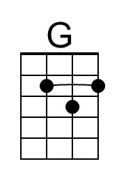
 |  |  |  |  |  |  |  | 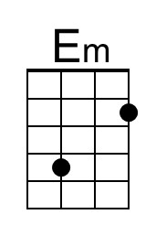
 |  |  |  |  |  |  |  | 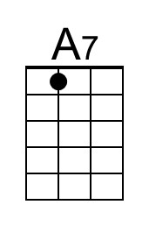
Baritone | 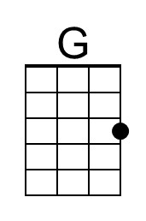 | 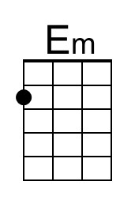 |  |  | 