**Save The Last Dance For Me** Key of C

Doc Pomus and Mort Shuman

**Intro: Chords for Chorus**

**C G**

You can dance, every dance with the guy who gives you the eye, let him hold you tight

**C**

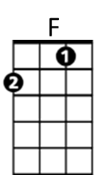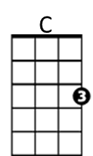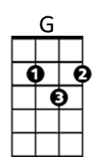You can smile ~ every smile for the man who held your hand 'neath the pale moonlight,

But -

**Chorus:**

**F C**

Don't forget who's taking you home and in whose arms you're gonna be ~~

**G C**

So darling, save the last dance for me

**C G**

Oh I know ~ that the music's fine like sparkling wine, Go and have your fun

**C**

Laugh and sing ~ but while we're apart, Don't give your heart to anyone, and -

**(CHORUS)**

**C G C**

Baby don't you know I love you so - Can't you feel it when we touch

**G C**

I will never never let you go - Cause I love you oh so much

**C G**

You can dance ~ go and carry on, till the night is gone and it's time to go

**C**

If he asks ~ if you're all alone can he take you home, you must tell him no, and

**(CHORUS)**

**ending:**



G

C



F

**BARITONE**

**G C**

So darling, save the last dance for me ( 2x)