Scarlet Ribbons (Evelyn Danzig, Jack Segal)
¾ Time – Key of C – Scarlet Ribbons by Jim Ed Brown

Intro: Chords for last verse, last line.  C F G7 C F G7 F C  I peeked in to say good night, when I heard my child in prayer  D7 G7 C F G7 F C  “Send, dear God, some scarlet ribbons, scarlet ribbons for my hair.”  G7 C F A7 D7 G7  All the stores were closed and shuttered, all the streets were dark and bare.  C D7 G7 C F G7 F C  In our town no scarlet ribbons, not one ribbon for her hair.  G7 C F A7 D7 G7  Through the night my heart was aching, just be-fore the dawn was breaking,  C F G7 C F G7 F C  I peeked in and on her bed, in gay pro-fusion lying there,  F G7 C F G7 F C  I saw ribbons scarlet ribbons, scarlet ribbons for her hair.  G7 C F A7 D7 G7  If I live to be a hundred, I will never know from where  C F G7 C F G7 F G7 C  Came those lovely scarlet ribbons, scarlet ribbons for her hair. |  |  |  |  |  |  | 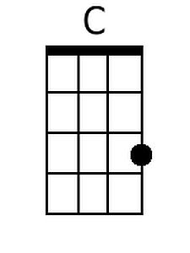
 |  |  |  |  |  |  | 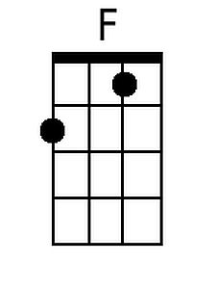
 |  |  |  |  |  |  | 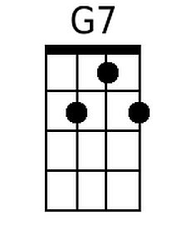
 |  |  |  |  |  |  | 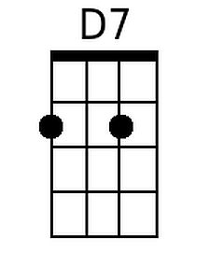
 |  |  |  |  |  |  | 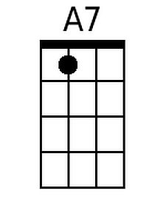
Bari
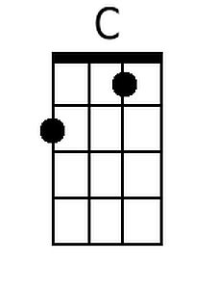 | 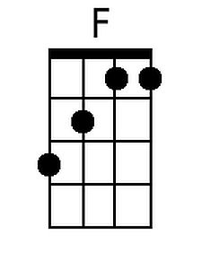 | 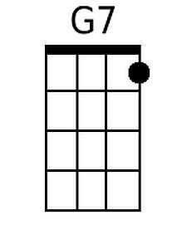 | 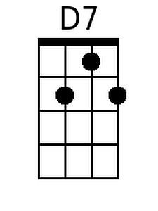 | 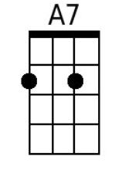

Scarlet Ribbons (Evelyn Danzig, Jack Segal)
¾ Time – Key of G – Scarlet Ribbons by Jim Ed Brown

Intro: Chords for last verse, last line.  G C D7 G C D7 C G  I peeked in to say good night, when I heard my child in prayer.  A7 D7 G C D7 C G  “Send, dear God, some scarlet ribbons, scarlet ribbons for my hair.”  D7 G C E7 A7 D7  All the stores were closed and shuttered, all the streets were dark and bare.  G A7 D7 G C D7 C G  In our town no scarlet ribbons, not one ribbon for her hair.  D7 G C E7 A7 D7  Through the night my heart was aching, just be-fore the dawn was breaking,  G C D7 G C D7 C G  I peeked in and on her bed, in gay pro-fusion lying there.  C D7 G C D7 C G  I saw ribbons scarlet ribbons, scarlet ribbons for her hair.  D7 G C E7 A7 D7  If I live to be a hundred, I will never know from where  G C D7 G C D7 C D7 G  Came those lovely scarlet ribbons, scarlet ribbons for her hair. |  |  |  |  |  |  | 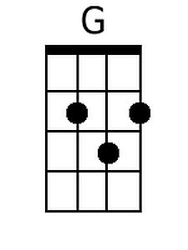
 |  |  |  |  |  |  | 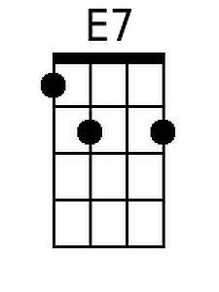
Bari
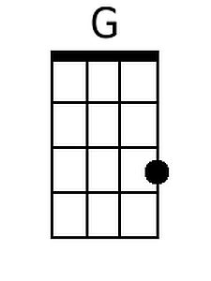 |  |  |  | 