**Scotland the Brave (Marion McClurg / Cliff Hanley)**



G

F



C

**C**

Hark when the night is falling, Hear! Hear! The pipes are calling,

**F C G**

Loudly and proudly calling, down thro' the glen.

**C**

There where the hills are sleeping, now feel the blood a-leaping,

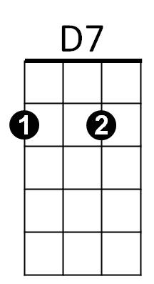**F C G C**

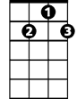

G7

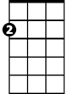

Am

High as the spirits of the old Highland men.

**Chorus:**

**G C**

Towering in gallant fame, Scotland my mountain hame,

**Am D7 G G7**

High may your proud standards gloriously wa ve!

**C**

Land of my high endeavour, land of the shining river,

**F C G C**

Land of my heart for ever, Scotland the Brave.

**C**

High in the misty Highlands out by the purple islands,

**F C G G7**

Brave are the hearts that beat beneath Scottish skies.

**C**

Wild are the winds to meet you, staunch are the friends that greet you,

**F C G C**

Kind as the love that shines from fair maidens' eyes.

**(Chorus)**

**BARITONE**



F

C



G

**C**

Far off in sunlit places, sad are the Scottish faces,

**F C G**

Yearning to feel the kiss of sweet Scottish rain.

**C**

Where are the tropics beaming, love sets the heart a-dreaming,

**F C G C**

Longing and dreaming for the hameland again.

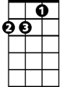

Am



D7

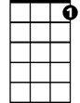

G7

**(Chorus)**

**F C G C**

Land of my heart for ever, Scotland the Brave!