**Sea of Love (George Khoury & John Phillip Baptiste, 1959)**

**Arrangement:** [**Sea of Love**](https://www.youtube.com/watch?v=L0DTHA3HVj8) **by Phil Phillips (John Phillip Baptiste) (1959)**

**Intro: First verse melody**

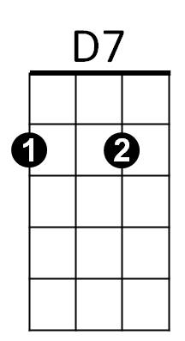

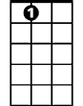

E7

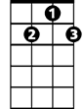

D7

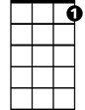

G7



G



F

C



**BARITONE**



G7

E7

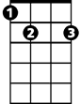

G

F



C

**C E7**

Come with me, my love

**F D7**

To the sea, the sea of love

**C F G7 C F C G**

I want to tell you, how much I love you.

**C E7**

Do you remember when we met

**F D7**

That's the day I knew you were my pet

**C F G7 C F C F**

I want to tell you, how much I love you.

**G F G F E7 G7**

Come with me . . . to the sea, of - love.

**Repeat from Verse Two**

**C E7**

Do you remember when we met

**F D7**

That's the day I knew you were my pet

**C F G7 C F C**

I want to tell you, how much I love you.