**Sea of Love (George Khoury & John Phillip Baptiste, 1959)**

**Arrangement:** [**Sea of Love**](https://www.youtube.com/watch?v=0p3xZYwEf7Y) **by the Honeydrippers (1984)**

**C E7**

Do you remember when we met

**F D7**

That's the day I knew you were my pet

**C F G7 C F C**

I want to te ll you, how much I love you.

**C E7**

Come with me my love

**F D7**

To the sea, the sea of love

**C F G7 C F C (C/ G/ F/)**

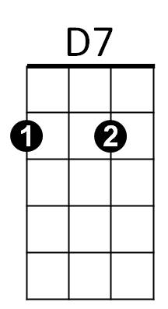I wanna tell you, just how much I love you.

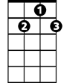

G7



G



C

E7

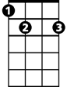

F



**G F G F E7 G7**

Come with me . . . to the sea, of - love .

**Repeat Verse One**

**Instrumental Second Verse**

**G F G F E7 G7**

Come with me . . . to the sea, of - love.

**C E7**

Do you remember my love

**F D7**

To the sea, the sea of love

**C F G7 C F C**

I wanna tell you, just how much I love you.

**C F G7 C F C**

I wanna tell you, oh, how much I love you.

**BARITONE**



G

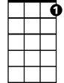

G7

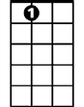

E7



F



D7

C

