Sea of Love (George Khoury & John Phillip Baptiste, 1959)
Version 1 – Sea of Love by Phil Phillips (John Phillip Baptiste) (1959) – Key of C

Intro: First verse melody  C E7  Come with me, my love  F D7  To the sea, the sea of love  C F G7 C F C G  I want to tell you, how much I love you.  C E7  Do you remember when we met  F D7  That's the day I knew you were my pet  C F G7 C F C F  I want to tell you, how much I love you.  G F G F E7 G7  Come with me . . . to the sea, of - love.  Repeat from Verse Two  C E7  Do you remember when we met  F D7  That's the day I knew you were my pet  C F G7 C F C  I want to tell you, how much I love you. |  |  |  |  |  |  |  | 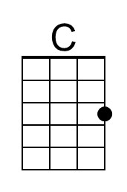
 |  |  |  |  |  |  |  | 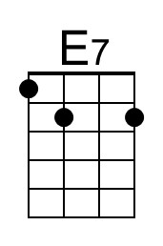
 |  |  |  |  |  |  |  | 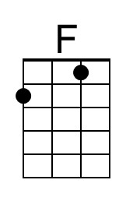
 |  |  |  |  |  |  |  | 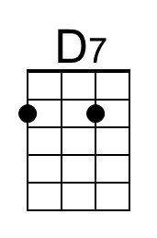
 |  |  |  |  |  |  |  | 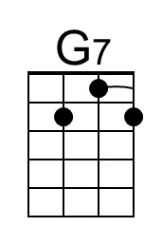
 |  |  |  |  |  |  |  | 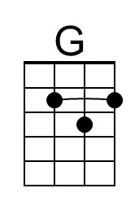
 | Bari | 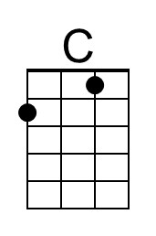 | 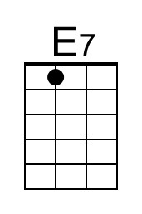 | 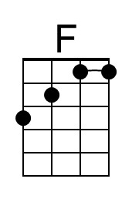 | 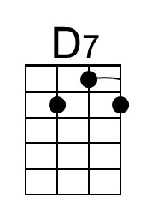 | 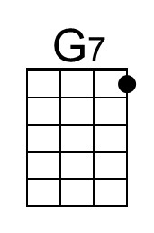 | 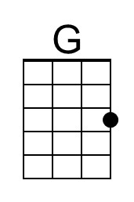

Sea of Love (George Khoury & John Phillip Baptiste, 1959)
Version 1 – Sea of Love by Phil Phillips (John Phillip Baptiste) (1959) – Key of G

Intro: First verse melody

G B7
Come with me, my love
C A7
To the sea, the sea of love
G C D7 G C G D
I want to tell you, how much I love you.

G B7
Do you remember when we met
C A7
That's the day I knew you were my pet
G C D7 G C G C
I want to tell you, how much I love you.

D C D C B7 D7
Come with me . . . to the sea, of - love.

Repeat from Verse Two

G B7
Do you remember when we met
C A7
That's the day I knew you were my pet
G C D7 G C G
I want to tell you, how much I love you.

 |  |  |  |  |  |  |  | 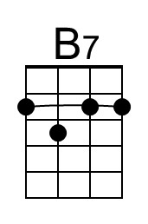
 |  |  |  |  |  |  |  | 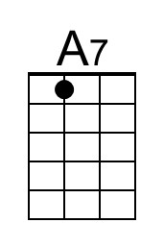
 |  |  |  |  |  |  |  | 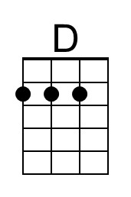
 | Bari |  | 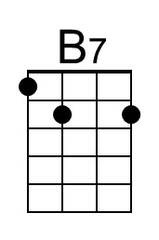 |  | 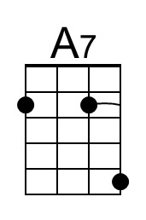 |  | 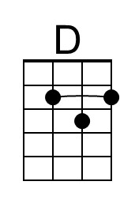

Sea of Love (George Khoury & John Phillip Baptiste, 1959)
Version 2 – Sea of Love by the Honeydrippers (1984) – Key of C

C E7
Do you remember when we met
F D7
That's the day I knew you were my pet
C F G7 C F C
I want to te ll you, how much I love you.

C E7
Come with me my love
F D7
To the sea, the sea of love
C F G7 C F C (C/ G/ F/)
I wanna tell you, just how much I love you.

G F G F E7 G7
Come with me . . . to the sea, of - love .

Repeat Verse One

Instrumental Second Verse

G F G F E7 G7
Come with me . . . to the sea, of - love.

C E7
Do you remember my love
F D7
To the sea, the sea of love
C F G7 C F C
I wanna tell you, just how much I love you.
C F G7 C F C
I wanna tell you, oh, how much I love you.

Bari

Sea of Love (George Khoury & John Phillip Baptiste, 1959)
Version 2 – Sea of Love by the Honeydrippers (1984) – Key of G

G B7
Do you remember when we met
C A7
That's the day I knew you were my pet
G C D7 G C G
I want to te ll you, how much I love you.

G B7
Come with me my love
C A7
To the sea, the sea of love
G C D7 G C G (G/ D/ C/)
I wanna tell you, just how much I love you.

D C D C B7 D7
Come with me . . . to the sea, of - love .

Repeat Verse One

Instrumental Second Verse

D C D C B7 D7
Come with me . . . to the sea, of - love.

G B7
Do you remember my love
C A7
To the sea, the sea of love
G C D7 G C G
I wanna tell you, just how much I love you.
G C D7 G C G
I wanna tell you, oh, how much I love you.

Bari

