**Season Of The Witch (Donovan)**

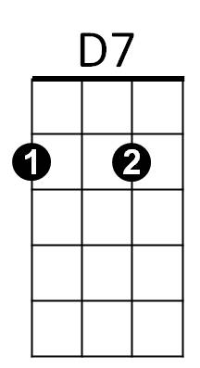**A7 D7 x4**

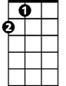

A

E7

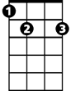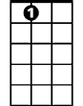

A7

**A7 D7**

When I look out my window,

**A7 D7**

Many sights to see.

**A7 D7**

And when I look in my window,

**A7 D7**

So many different people to be.

**A7 D7 A7 D7**

That it's strange. - So strange.

**A7 D7 (3X)**

You got to pick up every stitch.

**A7 D7**

MmmHmmm

**D7 E7 A**

Must be the season of the witch,

**D7 E7 A**

Must be the season of the witch, yeah,

**D7 E7 A7**

Must be the season of the witch.

**A7 D7 (2X)**

**A7 D7**

When I look over my shoulder,

**A7 D7**

What do you think I see?

**A7 D7 A7 D7**

Summer kept lookin over - his shoulder at me.

**A7 D7 A7 D7**

And he’s strange - sure is strange.

**A7 D7**

You got to pick up every stitch.

**A7 D7**

You got to pick up every stitch, yeah.

**A7 D7**

Beatniks are out to make it rich

**A7 D7**

Oh - no...

**D7 E7 A**

Must be the season of the witch,

**D7 E7 A**

Must be the season of the witch, yeah

**D7 E7 A7**

Must be the season of the witch.

**A7 D7 (5X)**

**A7 D7**

You got to pick up every stitch,

**A7 D7**

The rabbit’s running in the ditch.

**A7 D7**

Beatniks are out to make it rich.

**A7 D7**

Oh - no

**BARITONE**

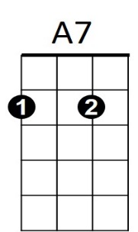**D7 E7 A**

Must be the season of the witch,

**D7 E7 A**

Must be the season of the witch,

**D7 E7 A7**

Must be the season of the witch.

**A7 D7 A7 D7 A7 D7**

When I go

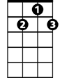

D7

**A7 D7**

When I look out my window,

**A7 D7**

What do you think I see?

**A7 D7**

And when I look in my window,



E7

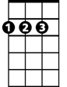

A

**A7 D7**

So many different people to be.

**A7 D7 A7 D7**

It's strange - Sure is strange.

**A7 D7**

You got to pick up every stitch,

**A7 D7**

You got to pick up every stitch

**A7 D7**

Two rabbits running in the ditch.

**A7 D7**

Oh - no

**D7 E7 A**

Must be the season of the witch,

**D7 E7 A**

Must be the season of the witch, yeah,

**D7 E7 A7**

Must be the season of the witch.

**A7 D7 A7 D7 A7 D7 A7**

When I go When I go