**Secret Agent Man (Steve Barri / P F Sloan) Key Am**

**A Am\F 4x**

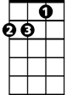

Dm

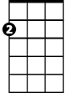

Am

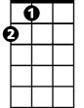

A

**Am Dm Am**

There's a man who leads a life of danger

**E7**

To everyone he meets he stays a stranger

**Am Dm**

F



Em

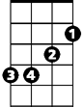

E7

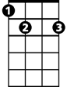

With every move he makes, another chance he takes

**Am Dm Am**

Odds are he won't live to see tomorrow

**Chorus:**

**Em Am Em Am**

Secret agent man, secret agent man

**F E7 Am Am\F A**

They've given you a number and taken away your name

**Am Dm Am**

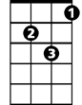

Dm



Am

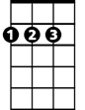

A

**BARITONE**

Beware of pretty faces that you find

**E7**

A pretty face can hide an evil mind

**Am Dm**

Ah, be careful what you say, Or you'll give yourself away

**Am Dm Am**



F



Em

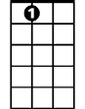

E7

Odds are he won't live to see tomorrow

**(Chorus)**

**Am Dm Am**

Swingin' on the Riviera one day

**E7**

And then layin' in the Bombay alley next day

**Am Dm**

Oh no, you let the wrong word slip, while kissing persuasive lips

**Am Dm Am**

Odds are you won't live to see tomorrow

**(Chorus)**

**Am\F A 3x**

**TACET**

Secret agent man

**Secret Agent Man (Steve Barri / P F Sloan) Key Dm**

**Dm\F 4x**



Gm



Dm



D

**Dm Gm Dm**

There's a man who leads a life of danger

**A7**

To everyone he meets he stays a stranger

**Dm Gm**



A7



Bb



Am

With every move he makes, another chance he takes

**Dm Gm Dm**

Odds are he won't live to see tomorrow

**Chorus:**

**Am Dm Am Dm**

Secret agent man, secret agent man

**Bb A7 Dm Dm\F D**

They've given you a number and taken away your name

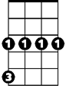

Gm



D



Dm

**BARITONE**

**Dm Gm Dm**

Beware of pretty faces that you find

**A7**

A pretty face can hide an evil mind

**Dm Gm**

Ah, be careful what you say, Or you'll give yourself away

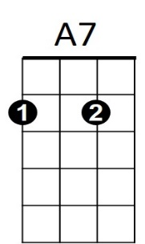**Dm Gm Dm**



Am

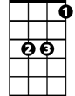

Bb

Odds are he won't live to see tomorrow

**(Chorus)**

**Dm Gm Dm**

Swingin' on the Riviera one day

**A7**

And then layin' in the Bombay alley next day

**Dm Gm**

Oh no, you let the wrong word slip, while kissing persuasive lips

**Dm Gm Dm**

Odds are you won't live to see tomorrow

**(Chorus)**

**Dm\F D 3x**

**TACET**

Secret agent man

**Secret Agent Man (Steve Barri / P F Sloan) Key Em**

**Em\C 4x**

Em



Am

**BARITONE**

**Em Am Em**

There's a man who leads a life of danger

**B7**

To everyone he meets he stays a stranger

**Em Am**



C

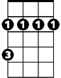

Bm

With every move he makes, another chance he takes

**Em Am Em**

Odds are he won't live to see tomorrow

**Chorus:**

**Bm Em Bm Em**

Secret agent man, secret agent man

**C B7 Em Em\C E**

They've given you a number and taken away your name

**Em Am Em**



Am



Em



E

Beware of pretty faces that you find

**B7**

A pretty face can hide an evil mind

**Em Am**

Ah, be careful what you say, Or you'll give yourself away

**Em Am Em**

B7



Bm



C



Odds are he won't live to see tomorrow

**(Chorus)**

**Em Am Em**

Swingin' on the Riviera one day

**B7**

And then layin' in the Bombay alley next day

**Em Am**

Oh no, you let the wrong word slip, while kissing persuasive lips

**Em Am Em**

Odds are you won't live to see tomorrow

**(Chorus)**

**Em\C E 3x**

**TACET**

Secret agent man