See You in September (Sherman Edwards and Sid Wayne, 1959) (Em)

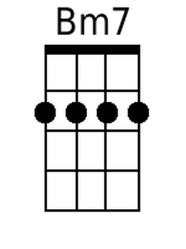  Starting Note: low B  Intro:  Bm7↓ E7↓  I’ll be a-lone each and ev-‘ry night,  Bm7↓ E7↓  While you’re a-way, don’t for-get to write  Em7 A7 Em7 A7↓  Bye-bye, so long fare-well, bye-bye, so long.  Em7 A7 F#m B7 Em7 A7 F#m B7  See you in Sep-tember. See you when the summer’s through.  Em7 A7 F#m B7  Here we are ----- saying good-bye at the sta---tion  (Bye baby, good-bye-----------------------bye baby good-bye)  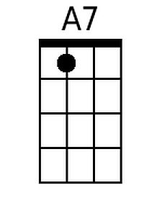  Em7 E7 Em7 A7  summer va-ca----tion is taking you a-way.  (Bye baby, good-bye------- bye baby good-bye)  Chorus  Em7 A7 F#m B7  Have a good time, but re-member.  Em7 A7 F#m B7  There is dan-ger in the summer moon a-bove.  Em7 Fdim7 Dmaj7 B7 Em7 A7↓↓ (---tacet----)  Will I see you in Sep-tember? or lose you to a summer-  Bm7 E7 Bm7 E7  Lo------------------------------o-o-o-o----ove? . . . . . . . . . . . .  (count-ing the days till I’ll be with you-- count-ing the hours and the  min-utes, too  Em7 A7 Em7 A7  Bye baby, good-bye bye baby good-bye.  Em7 A7 Em7 A7  Bye baby, good-bye . . . . bye baby good-bye. Chorus  (Bye-bye-- so long fare-well, bye-bye- so long)  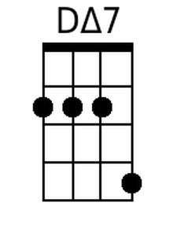  Outro (Slow):  Em7 A7 Dmaj7 D↓  See you in Sep - tem - - ber. |  |  |  |  |  | 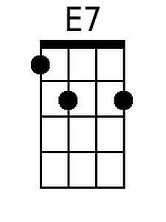
 |  |  |  |  |  | 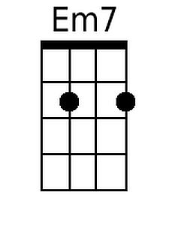
 |  |  |  |  |  | 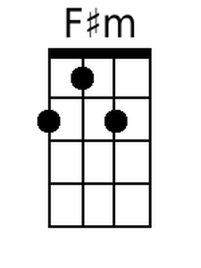
 |  |  |  |  |  | 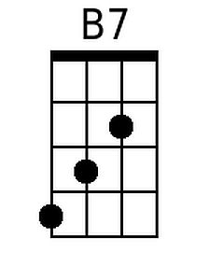
 |  |  |  |  |  | 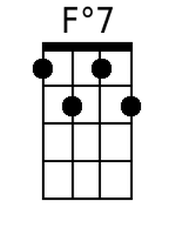
 |  |  |  |  |  | 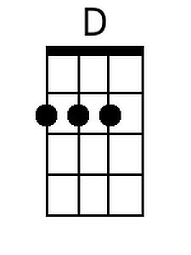
Baritone | 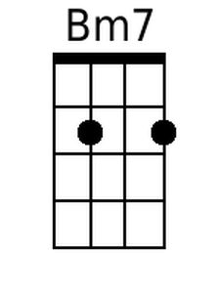 | 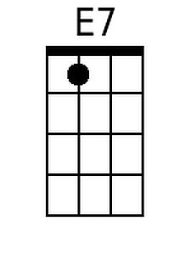 | 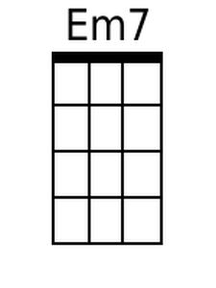 | 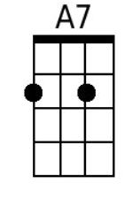 | 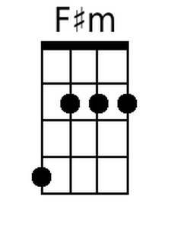
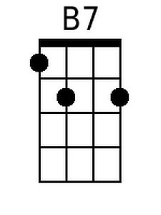 | 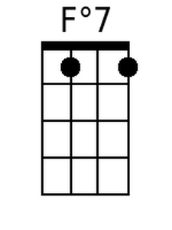 | 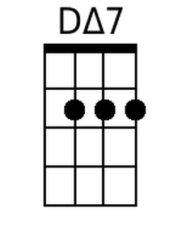 | 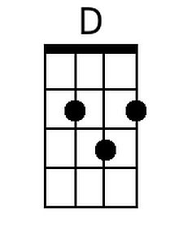

See You in September (Sherman Edwards and Sid Wayne, 1959) (Am)

Starting Note: E

Intro:
Bm7↓ E7↓
I'll be a-lone each and ev-'ry night,
Bm7↓ E7↓
While you're a-way, don't for-get to write
Em7 A7 Em7 A7↓
Bye-bye, so long fare-well, bye-bye, so long.

Am7 D7 Bm E7 Am7 D7 Bm E7
See you in Sep-tember. See you when the summer's through.
Am7 D7 Bm E7
Here we are ----- saying good-bye at the sta---tion
(Bye baby, good-bye-----------------------bye baby good-bye)
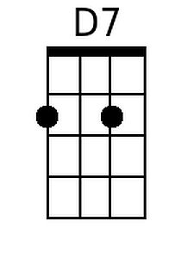
Am7 A7 Am7 D7
summer va-ca----tion is taking you a-way.
(Bye baby, good-bye------- bye baby good-bye)

Chorus
Am7 D7 Bm E7
Have a good time, but re-member.
Am7 D7 Bm E7
There is dan-ger in the summer moon a-bove.
Em7 Fdim7 Dmaj7 B7 Em7 A7↓↓ (---tacet----)
Will I see you in Sep-tember? or lose you to a summer-
Em7 A7 Em7 A7
Lo------------------------------o-o-o-o----ove? . . . . . . . . . . . .
(count-ing the days till I'll be with you-- count-ing the hours and the
min-utes, too)
Am7 D7 Am7 D7
Bye baby, good-bye bye baby good-bye.
Am7 D7 Am7 D7
Bye baby, good-bye . . . . bye baby good-bye. Chorus
(Bye-bye-- so long fare-well, bye-bye- so long)

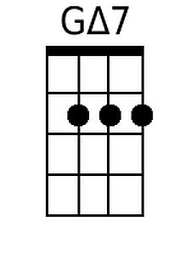
Outro (Slow):
Em7 A7 Dmaj7 D↓
See you in Sep - tem - - ber.

 |  |  |  |  |  | 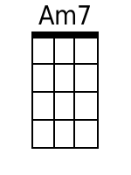
 |  |  |  |  |  | 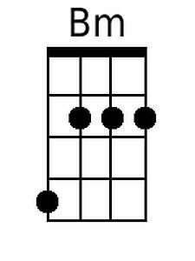
 |  |  |  |  |  | 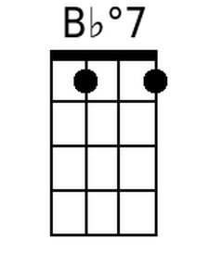
 |  |  |  |  |  | 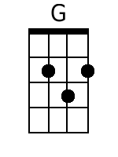
Baritone |  |  | 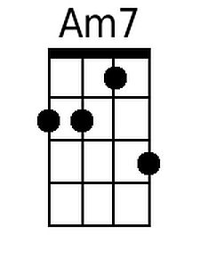 | 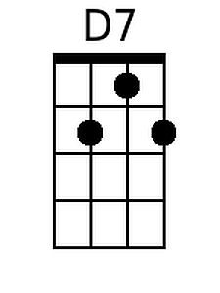
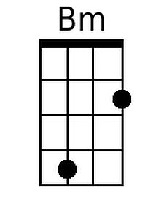 |  | 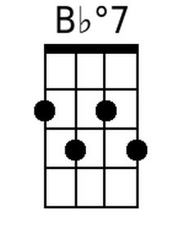 | 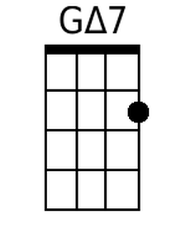 | 