**Semper Paratus (Always Ready) (Capt. Francis Van Boskerck, USCG)**

**The United States Coast Guard theme song**

F

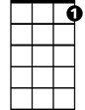

C7

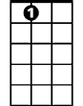

A7

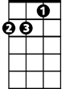

Dm

**F**

From Aztec Shore to Arctic Zone,

**C7 F**

To Europe and Far East

**C7 F A7 Dm**

The Flag is carried by our ships,

**G7 C**

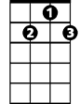

G7



Bb



C

In times of war and peace

**F**

And never have we struck it yet,

**C7 F**

In spite of foemen's might,

**C7 F A7 Dm**

Who cheered our crews and cheered a - gain,

**F C7 F C7**

For showing how to fight.

**Chorus:**

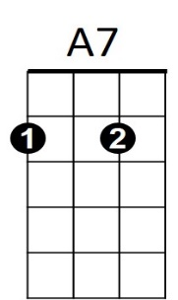**F**

**BARITONE**

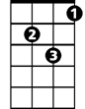

Dm

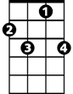

C7



F

We're always ready for the call,

**Bb F**

We place our trust in Thee.

**C7 F A7 Dm**

Through surf and storm and howl-ing gale,

**G7 C C7**

High shall our purpose be



G7

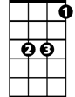

Bb

C



**F**

"Semper Paratus" is our guide,

**Bb F**

Our fame, our glory, too.

**C7 F A7 Dm**

To fight to save or fight and die!

**F C7 F**

Aye! Coast Guard, we are for you.

**(Repeat Chorus)**