Senôr Don Gato (Traditional Spanish Folksong) (Dm)
Version 1 – YouTube: Senôr Don Gato (in Dm)

Introduction: Dm  Dm C Dm  1. Oh Sen-or Don Gato was a cat;  Dm C Dm  On a high red roof Don Ga-to sat;  A7 Gm  He went there to read a letter, meow meow meow,  Dm  Where the reading light was better, meow meow meow,  A7 Dm  'Twas a love-note for- Don Gato.  Dm C Dm  2. "I a-dore you," wrote the lady cat  Dm C Dm  Who was flu-ffy, white and nice and fat.  A7 Gm  There was not a sweeter kitty, meow meow meow  Dm  In the country or the city, meow meow meow  A7 Dm  And she said she'd wed Don Gato.  Dm C Dm  3. Oh, Don Ga-to jumped so happily  Dm C Dm  He fell off the roof and broke his knee  A7 Gm  Broke his ribs and all his whiskers, meow meow meow  Dm  and his little solar plexus, meow meow meow  A7 Dm  "Ay ca-rum-ba!" cried Don Gato. |  |  |  |  |  |  | 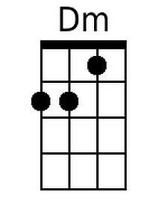
 |  |  |  |  |  |  | 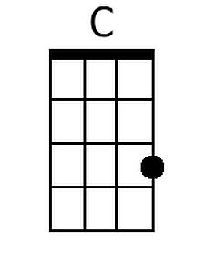
 |  |  |  |  |  |  | 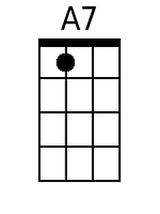
 |  |  |  |  |  |  | 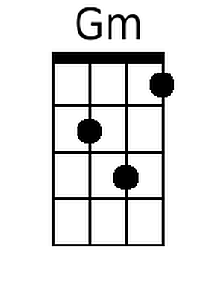
Baritone
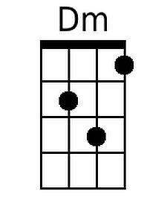 | 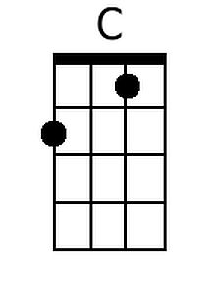 | 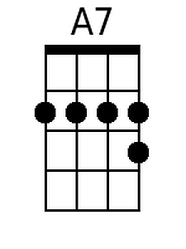 | 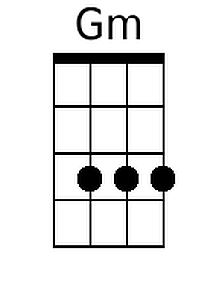

Senôr Don Gato (Dm) – Page 2

Dm C Dm
4. Then the doc-tors all came on the run
Dm C Dm
Just to see if some-thing could be done;
A7 Gm
And they held a consultation, meow meow meow
Dm
About how to save their patient, meow meow meow
A7 Dm
How to save Senor Don Gato.

Dm C Dm
5. But in spite of ev-ery thing they tried
Dm C Dm
Poor Sen-or Don Ga-to up and died;
A7 Gm
Oh, it wasn't very merry, meow meow meow
Dm
Going to the cemetery, meow meow meow
A7 Dm
For the end-ing of Don Gato.

Dm C Dm
6. As the fun-eral passed the market square
Dm C Dm
Such a smell of fish was in the air
A7 Gm
Though his burial was slated, meow meow meow
Dm
He became re-ani-mated, meow meow meow
A7 Dm A7 Dm
He came back to life Don Gato! -- O - le' !

