Senôr Don Gato
Traditional Spanish Folksong
Key of Am – YouTube: Senôr Don Gato (in Dm)

Introduction: Am  Am G Am  1. Oh Sen-or Don Ga-to was a cat;  Am G Am  On a high red roof Don Ga-to sat;  E7 Dm  He went there to read a letter, meow meow meow,  Am  Where the reading light was better, meow meow meow,  E7 Am  'Twas a love-note for- Don Gato.  Am G Am  2. "I a-dore you," wrote the lady cat  Am G Am  Who was fluffy, white and nice and fat.  E7 Dm  There was not a sweeter kitty, meow meow meow  Am  In the country or the city, meow meow meow  E7 Am  And she said she'd wed Don Gato.  Am G Am  3. Oh, Don Ga-to jumped so happily  Am G Am  He fell off the roof and broke his knee  E7 Dm  Broke his ribs and all his whiskers, meow meow meow  Am  and his little solar plexus, meow meow meow  E7 Am  "Ay ca-rum-ba!" cried Don Gato. | 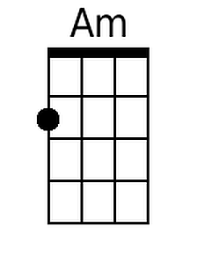  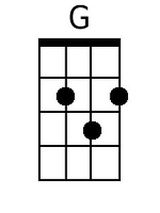  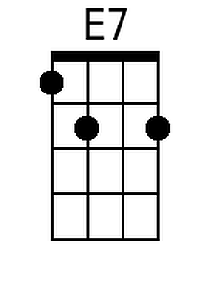  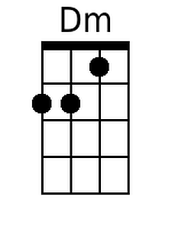

Bari
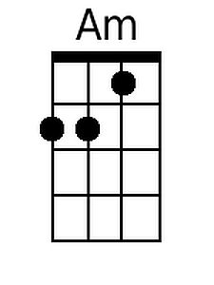 | 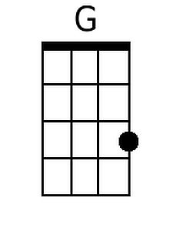 | 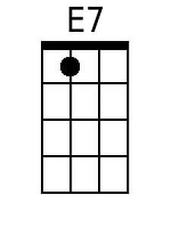 | 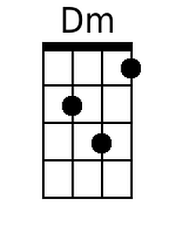

Senôr Don Gato – Page 2

Am G Am
4. Then the doc-tors all came on the run
Am G Am
Just to see if some-thing could be done;
E7 Dm
And they held a consultation, meow meow meow
Am
About how to save their patient, meow meow meow
E7 Am
How to save Senor Don Gato.

Am G Am
5. But in spite of ev-ery thing they tried
Am G Am
Poor Sen-or Don Ga-to up and died;
E7 Dm
Oh, it wasn’t very merry, meow meow meow
Am
Going to the cemetery, meow meow meow
E7 Am
For the end-ing of- Don Gato.

Am G Am
6. As the fu-neral passed the market square
Am G Am
Such a smell of fish was in the air
E7 Dm
Though his burial was slated, meow meow meow
Am
He became re-ani-mated, meow meow meow
E7 Am E7 Am
He came back to life Don Gato! -- O - le’ !

