Senôr Don Gato
Traditional Spanish Folksong
Key of Am – YouTube: Senôr Don Gato (in Dm)

Introduction: Am  Am G Am  1. Oh Sen-or Don Ga-to was a cat;  Am G Am  On a high red roof Don Ga-to sat;  E7 Dm  He went there to read a letter, meow meow meow,  Am  Where the reading light was better, meow meow meow,  E7 Am  'Twas a love-note for- Don Gato.  Am G Am  2. "I a-dore you," wrote the lady cat  Am G Am  Who was flu-ffy, white and nice and fat.  E7 Dm  There was not a sweeter kitty, meow meow meow  Am  In the country or the city, meow meow meow  E7 Am  And she said she'd wed Don Gato.  Am G Am  3. Oh, Don Ga-to jumped so happily  Am G Am  He fell off the roof and broke his knee  E7 Dm  Broke his ribs and all his whiskers, meow meow meow  Am  and his little solar plexus, meow meow meow  E7 Am  "Ay ca-rum-ba!" cried Don Gato. | 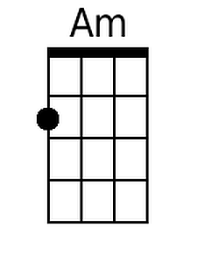  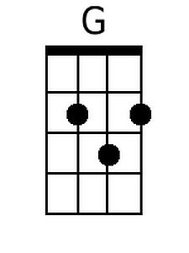  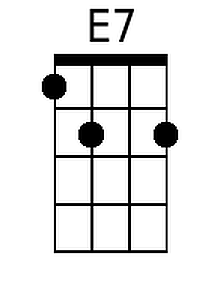  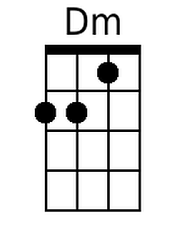

Bari
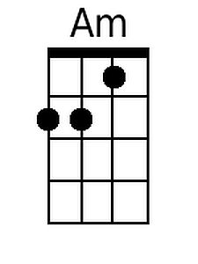 | 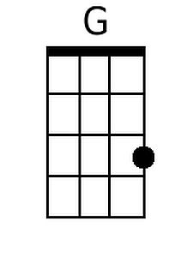 | 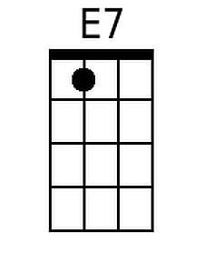 | 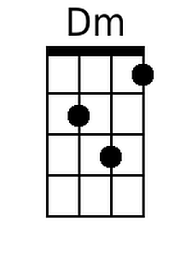

Senôr Don Gato – Page 2

Am G Am
4. Then the doc-tors all came on the run
Am G Am
Just to see if some-thing could be done;
E7 Dm
And they held a consultation, meow meow meow
Am
About how to save their patient, meow meow meow
E7 Am
How to save Senor Don Gato.

Am G Am
5. But in spite of ev-ery thing they tried
Am G Am
Poor Sen-or Don Ga-to up and died;
E7 Dm
Oh, it wasn’t very merry, meow meow meow
Am
Going to the cemetery, meow meow meow
E7 Am
For the en-ding of- Don Gato.

Am G Am
6. As the fu-neral passed the market square
Am G Am
Such a smell of fish was in the air
E7 Dm
Though his burial was slated, meow meow meow
Am
He became re-ani-mated, meow meow meow
E7 Am E7 Am
He came back to life Don Gato! -- O - le’ !

Senôr Don Gato
Traditional Spanish Folksong
Key of G – YouTube: Senôr Don Gato (in Dm)
Version 1

Introduction: Dm  Dm C Dm  1. Oh Sen-or Don Ga-to was a cat;  Dm C Dm  On a high red roof Don Ga-to sat;  A7 Gm  He went there to read a letter, meow meow meow,  Dm  Where the reading light was better, meow meow meow,  A7 Dm  'Twas a love-note for- Don Gato.  Dm C Dm  2. "I a-dore you," wrote the lady cat  Dm C Dm  Who was flu-ffy, white and nice and fat.  A7 Gm  There was not a sweeter kitty, meow meow meow  Dm  In the country or the city, meow meow meow  A7 Dm  And she said she'd wed Don Gato.  Dm C Dm  3. Oh, Don Ga-to jumped so happily  Dm C Dm  He fell off the roof and broke his knee  A7 Gm  Broke his ribs and all his whiskers, meow meow meow  Dm  and his little solar plexus, meow meow meow  A7 Dm  "Ay ca-rum-ba!" cried Don Gato. | 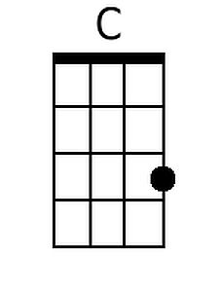  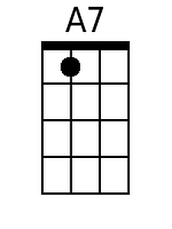  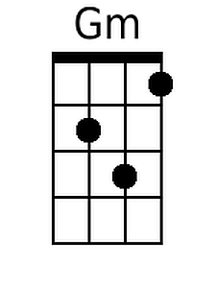

Bari
 | 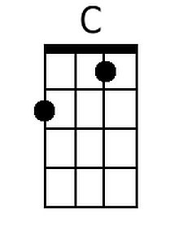 | 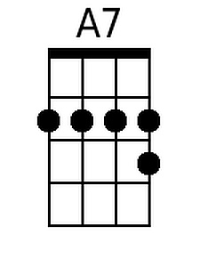 | 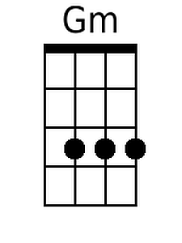

Dm C Dm
4. Then the doc-tors all came on the run
Dm C Dm
Just to see if some-thing could be done;
A7 Gm
And they held a consultation, meow meow meow
Dm
About how to save their patient, meow meow meow
A7 Dm
How to save Senor Don Gato.

Dm C Dm
5. But in spite of ev-ery thing they tried
Dm C Dm
Poor Sen-or Don Ga-to up and died;
A7 Gm
Oh, it wasn’t very merry, meow meow meow
Dm
Going to the ceme-tary, meow meow meow
A7 Dm
For the en-ding of- Don Gato.

Dm C Dm
6. As the fu-neral passed the market square
Dm C Dm
Such a smell of fish was in the air
A7 Gm
Though his burial was slated, meow meow meow
Dm
He became re-ani-mated, meow meow meow
A7 Dm A7 Dm
He came back to life Don Gato! -- O - le’ !

Senôr Don Gato
Traditional Spanish Folksong
Key of Em – YouTube: Senôr Don Gato (in Dm)
Version 1

Introduction: Em  Em D Em  1. Oh Sen-or Don Ga-to was a cat;  Em D Em  On a high red roof Don Ga-to sat;  B7 Am  He went there to read a letter, meow meow meow,  Em  Where the reading light was better, meow meow meow,  B7 Em  'Twas a love-note for- Don Gato.  Em D Em  2. "I a-dore you," wrote the lady cat  Em D Em  Who was flu-ffy, white and nice and fat.  B7 Am  There was not a sweeter kitty, meow meow meow  Em  In the country or the city, meow meow meow  B7 Em  And she said she'd wed Don Gato.  Em D Em  3. Oh, Don Ga-to jumped so happily  Em D Em  He fell off the roof and broke his knee  B7 Am  Broke his ribs and all his whiskers, meow meow meow  Em  and his little solar plexus, meow meow meow  B7 Em  "Ay ca-rum-ba!" cried Don Gato. | 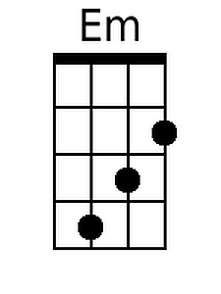  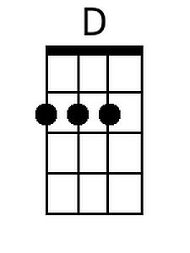  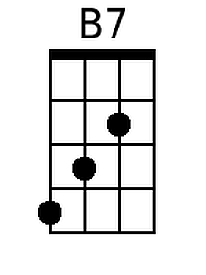

Bari
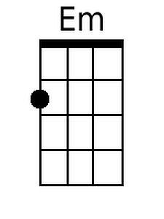 | 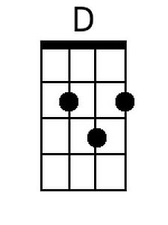 | 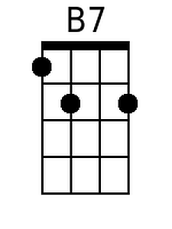

Em D Em
4. Then the doc-tors all came on the run
Em D Em
Just to see if some-thing could be done;
B7 Am
And they held a consultation, meow meow meow
Em
About how to save their patient, meow meow meow
B7 Em
How to save Senor Don Gato.

Em D Em
5. But in spite of ev-ery thing they tried
Em D Em
Poor Sen-or Don Ga-to up and died;
B7 Am
Oh, it wasn’t very merry, meow meow meow
Em
Going to the ceme-tary, meow meow meow
B7 Em
For the en-ding of- Don Gato.

Em D Em
6. As the fu-neral passed the market square
Em D Em
Such a smell of fish was in the air
B7 Am
Though his burial was slated, meow meow meow
Em
He became re-ani-mated, meow meow meow
B7 Em B7 Em
He came back to life Don Gato! -- O - le’ !

