September in the Rain (Harry Warren & Al Dubin, 1937) (C)

Starting Note: G  C Em Am Em Dm  The leaves of brown came tumbling down, re-member  Am Dm G7 C G+  That Sep-tember in the rain.  C Em Am Em Dm  The sun went out just like a dying ember  Am Dm G7 C C7  That Sep-tember in the rain.  Bridge:  Gm7 C7 Gm7 C7 Dm  To every word of love I heard you whisper  Am D7 Am D7 G7 G+  The rain drops seemed to play a sweet re-frain.  C Em Am Em Dm  Though spring is here, to me it’s still Sep-tember  Am Dm G7 C C7 (To Bridge)  That Sep-tember in the rain.  A7 (To Outro)  Repeat From Bridge  Outro:  Dm G7 C C C#7 C  That Sep-tember in the rain. |  |  |  |  |  | 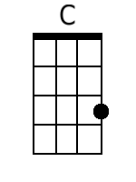 | 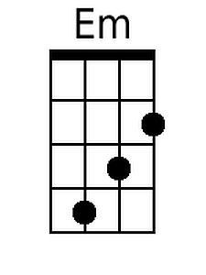
 |  |  |  |  |  | 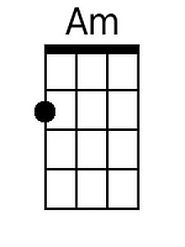 | 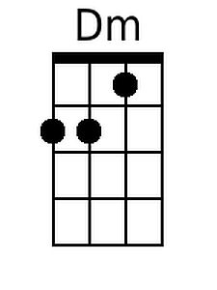
 |  |  |  |  |  | 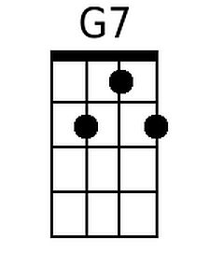 | 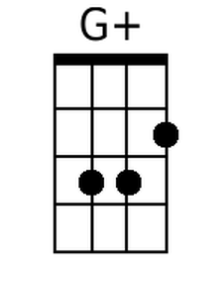
 |  |  |  |  |  | 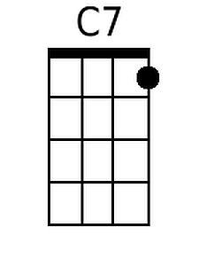 | 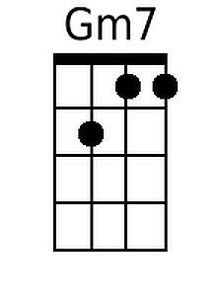
 |  |  |  |  |  | 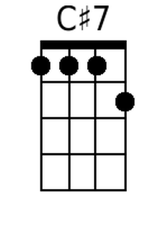 | 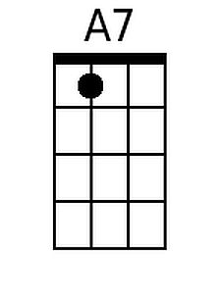
Baritone
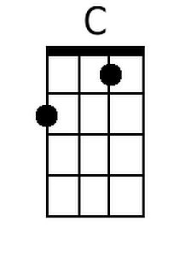 | 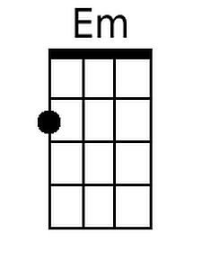 | 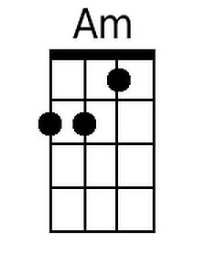 | 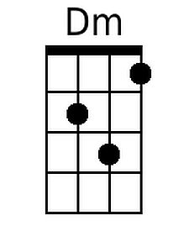 | 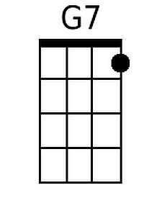
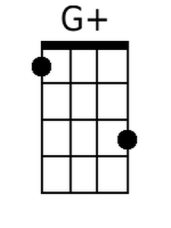 | 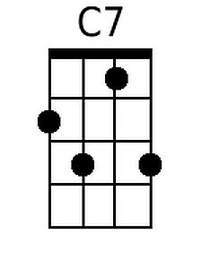 | 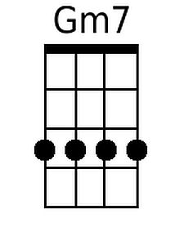 | 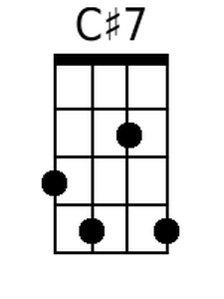 | 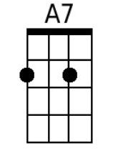

September in the Rain (Harry Warren & Al Dubin, 1937) (G)

Starting Note: D  G Bm Em Bm Am  The leaves of brown came tumbling down, re-member  Em Am D7 G D+  That Sep-tember in the rain.  G Bm Em Bm Am  The sun went out just like a dying ember  Em Am D7 G G7  That Sep-tember in the rain.  Bridge:  Dm7 G7 Dm7 G7 Am  To every word of love I heard you whisper  Em A7 Em A7 D7 D+  The rain drops seemed to play a sweet re-frain.  G Bm Em Bm Am  Though spring is here, to me it’s still Sep-tember  Em Am D7 G G7 (To Bridge)  That Sep-tember in the rain.  E7 (To Outro)  Repeat From Bridge  Outro:  Am D7 G G G#7 G  That Sep-tember in the rain. |  |  |  |  |  | 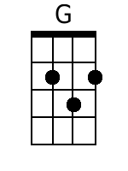 | 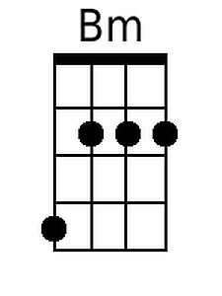
 |  |  |  |  |  |  | 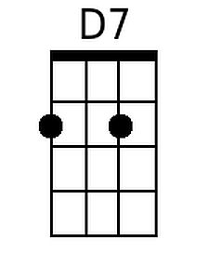
 |  |  |  |  |  | 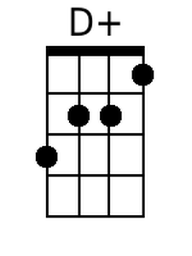 | 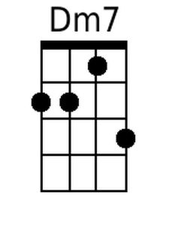
 |  |  |  |  |  |  | 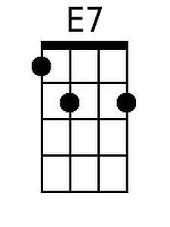
Baritone
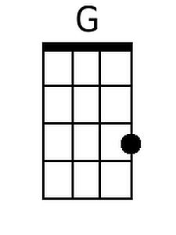 | 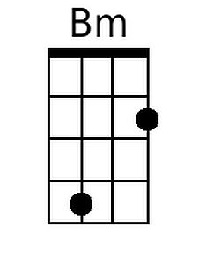
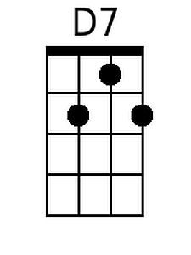 | 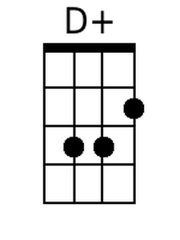 | 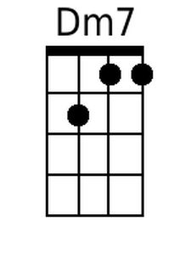 |  | 