Seven Nation Army (Jack White) - Em
The White Stripes, Seven Nation Army
Seven Nation Army
Jack White
Key: Em
The White Stripes, Seven Nation Army

Intro: | Em C B | (4x)  Em C B  1. I'm gonna fight 'em off  Em C B  A seven nation army couldn't hold me back  Em C B  They're gonna rip it off  Em C B  Taking their time right be-hind my back  Em C  And I'm talking to my-self at night  B Em C B  Because I can't for-get  Em C  Back and forth through my mind  B Em C B  Behind a ciga-rette  G A  And a message coming from my eyes says leave it alone  | Em C B | (4x) | Am B Em |  Em C B  2. Don't want to hear about i t  Em C B  Every single one's got a story to tell  Em C B  Everyone knows about it  Em C B  From the Queen of England to the hounds of Hell  Em C B  And if I catch it coming b-ack my way  Em C B  I'm gonna serve it to you  Em C B  And that ain't what you want to hear  Em C B  But that's what I'll do  Am B  And a feeling coming from my bones says find a home |     or  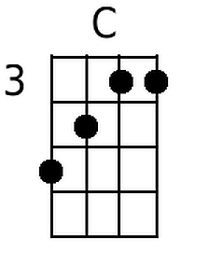    Bari      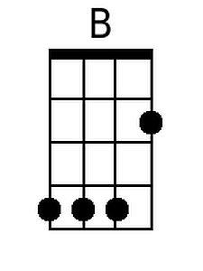
Em C B
3. I'm going to Wichita
Em C B
Far from this opera, forever more
Em C B
I'm going to work the stra-aw
Em C B
Make the sweat drip out of eve-ry pore
Em C B
And I'm bl-eeding and I'm bl-eeeding and I'm bleeding
Em C B
Right before the Lord
Em C B
All the words are going to bl-eed from me
Em C B
And I will think no more
G A
And the stains coming from my blood tell me go back home

| Em C B | (3x)

Optional Bari 1 Optional Bari 2

 | 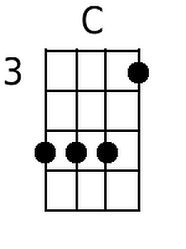 |  |  | 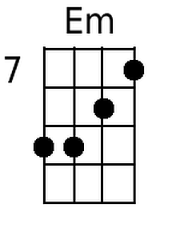 | 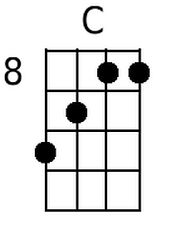 | 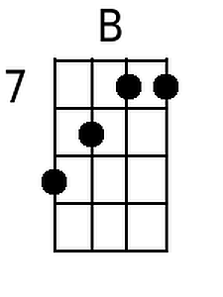

Bari With Added G Chord:


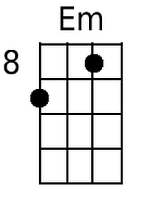 | 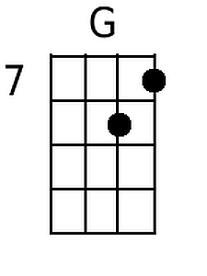 |  |  |  |  | 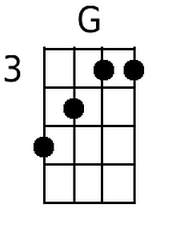

Seven Nation Army
Jack White
Key: Am
The White Stripes, Seven Nation Army

Intro: | Am F E | (4x)

Am F E
I'm gonna fight 'em off
Am F E
A seven nation army couldn't hold me back
Am F E
They're gonna rip it off
Am F E
Taking their time right be-hind my back
Am F
And I'm talking to my-self at night
E Am F E
Because I can't for-get
Am F
Back and forth through my mind
E Am F E
Behind a ciga-rette
C D
And a message coming from my eyes says leave it alone

| Am F E | (4x) | Dm E Am |

Am F E
Don't want to hear about i t
Am F E
Every single one's got a story to tell
Am F E
Everyone knows about it
Am F E
From the Queen of England to the hounds of Hell
Am F E
And if I catch it coming b-ack my way
Am F E
I'm gonna serve it to you
Am F E
And that ain't what you want to hear
Am F E
But that's what I'll do
Dm E
And a feeling coming from my bones says find a home
Am F E
I'm going to Wichita
Am F E
Far from this opera, forever more
Am F E
I'm going to work the stra-aw
Am F E
Make the sweat drip out of eve-ry pore
Am F E
And I'm bl-eeding and I'm bl-eeeding and I'm bleeding
Am F E
Right before the Lord
Am F E
All the words are going to bl-eed from me
Am F E
And I will think no more
C D
And the stains coming from my blood tell me go back home

| Am F E | (3x)

