Sh-Boom (Life Could Be A Dream) (C)
(James Keyes, Claude Feaster, Carl Feaster, Floyd F. McRae, and James Edwards, 1954)
Sh-boom by The Crew Cuts (F – 130 BPM) – Sh-boom by The Chords (F – 137 BPM)

Intro  C Am Dm7 G7  Hey nonny, ding dong, a-lang a-lang a-lang.  C Am Dm7 G7  Boom ba-doh, ba-doo, ba-doo, ba-day.  C Am  Oh, life could be a dream, sh-boom  Dm G C Am  __ If I could take you up in paradise up a-bove. sh-boom  Dm G C Am  __ If you would tell me I'm the only one that you love,  Dm G7 C  Life could be a dream, sweet-heart.  Am Dm G7  Hello, hello again, Sh-boom, I'm hoping we'll meet again.  C Am  Oh, life could be a dream, sh-boom  Dm G C Am  __ If only all my precious plans would come true, sh-boom  Dm G C Am  __ If you would let me spend my whole life loving you,  Dm G7 C  Life could be a dream, sweet-heart.  Bridge  E E7 A  Now, every time I look at you, something is on my mind.  D D7 F G  If you'd do what I want you to, baby, we'd be so fine. |  |  |  |  |  |  |  | 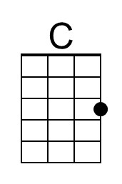 | 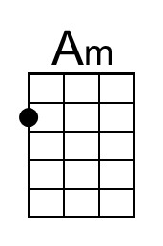
 |  |  |  |  |  |  |  | 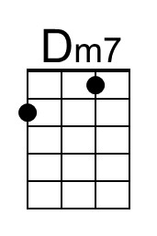 | 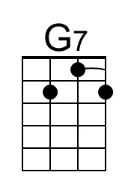
 |  |  |  |  |  |  |  | 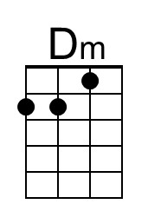 | 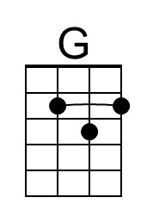
 |  |  |  |  |  |  |  | 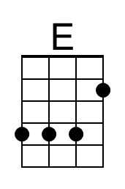 | 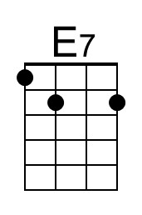
 |  |  |  |  |  |  |  | 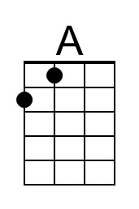 | 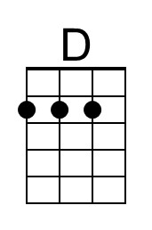
 |  |  |  |  |  |  |  | 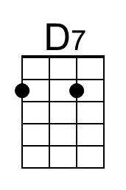 | 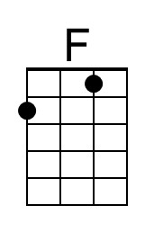
Bari | 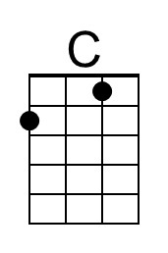 | 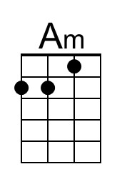 | 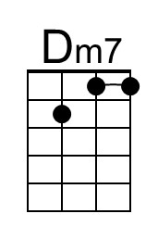 | 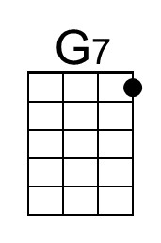 | 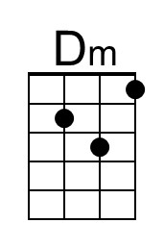 | 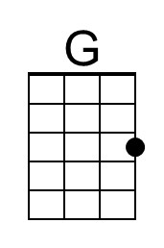
 | 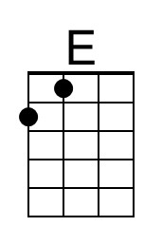 | 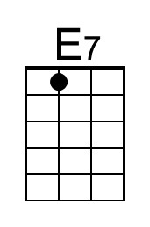 | 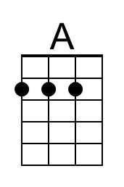 | 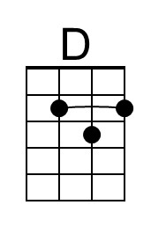 | 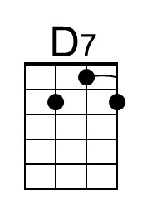 | 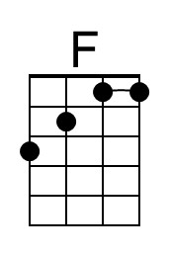

Sh-boom (Life Could Be A Dream) (C) – Page 2

C Am
Oh, life could be a dream, sh-boom,
Dm G C Am
__ If I could take you up in paradise up a-bove. sh-boom
Dm G C Am Dm G7 C
__ If you would tell me I'm the only one that you love, life could be a dream, sweet-heart.

Chorus (2x)
C Am Dm G
Sh-boom, Sh-boom, ya da da da da da da da da da.
C Am Dm G
Sh-boom, Sh-boom, ya da da da da da da da da da.
C Am Dm G C
Sh-boom, Sh-boom, ya da da da da da da da da da. Sh-boom!

Bridge
E E7 A
Now, every time I look at you, something is on my mind.
D D7 F G | G
If you'd do what I want you to, baby, we'd be so fine.

C Am
Oh, life could be a dream, sh-boom,
Dm G C Am
__ If I could take you up in paradise up a-bove. sh-boom
Dm G C Am Dm G7 C
__ If you would tell me I'm the only one that you love, life could be a dream, sweet-heart.

Am Dm G7
Hello, hello again, Sh-boom, I'm hoping we'll meet again.
C Am Dm7 G7
Hey nonny, ding dong, a-lang a-lang a-lang.
C Am Dm7 G7
Sh-boom, ba-doh, ba-doo, ba-doo, ba-day.
C Am C Am C
Life could be a dream, life could be a dream, sweet-heart.

C Am Dm G C Am
Life could be a dream, __ if only all my precious plans would come true,
Dm G C Am Dm G7 C
__ If you would let me spend my whole life loving you, life could be a dream, sweet-heart.

C Am Dm7 G7 C Am Dm7 G7
Dee-oo, dee-oo, sh-boom, sh-boom. Dee-oo, dee-oo, sh-boom, sh-boom.
C Am Dm7 G7 C Am | Dm7 G7 C
Dee-oo, dee-oo, sh-boom, sh-boom. Sweet-heart.

Sh-Boom (Life Could Be A Dream) (F)
(James Keyes, Claude Feaster, Carl Feaster, Floyd F. McRae, and James Edwards, 1954)
Sh-boom by The Crew Cuts (F – 130 BPM) - Sh-boom by The Chords (F – 137 BPM)

Intro
F Dm Gm7 C7
Hey nonny, ding dong, a-lang a-lang a-lang.
F Dm Gm7 C7
Boom ba-doh, ba-doo, ba-doo, ba-day.

F Dm
Oh, life could be a dream, sh-boom
Gm C F Dm
__ If I could take you up in paradise up a-bove. sh-boom
Gm C F Dm
__ If you would tell me I'm the only one that you love,
Gm C7 F
Life could be a dream, sweet-heart.

Dm Gm C7
Hello, hello again, Sh-boom, I'm hoping we'll meet again.

F Dm
Oh, life could be a dream, sh-boom
Gm C F Dm
__ If only all my precious plans would come true, sh-boom
Gm C F Dm
__ If you would let me spend my whole life loving you,
Gm C7 F
Life could be a dream, sweet-heart.

Bridge
A A7 D
Now, every time I look at you, something is on my mind.
G G7 Bb C
If you'd do what I want you to, baby, we'd be so fine.

 |  |  |  |  |  |  |  | 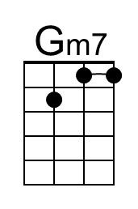 | 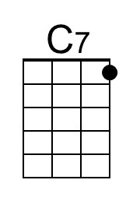
 |  |  |  |  |  |  |  | 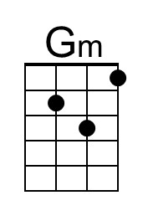
 |  |  |  |  |  |  |  |  | 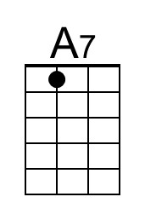
 |  |  |  |  |  |  |  |  | 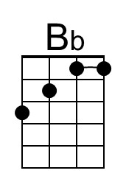
Bari |  |  | 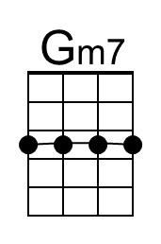 | 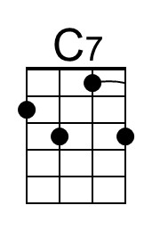 | 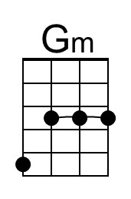
 |  | 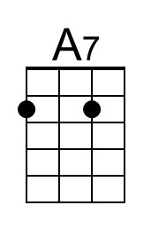 |  |  |  | 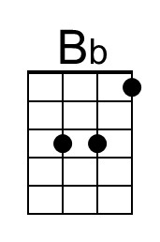

Sh-boom (Life Could Be A Dream) (F) – Page 2

F Dm
Oh, life could be a dream, sh-boom,
Gm C F Dm
__ If I could take you up in paradise up a-bove. sh-boom
Gm C F Dm Gm C7 F
__ If you would tell me I'm the only one that you love, life could be a dream, sweet-heart.

Chorus (2x)
F Dm Gm C
Sh-boom, Sh-boom, ya da da da da da da da da da.
F Dm Gm C
Sh-boom, Sh-boom, ya da da da da da da da da da.
F Dm Gm C F
Sh-boom, Sh-boom, ya da da da da da da da da da. Sh-boom!

Bridge
A A7 D
Now, every time I look at you, something is on my mind.
G G7 Bb C | C
If you'd do what I want you to, baby, we'd be so fine.

F Dm
Oh, life could be a dream, sh-boom,
Gm C F Dm
__ If I could take you up in paradise up a-bove. sh-boom
Gm C F Dm Gm C7 F
__ If you would tell me I'm the only one that you love, life could be a dream, sweet-heart.

Dm Gm C7
Hello, hello again, Sh-boom, I'm hoping we'll meet again.
F Dm Gm7 C7
Hey nonny, ding dong, a-lang a-lang a-lang.
F Dm Gm7 C7
Sh-boom, ba-doh, ba-doo, ba-doo, ba-day.
F Dm F Dm F
Life could be a dream, life could be a dream, sweet-heart.

F Dm Gm C F Dm
Life could be a dream, __ if only all my precious plans would come true,
Gm C F Dm Gm C7 F
__ If you would let me spend my whole life loving you, life could be a dream, sweet-heart.

F Dm Gm7 C7 F Dm Gm7 C7
Dee-oo, dee-oo, sh-boom, sh-boom. Dee-oo, dee-oo, sh-boom, sh-boom.
F Dm Gm7 C7 F Dm | Gm7 C7 F
Dee-oo, dee-oo, sh-boom, sh-boom. Sweet-heart.
Sh-Boom (Life Could Be A Dream) (G)
(James Keyes, Claude Feaster, Carl Feaster, Floyd F. McRae, and James Edwards, 1954)
Sh-boom by The Crew Cuts (F – 130 BPM) - Sh-boom by The Chords (F – 137 BPM)

Intro  G Em Am7 D7  Hey nonny, ding dong, a-lang a-lang a-lang.  G Em Am7 D7  Boom ba-doh, ba-doo, ba-doo, ba-day.  G Em  Oh, life could be a dream, sh-boom  Am D G Em  __ If I could take you up in paradise up a-bove. sh-boom  Am D G Em  __ If you would tell me I'm the only one that you love,  Am D7 G  Life could be a dream, sweet-heart.  Em Am D7  Hello, hello again, Sh-boom, I'm hoping we'll meet again.  G Em  Oh, life could be a dream, sh-boom  Am D G Em  __ If only all my precious plans would come true, sh-boom  Am D G Em  __ If you would let me spend my whole life loving you,  Am D7 G  Life could be a dream, sweet-heart.  Bridge  B B7 E  Now, every time I look at you, something is on my mind.  A A7 C D  If you'd do what I want you to, baby, we'd be so fine. |  |  |  |  |  |  |  |  | 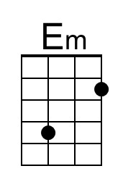
 |  |  |  |  |  |  |  | 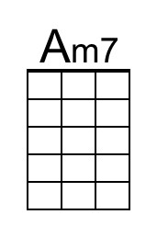
 |  |  |  |  |  |  |  | 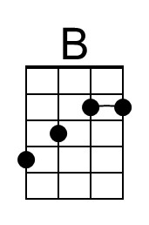 | 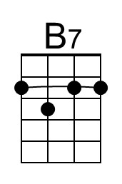
Bari |  | 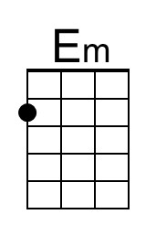 | 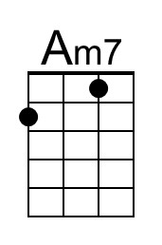
 | 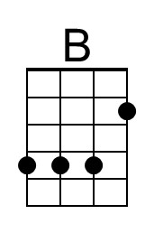 | 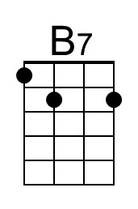

Sh-boom (Life Could Be A Dream) (G) – Page 2

G Em
Oh, life could be a dream, sh-boom,
Am D G Em
__ If I could take you up in paradise up a-bove. sh-boom
Am D G Em Am D7 G
__ If you would tell me I'm the only one that you love, life could be a dream, sweet-heart.

Chorus (2x)
G Em Am D
Sh-boom, Sh-boom, ya da da da da da da da da da.
G Em Am D
Sh-boom, Sh-boom, ya da da da da da da da da da.
G Em Am D G
Sh-boom, Sh-boom, ya da da da da da da da da da. Sh-boom!

Bridge
B B7 E
Now, every time I look at you, something is on my mind.
A A7 C D | D
If you'd do what I want you to, baby, we'd be so fine.

G Em
Oh, life could be a dream, sh-boom,
Am D G Em
__ If I could take you up in paradise up a-bove. sh-boom
Am D G Em Am D7 G
__ If you would tell me I'm the only one that you love, life could be a dream, sweet-heart.

Em Am D7
Hello, hello again, Sh-boom, I'm hoping we'll meet again.
G Em Am7 D7
Hey nonny, ding dong, a-lang a-lang a-lang.
G Em Am7 D7
Sh-boom, ba-doh, ba-doo, ba-doo, ba-day.
G Em G Em G
Life could be a dream, life could be a dream, sweet-heart.

G Em Am D G Em
Life could be a dream, __ if only all my precious plans would come true,
Am D G Em Am D7 G
__ If you would let me spend my whole life loving you, life could be a dream, sweet-heart.

G Em Am7 D7 G Em Am7 D7
Dee-oo, dee-oo, sh-boom, sh-boom. Dee-oo, dee-oo, sh-boom, sh-boom.
G Em Am7 D7 G Em | Am7 D7 G
Dee-oo, dee-oo, sh-boom, sh-boom. Sweet-heart.

