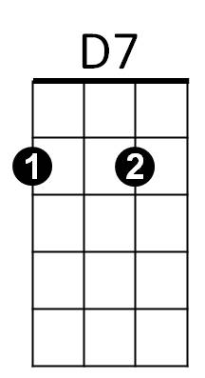**She's Always a Woman to Me (Billy Joel)**

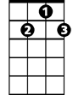

D7

**G D7 G D7 G**

She can kill with a smile, she can wound with her eyes.

**C Em C**

She can ruin your faith with her cas-u-al lies.

**D7 G D7 Bm**

And she only reveals what she wants you to see.

**Em Am C D7 G**



G

She hides like a child, but she's always a woman to me.

**D7 G D7 G**

She can lead you to love, she can take you or leave you.

**C Em C**

She can ask for the truth, but she'll ne-ver believe.



C

**D7 G D7 B**

And she'll take what you give her as long it's free.

**Em Am C D7 G**

She steals like a thief, but she's always a woman to me.

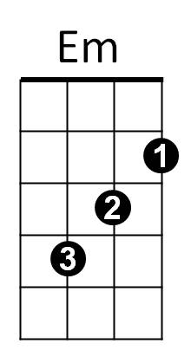**CHORUS:**

**Em A7 D Bm**

Ohhh... she takes care of herself.

**G C Am D7 G**

She can wait if she wants, she's ahead of her time.

**Gm C7 F Dm**

Ohhh... and she never gives out,

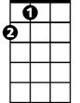

A

**Eb A A7 D**

And she never gives in, she just changes her mind.

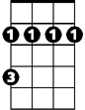

Bm

**D7 G D7 G**

And she'll promise you more than the garden of Eden.

**C Em C**

Then she'll carelessly cut you and laugh while you're bleeding.

**D7 G D7 Bm**

But she brings out the best and the worst you can be.

**Em Am C D7 G**

Blame it all on yourself, 'cause she's always a woman to me.

**D7 G D7 Bm**

Mmmmmmmmmmmmmmmmmmmmmmmmmmm

**Em Am C D7 G**

Mmmmmmmmmmmmmmmmmmmmmmmmmmm



G

**(CHORUS)**

**D7 G D7 G**

She's frequently kind and she's suddenly cruel.

**C Em C**

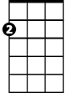

Em

She can do as she pleases, she's nobody's fool.

**D7 G D7 Bm**

But she can't be convicted, she's earned her degree.

**Em Am**

And the most she will do is throw shadows at you,

C



**C D7 G**

But she's always a woman to me.

**D7 G D7 Bm**

Mmmmmmmmmmmmmmmmmmmmmmmmmmm

**Em Am C D7 G**

Mmmmmmmmmmmmmmmmmmmmmmmmmmm

Bm

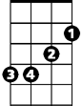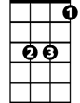

Eb



D

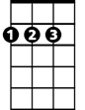

D

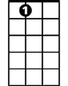

A7



Am

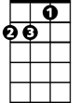

Am

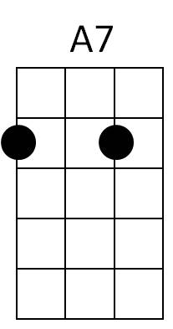



A

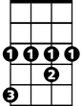

Eb



Dm

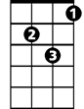

Dm