**She’s Not There (Rod Argent)**

**Intro:**  **/** **Am - D - / x4**

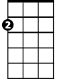

Am

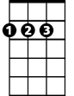

D

**Am** **D** **Am**  **D** **Am** **F** **Am** **D**

Well no one told me about her, the way she lied

**Am** **D** **Am** **D** **Am** **F** **A**

Well no one told me about her, how many people cried

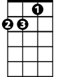

Dm

F

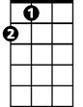

A

**Chorus:**

**D** **Dm** **Am**

But it's too late to say you're sorry

**Em Am**

How would I know, why should I care

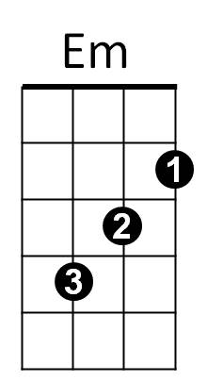 **D** **Dm** **C**

E7

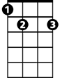

Please don't bother tryin' to find her

**E7**

She's not there

**Am**  **D**

Well let me tell you 'bout the way she looked

**Am** **F** **Am** **D**

The way she'd acted and the color of her hair

**Am** **F**

**BARITONE**

Her voice was soft and cool

**Am** **D**



D



Am



F

Her eyes were clear and bright

**A**

But she's not there

**Am - D - / x4**



A

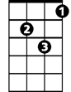

Dm



Em

**Am** **D** **Am** **D** **Am** **F** **Am** **D**

Well no one told me about her, what could I do

**Am** **D** **Am** **D** **Am** **F** **A**

Well no one told me about her, though they all knew

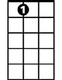

E7

**Repeat Chorus**