Shine On Harvest Moon
Jack Norwort and Nora Bayes (1908)

E7 A7  Shine on, shine on, harvest moon, up in the sky;  D7  I ain't had no lovin'  G Am7 Bbº G  Since January, February, June or July.  E7 A7  Snow time ain't no time to stay, outdoors and spoon;  D7 G  So, Shine on, shine on, harvest moon,  C G  For me and my gal.  Bari |  |  |  |  |  | 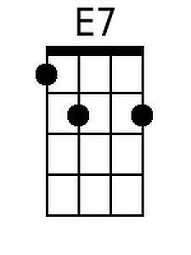  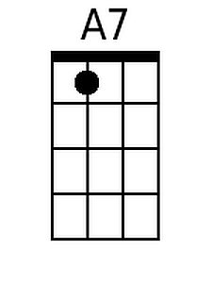  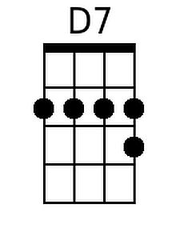
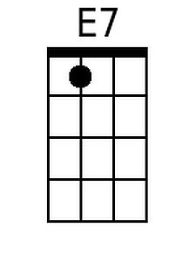 | 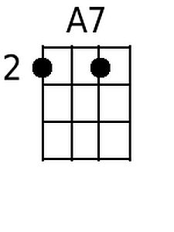 | 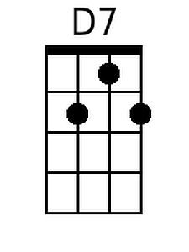 | 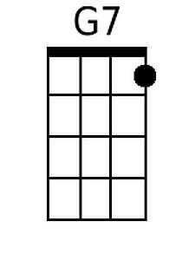 |  |  | 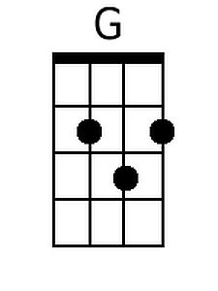
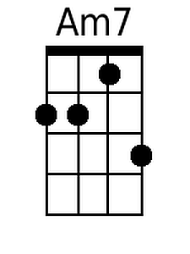 | 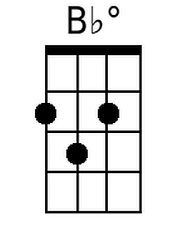 | 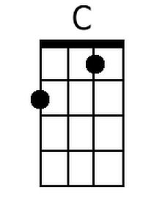 |  |  |  | 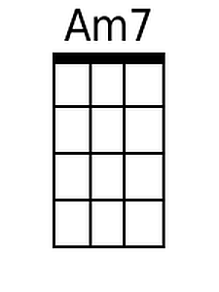
 |  |  |  |  |  | 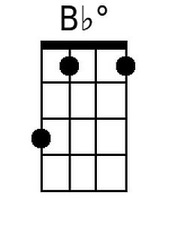
 |  |  |  |  |  | 