Shine On, Harvest Moon (Em) – Version 4 (GCEA)
(Nora Bayes and Jack Norworth, for “The Follies of 1908”)
Shine On, Harvest Moon by Leon Redbone (1977) (Bb)
4/4 Time – Moderately

Intro E5 B | E5 B | E5 B | E5 B

E5 G no5 B
Night was mighty dark so you could hardly see, for the moon refused to shine.
E5 G no5 D
Couple sitting underneath a willow tree, for love __ they pine.
D7 G D no5
Little maid was kind afraid of darkness, so she said, "I guess I'll go."
A7 Bm D
Boy began to sigh, looked up at the sky, told the moon his little tale of woe:

Chorus
C no5 A no5 A
"Oh, shine on, shine on, harvest moon, up in the sky.
Dm no5 Em C
I ain't had no lovin' since January, February, June or July.
E no5 A no5 A
Snow time ain't no time to stay __ out doors and spoon,
Bm no5 G
So shine on, shine on, harvest moon, for me and my gal."

E5 G no5 B
I can't see why the boy should sigh, when by his side is the girl he loves so true
E5 G no5 D
All he has to say is, “Won't you be my bride? For I __ love you.”
D7 G D no5
Why should I be telling you this secret, when I know __ that you can guess?'
A7 Bm
Harvest moon will smile, shine on all the while
Em A7 D
If the little girl should answer, “Yes.” Chorus

Outro D7 Em?
Total = 16 chords (Key of G)
E5 B Gno5 D D7 G Dno5 A7
Bm Cno5 Ano5 A Dmno5 C Eno5 Bmno5
E5 | B | Gno5 | D | D7 | G | Dno5 | A7
Bm | Cno5 | Ano5 | A | Dmno5 | C | Eno5 | Bmno5

E5 |  |  |  | 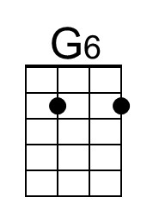 |  |  | 
Shine On, Harvest Moon (Em) – Version 4 (DGBE)
(Nora Bayes and Jack Norworth, for “The Follies of 1908”)
Shine On, Harvest Moon by Leon Redbone (1977) (Bb)
4/4 Time – Moderately

Intro E5 B | E5 B | E5 B | E5 B

E5 G^{no}5 B
Night was mighty dark so you could hardly see, for the moon refused to shine.
E5 G^{no}5 D
Couple sitting underneath a willow tree, for love __ they pine.
D7 G D^{no}5
Little maid was kind afraid of darkness, so she said, "I guess I'll go."
A7 Bm D
Boy began to sigh, looked up at the sky, told the moon his little tale of woe:

Chorus
C^{no}5 A^{no}5 A
"Oh, shine on, shine on, harvest moon, up in the sky.
Dm^{no}5 Em C
I ain't had no lovin' since January, February, June or July.
E^{no}5 A^{no}5 A
Snow time ain't no time to stay __ out doors and spoon,
Bm^{no}5 G
So shine on, shine on, harvest moon, for me and my gal."

E5 G^{no}5 B
I can't see why the boy should sigh, when by his side is the girl he loves so true
E5 G^{no}5 D
All he has to say is, “Won't you be my bride? For I __ love you.”
D7 G D^{no}5
Why should I be telling you this secret, when I know __ that you can guess?'

A7 Bm
Harvest moon will smile, shine on all the while
Em A7 D
If the little girl should answer, “Yes.” Chorus

Outro D7 E5?

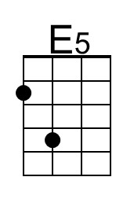 |  | 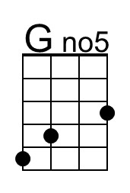 |  |  |  | 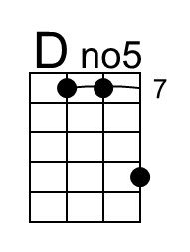 | 
 | 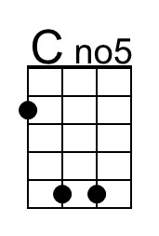 | A^{no}5 |  | Dm^{no}5 |  | E^{no}5 | 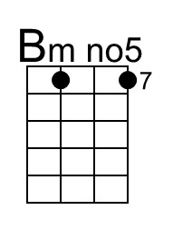

Total = 17 chords (Key of G)
E5 B Gno5 D D7 G Dno5 A7 Bm
Cno5 Ano5 A Dmno5 Em C Eno5 Bmno5

For Transpositions

