Shine On, Harvest Moon (Am) – Version 3
(Nora Bayes and Jack Norworth for “The Follies of 1908”)
Shine On, Harvest Moon by Leon Redbone (1977) (Gm)
Shine On, Harvest Moon by Leon Redbone (Live) (Gm)
4/4 Time – Moderately

Intro Am E7 | Am E7 | Am E7 | Am E7  Am E7  Night was mighty dark so you could hardly see, for the moon refused to shine.  Am D7 E7  Couple sitting underneath a willow tree, for love __ they pine.  Dm C Am  Little maid was kind afraid of darkness, so she said, "I guess I'll go."  D7 G - G7  Boy began to sigh, looked up at the sky, told the moon his little tale of woe:  Chorus  A7 D7  "Oh, shine on, shine on, harvest moon, up in the sky.  G7 C  I ain't had no lovin' since January, February, June or July.  A7 D7  Snow time ain't no time to stay __ out doors and spoon,  G7 C G7 C  So shine on, shine on, harvest moon, for me and my gal."  Am E7  I can't see why the boy should sigh, when by his side is the girl he loves so true  Am D7 E7  All he has to say is, “Won't you be my bride? For I __ love you.”  Dm C Am  Why should I be telling you this secret, when I know __ that you can guess?'  D7 G – G7  Harvest moon will smile, shine on all the while, if the little girl should answer, “Yes.”  Chorus  Outro  G7 C G7 C  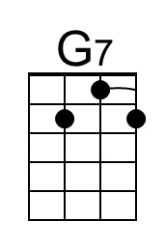  So shine on, shine on, harvest moon, for me and my gal."  Note. Lyrics are from the 1908 sheet music except for changes to the first two lines of the chorus which originally read:  “Oh, shine on harvest moon, up in the sky.  I ain't had no lovin' since April, January, June or July.” |  |  |  |  |  |  |  | 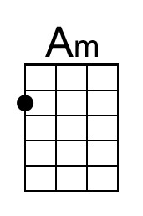
 |  |  |  |  |  |  |  | 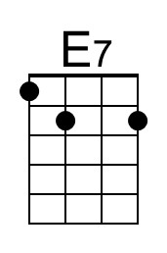
 |  |  |  |  |  |  |  | 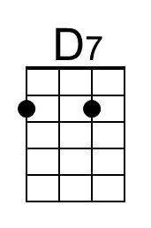
 |  |  |  |  |  |  |  | 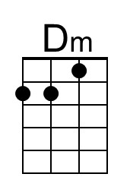
 |  |  |  |  |  |  |  | 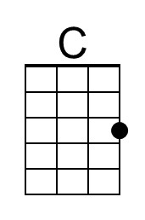
 |  |  |  |  |  |  |  | 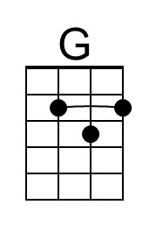
 |  |  |  |  |  |  |  | 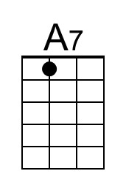
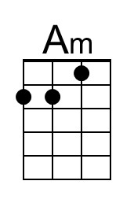 | 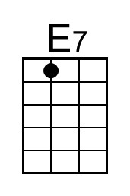 | 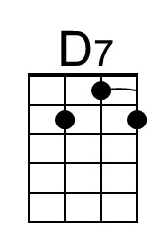 | 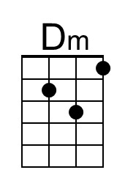 | 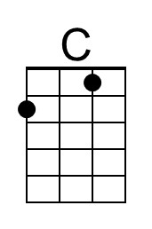 | 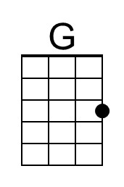 | 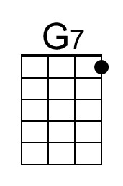 | 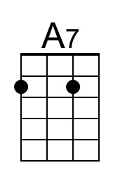

Shine On, Harvest Moon (Dm) – Version 3
(Nora Bayes and Jack Norworth for “The Follies of 1908”)
Shine On, Harvest Moon by Leon Redbone (1977) (Gm)
Shine On, Harvest Moon by Leon Redbone (Live) (Gm)
4/4 Time – Moderately

Intro Dm A7 | Dm A7 | Dm A7 | Dm A7

Dm A7
Night was mighty dark so you could hardly see, for the moon refused to shine.
Dm G7 A7
Couple sitting underneath a willow tree, for love __ they pine.
Gm F Dm
Little maid was kind afraid of darkness, so she said, "I guess I'll go."
G7 C - C7
Boy began to sigh, looked up at the sky, told the moon his little tale of woe:

Chorus
D7 G7
"Oh, shine on, shine on, harvest moon, up in the sky.
C7 F
I ain't had no lovin' since January, February, June or July.
D7 G7
Snow time ain't no time to stay __ out doors and spoon,
C7 F C7 F
So shine on, shine on, harvest moon, for me and my gal."

Dm A7
I can't see why the boy should sigh, when by his side is the girl he loves so true
Dm G7 A7
All he has to say is, “Won't you be my bride? For I __ love you.”
Gm F Dm
Why should I be telling you this secret, when I know __ that you can guess?'
G7 C – C7
Harvest moon will smile, shine on all the while, if the little girl should answer, “Yes.”
Chorus
Outro
C7 F C7 F
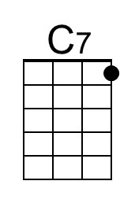
So shine on, shine on, harvest moon, for me and my gal."

Note. Lyrics are from the 1908 sheet music except for changes to the first two lines of the chorus which originally read:
“Oh, shine on harvest moon, up in the sky.
I ain't had no lovin' since April, January, June or July.”
 |  |  |  |  |  |  |  | 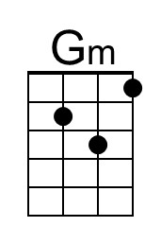
 |  |  |  |  |  |  |  | 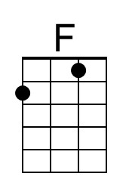
 |  |  | 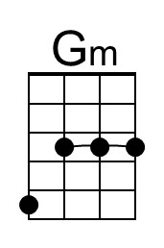 | 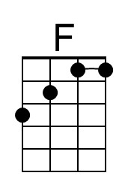 |  | 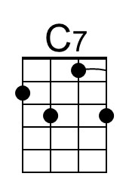

Shine On, Harvest Moon (Em) – Version 3
(Nora Bayes and Jack Norworth for “The Follies of 1908”)
Shine On, Harvest Moon by Leon Redbone (1977) (Gm)
Shine On, Harvest Moon by Leon Redbone (Live) (Gm)
4/4 Time – Moderately

Intro Em B7 | Em B7 | Em B7 | Em B7  Em B7  Night was mighty dark so you could hardly see, for the moon refused to shine.  Em A7 B7  Couple sitting underneath a willow tree, for love __ they pine.  Am G Em  Little maid was kind afraid of darkness, so she said, "I guess I'll go."  A7 D - D7  Boy began to sigh, looked up at the sky, told the moon his little tale of woe:  Chorus  E7 A7  "Oh, shine on, shine on, harvest moon, up in the sky.  D7 G  I ain't had no lovin' since January, February, June or July.  E7 A7  Snow time ain't no time to stay __ out doors and spoon,  D7 G D7 G  So shine on, shine on, harvest moon, for me and my gal."  Em B7  I can't see why the boy should sigh, when by his side is the girl he loves so true  Em A7 B7  All he has to say is, “Won't you be my bride? For I __ love you.”  Am G Em  Why should I be telling you this secret, when I know __ that you can guess?'  A7 D – D7  Harvest moon will smile, shine on all the while, if the little girl should answer, “Yes.”  Chorus  Outro  D7 G D7 G  So shine on, shine on, harvest moon, for me and my gal."  Note. Lyrics are from the 1908 sheet music except for changes to the first two lines of the chorus which originally read:  “Oh, shine on harvest moon, up in the sky.  I ain't had no lovin' since April, January, June or July.” |  |  |  |  |  |  |  | 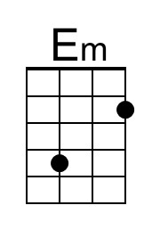
 |  |  |  |  |  |  |  | 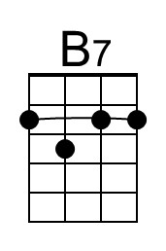
 |  |  |  |  |  |  |  | 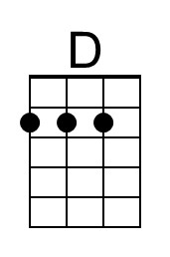
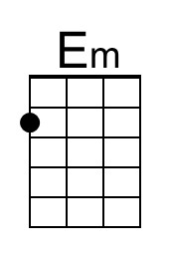 | 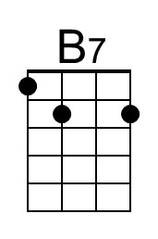 |  |  |  | 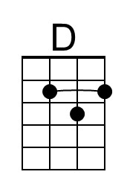

Shine On, Harvest Moon (Gm) – Version 3
(Nora Bayes and Jack Norworth for “The Follies of 1908”)
Shine On, Harvest Moon by Leon Redbone (1977) (Gm)
Shine On, Harvest Moon by Leon Redbone (Live) (Gm)
4/4 Time – Moderately

Intro Gm D7 | Gm D7 | Gm D7 | Gm D7

Gm D7
Night was mighty dark so you could hardly see, for the moon refused to shine.
Gm C7 D7
Couple sitting underneath a willow tree, for love __ they pine.
Cm Bb Gm
Little maid was kind afraid of darkness, so she said, "I guess I'll go."
C7 F - F7
Boy began to sigh, looked up at the sky, told the moon his little tale of woe:

Chorus
G7 C7
"Oh, shine on, shine on, harvest moon, up in the sky.
F7 Bb
I ain't had no lovin' since January, February, June or July.
G7 C7
Snow time ain't no time to stay __ out doors and spoon,
F7 Bb F7 Bb
So shine on, shine on, harvest moon, for me and my gal."

Gm D7
I can't see why the boy should sigh, when by his side is the girl he loves so true
Gm C7 D7
All he has to say is, “Won't you be my bride? For I __ love you.”
Cm Bb Gm
Why should I be telling you this secret, when I know __ that you can guess?'
C7 F – F7
Harvest moon will smile, shine on all the while, if the little girl should answer, “Yes.”
Chorus
Outro
F7 Bb F7 Bb
So shine on, shine on, harvest moon, for me and my gal."
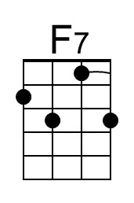

Note. Lyrics are from the 1908 sheet music except for changes to the first two lines of the chorus which originally read:
“Oh, shine on harvest moon, up in the sky.
I ain't had no lovin' since April, January, June or July.”
 |  |  |  |  |  |  |  | 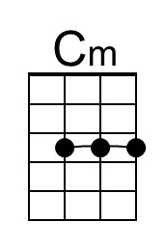
 |  |  |  |  |  |  |  | 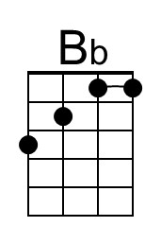
 |  |  | 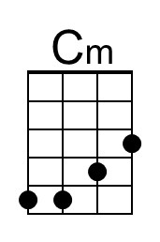 | 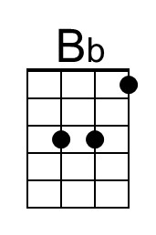 |  | 