Shine On, Harvest Moon (Am) – Version 2 – C-Tuning
(Nora Bayes and Jack Norworth, for “The Follies of 1908”)
Shine On, Harvest Moon by Harry Macdonough & Elise Stevenson (1908) (Both verses)
And by Ruth Edding (1931) and Leon Redbone (1977) 4/4 Time – Moderately

Intro Am E | Am E | Am E | Am E7

Am E Am E - E7
Night was mighty dark so you could hardly see, for the moon refused to shine.
Am E Am D7 G7
Couple sitting underneath a willow tree, for love __ they pine.
Dm G Dm C6 Cmaj7 - C#dim7
Little maid was kind afraid of darkness, so she said, “I guess I'll go.”
D7 G6 D7 G6
Boy began to sigh, looked up at the sky,
A7 D7 G – G#7 – G7
Told the moon his little tale of woe:

Chorus
A7 D7
“Oh, shine on, shine on, harvest moon, up in the sky.
G7 C6 Dm7 D#dim7 C7
I ain't had no lovin' since January, February, June or July.
A7 D7
Snow time ain't no time to stay __ out doors and spoon,
G7 C6 F7 C6 G#7 C6
So shine on, shine on, harvest moon, for me and my gal.”

Am E Am E - E7
I can't see why the boy should sigh, when by his side is the girl he loves so true
Am E Am A7 D7 G - G7
All he has to say is, “Won't you be my bride? For I __ love you.”
Dm G Dm G C6 Am - Am7
Why should I be telling you this secret, when I know __ that you can guess?'
D7 G6 D7 G6
Harvest moon will smile, shine on all the while
A7 D7 G – G#7 – G7
If the little girl should answer, “Yes.” Chorus.

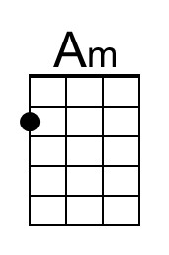 | 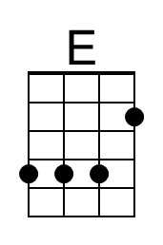 | 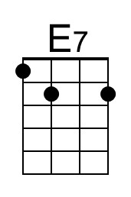 | 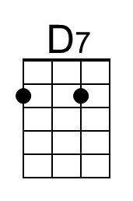 | 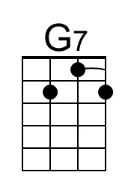 | 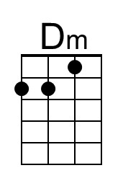 | 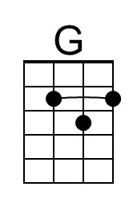 | 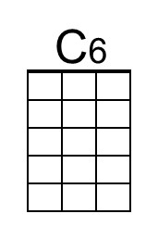
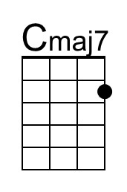 | 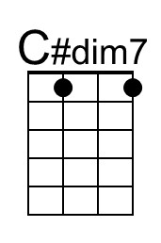 | 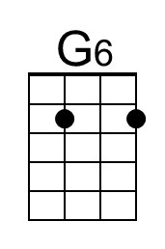 | 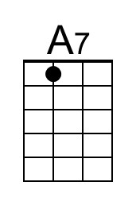 | 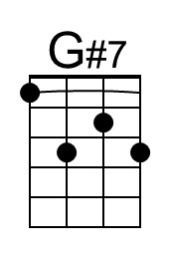 | 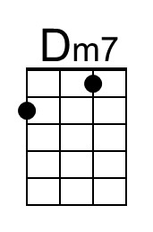 | 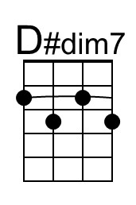 | 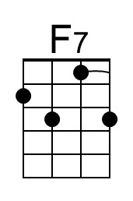

Notes on lyric alterations in Chorus
- Original 1st line: Oh, shine on, harvest moon, up in the sky.
- Original 2nd line: I ain't had no lovin' since April, January, June or July.
Shine On, Harvest Moon (Am) – Version 2 – G-Tuning
(Nora Bayes and Jack Norworth, for “The Follies of 1908”)
Shine On, Harvest Moon by Harry Macdonough & Elise Stevenson (1908) (Both verses)
And by Ruth Edding (1931) and Leon Redbone (1977) 4/4 Time – Moderately

Intro Am E | Am E | Am E | Am E7

Am E Am E - E7
Night was mighty dark so you could hardly see, for the moon refused to shine.
Am E Am D7 G7
Couple sitting underneath a willow tree, for love __ they pine.
Dm G Dm C6 Cmaj7 - C#dim7
Little maid was kind afraid of darkness, so she said, “I guess I'll go.”
D7 G6 D7 G6
Boy began to sigh, looked up at the sky,
A7 D7 G – G#7 – G7
Told the moon his little tale of woe:

Chorus
A7 D7
“Oh, shine on, shine on, harvest moon, up in the sky.
G7 C6 Dm7 D#dim7 C7
I ain't had no lovin' since January, February, June or July.
A7 D7
Snow time ain't no time to stay __ out doors and spoon,
G7 C6 F7 C6 G#7 C6
So shine on, shine on, harvest moon, for me and my gal.”

Am E Am E - E7
I can't see why the boy should sigh, when by his side is the girl he loves so true
Am E Am A7 D7 G - G7
All he has to say is, “Won't you be my bride? For I __ love you.”
Dm G Dm G C6 Am - Am7
Why should I be telling you this secret, when I know __ that you can guess?'
D7 G6 D7 G6
Harvest moon will smile, shine on all the while
A7 D7 G – G#7 – G7
If the little girl should answer, “Yes.” Chorus.

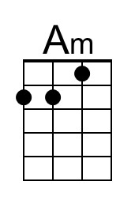 | 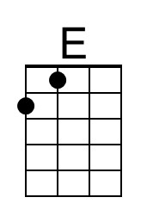 | 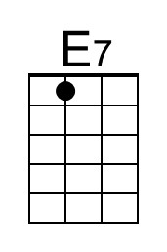 | 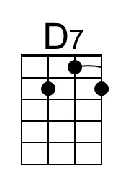 | 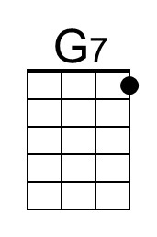 | 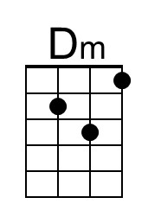 | 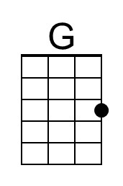 | 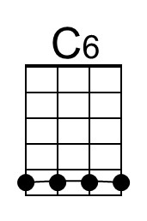
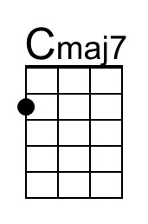 | 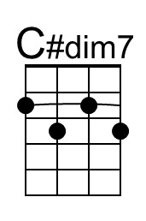 | 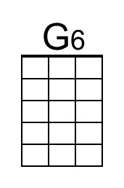 | 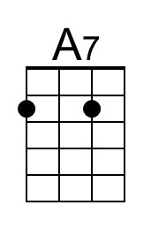 | 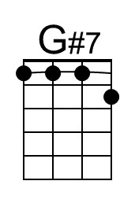 | 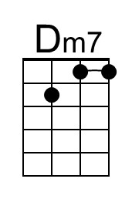 | 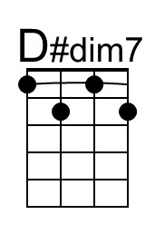 | 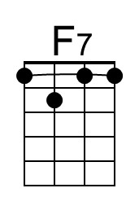

Notes on lyric alterations in Chorus
- Original 1st line: Oh, shine on, harvest moon, up in the sky.
- Original 2nd line: I ain't had no lovin' since April, January, June or July.
Shine On, Harvest Moon (Dm) – Version 2 – C-Tuning
(Nora Bayes and Jack Norworth, for “The Follies of 1908”)
Shine On, Harvest Moon by Harry Macdonough & Elise Stevenson (1908) (Both verses)
And by Ruth Edding (1931) and Leon Redbone (1977) 4/4 Time – Moderately

Intro Dm A | Dm A | Dm A | Dm A7

Dm A Dm A - A7
Night was mighty dark so you could hardly see, for the moon refused to shine.
Dm A Dm G7 C7
Couple sitting underneath a willow tree, for love __ they pine.
Gm C Gm F6 Fmaj7 - F#dim7
Little maid was kind afraid of darkness, so she said, “I guess I'll go.”
G7 C6 G7 C6
Boy began to sigh, looked up at the sky,
D7 G7 C – C#7 – C7
Told the moon his little tale of woe:

Chorus
D7 G7
“Oh, shine on, shine on, harvest moon, up in the sky.
C7 F6 Gm7 G#dim7 F7
I ain't had no lovin' since January, February, June or July.
D7 G7
Snow time ain't no time to stay __ out doors and spoon,
C7 F6 A#7 F6 C#7 F6
So shine on, shine on, harvest moon, for me and my gal.”

Dm A Dm A - A7
I can't see why the boy should sigh, when by his side is the girl he loves so true
Dm A Dm D7 G7 C - C7
All he has to say is, “Won't you be my bride? For I __ love you.”
Gm C Gm C F6 Dm - Dm7
Why should I be telling you this secret, when I know __ that you can guess?'
G7 C6 G7 C6
Harvest moon will smile, shine on all the while
D7 G7 C – C#7 – C7
If the little girl should answer, “Yes.” Chorus.

 | 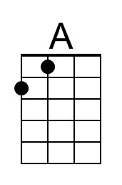 |  |  | 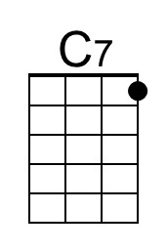 | 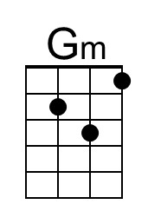 | 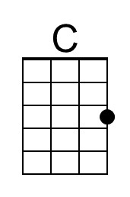 | 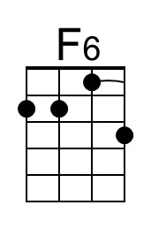
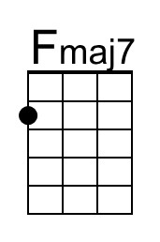 | 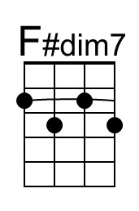 |  |  | 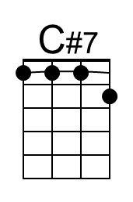 | 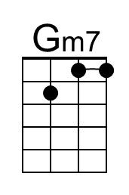 | 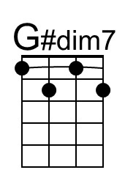 | 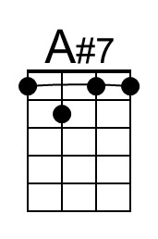

Notes on lyric alterations in Chorus
- Original 1st line: Oh, shine on, harvest moon, up in the sky.
- Original 2nd line: I ain't had no lovin' since April, January, June or July.

Shine On, Harvest Moon (Dm) – Version 2 – G-Tuning
(Nora Bayes and Jack Norworth, for “The Follies of 1908”)
Shine On, Harvest Moon by Harry Macdonough & Elise Stevenson (1908) (Both verses)
And by Ruth Edding (1931) and Leon Redbone (1977) 4/4 Time – Moderately

Intro Dm A | Dm A | Dm A | Dm A7

Dm A Dm A - A7
Night was mighty dark so you could hardly see, for the moon refused to shine.
Dm A Dm G7 C7
Couple sitting underneath a willow tree, for love __ they pine.
Gm C Gm F6 Fmaj7 - F#dim7
Little maid was kind afraid of darkness, so she said, “I guess I'll go.”
G7 C6 G7 C6
Boy began to sigh, looked up at the sky,
D7 G7 C – C#7 – C7
Told the moon his little tale of woe:

Chorus
D7 G7
“Oh, shine on, shine on, harvest moon, up in the sky.
C7 F6 Gm7 G#dim7 F7
I ain't had no lovin' since January, February, June or July.
D7 G7
Snow time ain't no time to stay __ out doors and spoon,
C7 F6 Bb7 F6 C#7 F6
So shine on, shine on, harvest moon, for me and my gal.”

Dm A Dm A - A7
I can't see why the boy should sigh, when by his side is the girl he loves so true
Dm A Dm D7 G7 C - C7
All he has to say is, “Won't you be my bride? For I __ love you.”
Gm C Gm C F6 Dm - Dm7
Why should I be telling you this secret, when I know __ that you can guess?'
G7 C6 G7 C6
Harvest moon will smile, shine on all the while
D7 G7 C – C#7 – C7
If the little girl should answer, “Yes.” Chorus.

 | 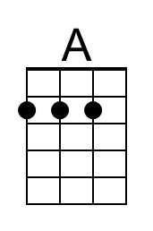 |  |  | 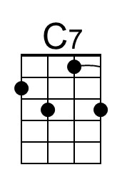 | 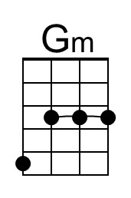 | 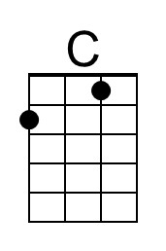 | 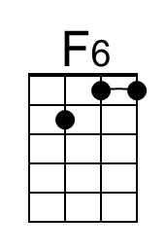
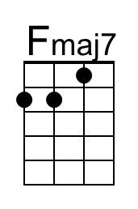 | 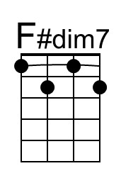 | 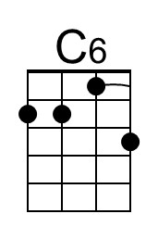 |  | 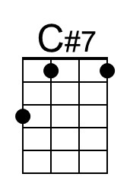 | 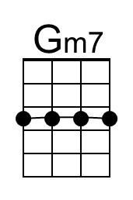 | 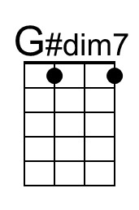 | 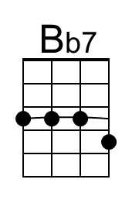

Notes on lyric alterations in Chorus
- Original 1st line: Oh, shine on, harvest moon, up in the sky.
- Original 2nd line: I ain't had no lovin' since April, January, June or July.

Shine On, Harvest Moon (Em) – Version 2 – C-Tuning
(Nora Bayes and Jack Norworth, for “The Follies of 1908”)
Shine On, Harvest Moon by Harry Macdonough & Elise Stevenson (1908) (Both verses)
And by Ruth Edding (1931) and Leon Redbone (1977) 4/4 Time – Moderately

Intro Em B | Em B | Em B | Em B7

Em B Em B - B7
Night was mighty dark so you could hardly see, for the moon refused to shine.
Em B Em A7 D7
Couple sitting underneath a willow tree, for love __ they pine.
Am D Am G6 Gmaj7 - G#dim7
Little maid was kind afraid of darkness, so she said, “I guess I'll go.”
A7 D6 A7 D6
Boy began to sigh, looked up at the sky,
E7 A7 D – D#7 – D7
Told the moon his little tale of woe:

Chorus
E7 A7
“Oh, shine on, shine on, harvest moon, up in the sky.
D7 G6 Am7 A#dim7 G7
I ain't had no lovin' since January, February, June or July.
E7 A7
Snow time ain't no time to stay __ out doors and spoon,
D7 G6 C7 G6 D#7 G6
So shine on, shine on, harvest moon, for me and my gal.”

Em B Em B - B7
I can't see why the boy should sigh, when by his side is the girl he loves so true
Em B Em E7 A7 D - D7
All he has to say is, “Won't you be my bride? For I __ love you.”
Am D Am D G6 Em - Em7
Why should I be telling you this secret, when I know __ that you can guess?'
A7 D6 A7 D6
Harvest moon will smile, shine on all the while
E7 A7 D – D#7 – D7
If the little girl should answer, “Yes.” Chorus

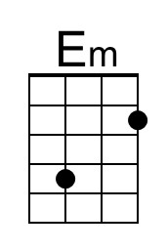 | 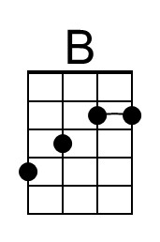 | 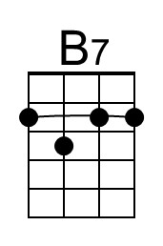 |  |  |  | 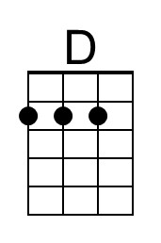
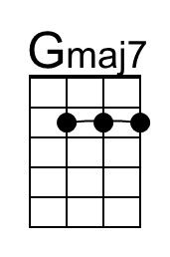 |  | 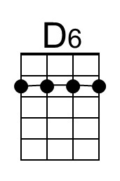 |  | 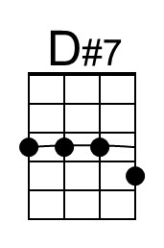 | 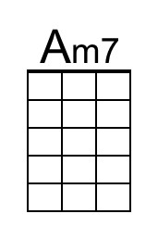 | 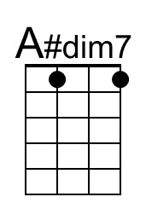

Notes on lyric alterations in Chorus
- Original 1st line: Oh, shine on, harvest moon, up in the sky.
- Original 2nd line: I ain't had no lovin' since April, January, June or July.

Shine On, Harvest Moon (Em) – Version 2 – G-Tuning
(Nora Bayes and Jack Norworth, for “The Follies of 1908”)
Shine On, Harvest Moon by Harry Macdonough & Elise Stevenson (1908) (Both verses)
And by Ruth Edding (1931) and Leon Redbone (1977) 4/4 Time – Moderately

Intro Em B | Em B | Em B | Em B7

Em B Em B - B7
Night was mighty dark so you could hardly see, for the moon refused to shine.
Em B Em A7 D7
Couple sitting underneath a willow tree, for love __ they pine.
Am D Am G6 Gmaj7 - G#dim7
Little maid was kind afraid of darkness, so she said, “I guess I'll go.”
A7 D6 A7 D6 E7 A7 D – D#7 – D7
Boy began to sigh, looked up at the sky, Told the moon his little tale of woe:

Chorus
E7 A7
“Oh, shine on, shine on, harvest moon, up in the sky.
D7 G6 Am7 A#dim7 G7
I ain't had no lovin' since January, February, June or July.
E7 A7
Snow time ain't no time to stay __ out doors and spoon,
D7 G6 C7 G6 D#7 G6
So shine on, shine on, harvest moon, for me and my gal.”

Em B Em B - B7
I can't see why the boy should sigh, when by his side is the girl he loves so true
Em B Em E7 A7 D - D7
All he has to say is, “Won't you be my bride? For I __ love you.”
Am D Am D G6 Em - Em7
Why should I be telling you this secret, when I know __ that you can guess?'
A7 D6 A7 D6
Harvest moon will smile, shine on all the while
E7 A7 D – D#7 – D7
If the little girl should answer, “Yes.” Chorus

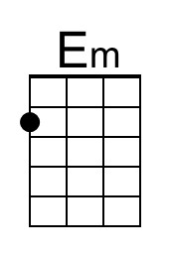 | 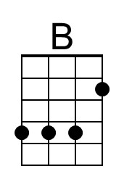 | 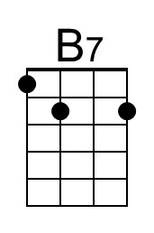 |  |  |  | 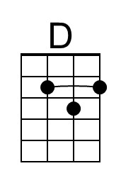
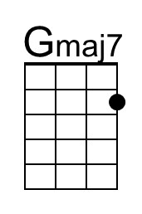 |  | 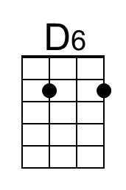 |  | 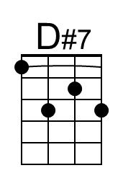 | 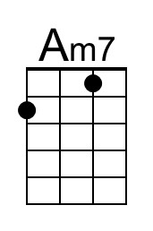 | 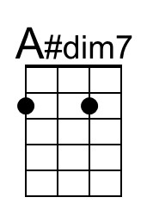

Notes on lyric alterations in Chorus
- Original 1st line: Oh, shine on, harvest moon, up in the sky.
- Original 2nd line: I ain't had no lovin' since April, January, June or July.

