Shine On, Harvest Moon (Am)
(Nora Bayes and Jack Norworth, for “The Follies of 1908”)
Shine On, Harvest Moon by Leon Redbone (1977)
4/4 Time – Moderately

Intro Am E7 | Am E7 | Am E7 | Am E7  Am E7  Night was mighty dark so you could hardly see, for the moon refused to shine.  Am D7  Couple sitting underneath a willow tree, for love __ they pine.  Dm C6  Little maid was kind afraid of darkness, so she said, “I guess I'll go.”  D7 G7  Boy began to sigh, looked up at the sky, told the moon his little tale of woe:  Chorus  A7 D7  “Oh, shine on, shine on, harvest moon, up in the sky.  G7 C6  I ain't had no lovin' since January, February, June or July.  A7 D7  Snow time ain't no time to stay __ out doors and spoon,  G7 C6  So shine on, shine on, harvest moon, for me and my gal.”  Repeat From Top  Outro G7 C6 |  |  |  |  |  |  | 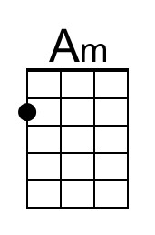
 |  |  |  |  |  |  | 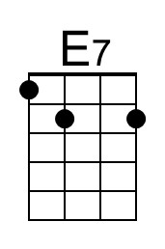
 |  |  |  |  |  |  | 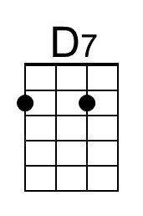
 |  |  |  |  |  |  | 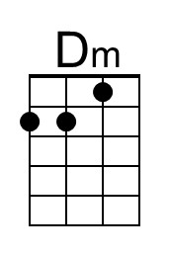
 |  |  |  |  |  |  | 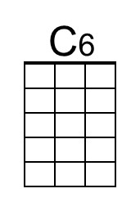
 |  |  |  |  |  |  | 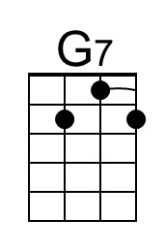
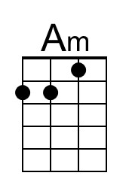 | 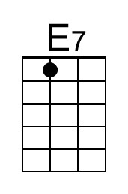 | 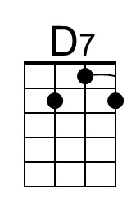 | 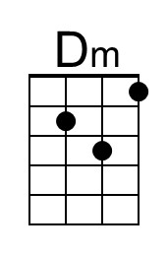 | 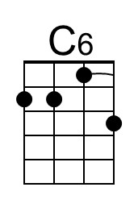 | 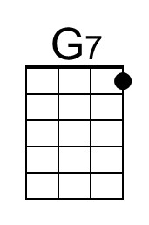 | 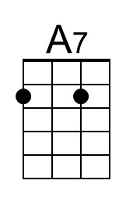 | 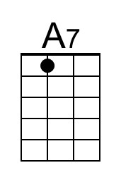

Shine On, Harvest Moon (Dm)
(Nora Bayes and Jack Norworth, for “The Follies of 1908”)
Shine On, Harvest Moon by Leon Redbone (1977)
4/4 Time – Moderately

Intro Dm A7 | Dm A7 | Dm A7 | Dm A7

Dm A7
Night was mighty dark so you could hardly see, for the moon refused to shine.
Dm G7
Couple sitting underneath a willow tree, for love __ they pine.
Gm F6
Little maid was kind afraid of darkness, so she said, "I guess I'll go."
G7 C7
Boy began to sigh, looked up at the sky, told the moon his little tale of woe:

Chorus
D7 G7
"Oh, shine on, shine on, harvest moon, up in the sky.
C7 F6
I ain't had no lovin' since January, February, June or July.
D7 G7
Snow time ain't no time to stay __ out doors and spoon,
C7 F6
So shine on, shine on, harvest moon, for me and my gal."

Repeat From Top

Outro C7 F6

 |  |  |  |  |  |  | 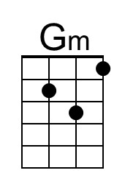
 |  |  |  |  |  |  | 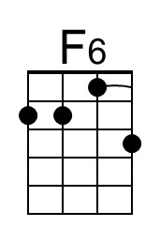
 |  |  |  |  |  |  | 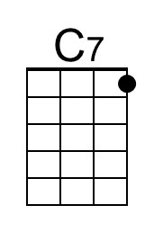
 |  |  | 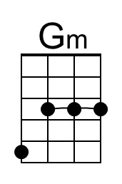 | 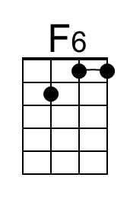 | 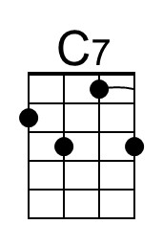

Shine On, Harvest Moon (Em)
(Nora Bayes and Jack Norworth, for “The Follies of 1908”)
Shine On, Harvest Moon by Leon Redbone (1977)
4/4 Time – Moderately

Intro Em B7 | Em B7 | Em B7 | Em B7  Em B7  Night was mighty dark so you could hardly see, for the moon refused to shine.  Em A7  Couple sitting underneath a willow tree, for love __ they pine.  Am G6  Little maid was kind afraid of darkness, so she said, "I guess I'll go."  A7 D7  Boy began to sigh, looked up at the sky, told the moon his little tale of woe:  Chorus  E7 A7  "Oh, shine on, shine on, harvest moon, up in the sky.  D7 G6  I ain't had no lovin' since January, February, June or July.  E7 A7  Snow time ain't no time to stay __ out doors and spoon,  D7 G6  So shine on, shine on, harvest moon, for me and my gal."  Repeat From Top  Outro D7 G6 |  |  |  |  |  |  | 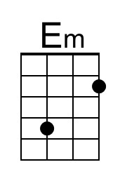
 |  |  |  |  |  |  | 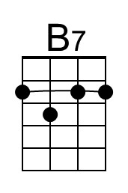
 |  |  |  |  |  |  | 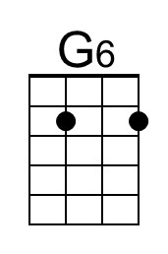
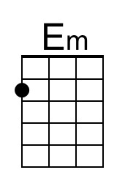 | 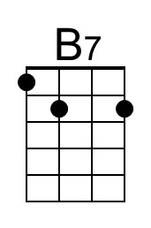 |  |  | 