**Shine on Harvest Moon** (Gerald Casale / Mark Allen Mothersbaugh)

Key Am

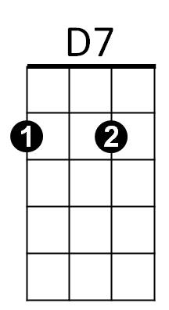 **A** **7 D7**

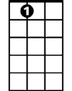

A7

Oh shine on shine on harvest moon up in the sky

**G7 C F C**

I ain't had no lovin' since January February June or July

**A7 D7**

Snow time ain't no time to sit outdoors and spoon

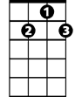

G7



C

**G7 C F C**

So shine on shine on harv est moon for me and my gal

**Am E7 Am**

The night wa s mighty dark so you could hardly see

**C E7**

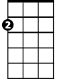

Am

E7

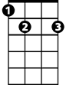

G

F



Cause the moon refused to shine

**Am E7 Am**

Couple sittin' underneath the willow tree

**D7 G**

For love they pine

**BARITONE**

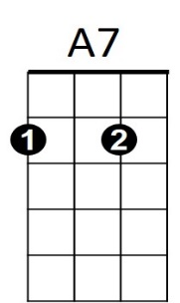**G G7**

C

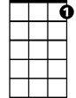

G7



D7

Little maid was mighty afraid of darkness

**C**

So she said, “I think I'll go!”

**D7**

Boy began to sigh, looked up at the sky



F

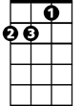

Am

**G G7**

And told the moon his little tale of woe

**A7 D7**

Oh shine on shine on harvest moon up in the sky

**G7 C F C**



G



E7

I ain't had no lovin' since January February June or July

**A7 D7**

Snow time ain't no time to sit outdoors and spoon

**G7 C F C**

So shine on shine on harvest moon for me and my gal

**Shine on Harvest Moon (Gerald Casale / Mark Allen Mothersbaugh)**

**Key Em**

**E7 A7**

E7



A7

**BARITONE**

Oh shine on shine on harvest moon up in the sky

**D7 G C G**

I ain't had no lovin' since January February June or July

**E7 A7**

****Snow time ain't no time to sit outdoors and spoon



G

**D7 G C G**

So shine on shine on harvest moon for me and my gal

**Em B7 Em**

The night was mighty dark so you could hardly see

Em

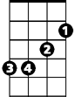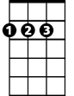

D

**G B7**



C

Cause the moon refused to shine

**Em B7 Em**

Couple sittin' underneath the willow tree

**A7 D**

For love they pine



**D D7**



G



D7



E7

Little maid was mighty afraid of darkness

**G**

So she said, “I think I'll go!”

**A7**

Boy began to sigh, looked up at the sky

C



Em

**D D7**

And told the moon his little tale of woe

**E7 A7**

Oh shine on shine on harvest moon up in the sky



D

B7



**D7 G C G**

I ain't had no lovin' since January February June or July

**E7 A7**

Snow time ain't no time to sit outdoors and spoon

**D7 G C G**

So shine on shine on harvest moon for me and my gal