Silent Night – 7 SEP 09

Yi-Peng:

Sorry for the delay. I just finished two more small books (concerning prayer) last night, and can now devote the needed time to researching your question about the A.R. Friese arrangement of “Silent Night” Unfortunately, it seems to have been lost in the mists of time. If it is to be discovered, it will almost certainly be in Germany.

Did those two web pages on “Silent Night” and “Away In A Manger” answer the questions that you had? If not, please let me know.

“If it's got through please could I send you a few carol arrangements I imputed into Sibelius?”
I would love to have them and post them with your permission. Please provide the attribution that you would like to have on the web page (First and last name), plus anything else you would like. Do you have a web site?

Good to hear from you again.

Best wishes,

Doug

I know this may have been impossible for me but I've managed to find a copy of the score of the Festgesang cantata that contains Mendelssohn's original tune. However, this score is a piano-vocal score and as such is a reduction of the original brass band accompaniment. I've managed to make a photocopy of the work, including the second movement that includes Hark. However, please could I ask if I could just send you a PDF scan of the pages of the second movement? I'm a little concerned because I might be violating copyright regulations. I know the music is out of copyright and that the score I borrowed is actually a facsimile reproduction of the original Beritkopf & Hartel parts. So please could I ask if it's OK?
Also, while you're doing it, please could I use this occasion to suggest two corrections to the background of the Mendelssohn tune? Firstly, please let me mention that although you're familiar with the Festgesang an die Kunstler op. 68, this is a separate Festgesang from the Gutenberg piece we have in mind. The piece is called Festgesang zur Säkularfeier der Erfindung der Buchdruckerkunst, and I've found it out on the Breitkopf & Härtel web site. Also, please could I mention that the movement that gave us Hark is actually called Vaterland, in deinen Gauen? I know you may have your own research and I know I might not have proof but I'm sure this is worth mentioning on your page of Hark.

I'll be looking at the PDF that you sent later in the day. Thanks for sending that along. To be clear, is this Festgesang also from the Gutenberg piece? If so, it bears mentioning that Mendelssohn gave a treatment of this tune in this Lied, as well as the other location within the Gutenberg piece.

From the “Hark! The Herald Angels Sing” web page @ HCC:

Music: "Mendelssohn," Felix Mendelssohn, 1840
Based on "Gott ist Licht" ("God is Light"), from "Festgesant" ("Festival Song"), a cantata honoring printer Johann Gutenberg.
Arranged by William Hayman Cummings; first presented Christmas Day, 1855

Mendelssohn "Festgesant"

In addition to the textual changes, two different tunes have been attached. Originally, the tune was one commonly affixed to Wesley's celebrated Easter song, "Christ the Lord is Risen Today." According to William Studwell, it was "a poor fit at best." But in 1855, William Hayman Cummings (1831-1915), an English organist, adapted Wesley's hymn to some music of "Gott ist Licht" ("God is Light") by Felix Mendelssohn (1809-1847) from the June 1840 choral work entitled "Festgesant" ("Festival Song"), which celebrated the 400th anniversary of Johann Gutenberg's invention of moveable type. Cummings was a Mendelssohn enthusiast who sang as a choirboy under the composer’s direction in London.
Mendelssohn had earlier predicted that this particular music would never be quite suited to a sacred text, describing the piece as ‘soldierlike and buxom’ (in a letter to his English Publisher, Mr. E. Buxton, 30 April 1843). H. J. Gauntlett also united it with Wesley’s hymn in an arrangement which appeared in 1858.

From ChoralNet

Mendelssohn wrote two Festgesangs for men's choir and winds. One is the
famous "Festgesang an die Kunstler." The Wabash Glee Club has just
performed the second movement of the other one: it's the tune that was
later used for "Hark! the Herald Angels Sing," and it's a Mannerchor-style
text commemorating the quadricentennial of the invention of the printing
press (!). It's very easy (mostly unison; a few lines of parallel thirds), and
you wouldn't want it to be your only combined number. It would be easy to
adapt for mixed voices, if necessary - just double it. Someone like Broude
publishes it in English and (I think) rents parts. If you need the original
vocal parts in a readable transcription, contact me!

Nina Gilbert
gilbertn(a)scholar.wabash.edu
Wabash College, Crawfordsville IN 47933 (USA)
phone/FAX 317-364-4299

http://testing.choralnet.org/view/221450

Festgesang an die Kuenstler

Wikipedia

Festgesang an die Künstler

From Wikipedia, the free encyclopedia

Jump to: navigation, search
This article does not cite any references or sources. Please help improve this article by adding citations to reliable sources. Unsourced material may be challenged and removed. (April 2008)
Felix Mendelssohn composed the cantata Festgesang an die Künstler, Op. 68 which many sources cite incorrectly as written in 1840 for the Gutenberg Festival as part of the celebration of the 400th anniversary of Johannes Gutenberg’s invention of the printing press--and as the source of the melody for the Christmas carol "Hark! The Herald Angels Sing". However, this citation is incorrect, as can be heard by actually listening to the piece [on the "Time of Day" CD recorded by the Turtle Creek Chorale, on Reference Recordings RR-67CD]. In fact, Mendelssohn wrote two pieces called "Festgesang," one as Op. 68 and another with no opus number. It is the second that is the source of "Hark, the Herald Angels Sing," as verified in the book "Mendelssohn," written by W.S. Rockstro in 1895, and available for viewing online from the University of California at http://www.archive.org/stream/mendelssohn00rockiala/#page/n3/mode/2up
The book discusses the two different "Festgesang" works, and lists both--separately in its bibliography.

Mendelssohn Rockstro

Festgesang, for Male Voices and Orch.
vs.
Op. 68. Festgesang, Schiller's Poem, "An die Kunstler," for Male Voices, with Accomp. of Brass Instr. [this is the text version of Rockstro from Internet Archive (scan converted to text).
Circa 1845-1846-1847 based on the dates of Opus 67 (1843-1845) and Opus 69 (1847).

The Festegang celebrating Gutenberg was performed June 24-5, 1840 in Leipzig (see p. 71 of Rockstro). Rockstro notes: “The former, not published until after his death, is best known in England by a Volkslied, tortured into connexion with the words of a grand old Christmas carol.” (p. 71)

W. S. Rockstro, Mendelssohn (London: Sampson Low, Martston, Searle, and Rivington, 1844).

William Leonhard Gage, The Life of Felix Mendelssohn Bartholdy (London: William Reeves, 1876), p. 67:
“The piece began with a choral, 'With solemn hymn of praise,' sung to the tune 'Honor to God alone in the highest.' The song in memory of Guttenberg [sic] followed; then an allegro molto for tenor voices, 'And God said, Let there be light, and there was light;' and, finally, a choral sung to the tune, 'Now thank God, all.' This piece is not numbered among Mendelssohn's collected works, but was published among his latest productions by Brietkopf and Härtel. The same house issued also the Guttenberg Song, arranged as a solo.”

Gage then discusses what he describes as one of Mendelssohn's greatest works “Hymn of Praise,” [Lobgesang] a great Symphony Cantata, written by Mendelssohn solely for this occasion, was publicly produced for the first time in St. Thomas' Church, Leipzig, the 25th of June, before a distinguished and highly appreciative audience.”
(pp. 67-8)
In this piece “He undertook to show the triumph, at the creation of Light over Darkness.” (68)

Vernon Blackburn, Mendelssohn (London: George Bell & Sons, 1904)
This work not mentioned in the main text.

Stephen S. Stratton, Mendelssohn (London: J. M. Dent & Co., 1901).
p. 111.

“For the festival in commemoration of the Invention of Printing held at Leipzig in June, he composed the Festgesang, for men's voices and brass band, and the Lobgesang (“Hymn of Praise”), a Symphony-Cantata, Op. 52. The first was performed in the open marketplace, Leipzig, on Wednesday, June 24th, and the Lobgesang in the Church of St. Thomas, on Thursday, June 25th.”

Stille Nacht Franz Xavier Gruber guitar score 1818, printed 1836, printed A.R. Friese c.1832 with "sleep in heavenly peace" phrase raised a third

Source: Christmas carol notes, Compiled by Dianne Phelan
http://www.village.org/villagers/dianne/music/carol-dates.html#Sources

Her Sources:
New Oxford book of carols
Oxford book of carols
Christmas in Song, Theo. Preuss
A treasury of Christmas songs and carols, Henry W. Simon
The Christmas fake book, Warner Brothers
50 Christmas carols for all harps, Sylvia Woods

Alexander Campbell, “The Christian Hymn Book,” 1866 (the 1865 hymnal not available at Google Books). Text only to “Silent Night! Hallowed Night!”:

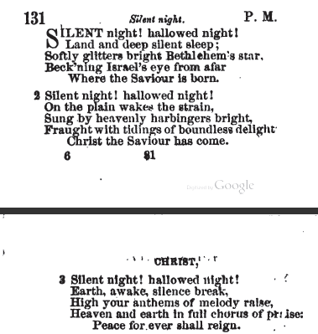

Unrelated is “O Silent Night” from Leo Rich Lewis, Sunday-School Harmonies (Boston: Universalist Publishing House, 1897), pp. 70-1. This book contained four editions of the original pamphlets. “O Silent Night” was contained in Number Three. Table of Contents begins on p. 12. No subject matter index. Other undiscovered Christmas songs.
By Leo Rich Lewis
#70 / page 70. Emma Pitt | W.F. Sherwin
Begins:
Judea's calm and silent night
Had cast her veil o'er hill and plain;
The stars looked on, from far-off homes,
Where watching shepherds oft had lain;
…

With sheet music.
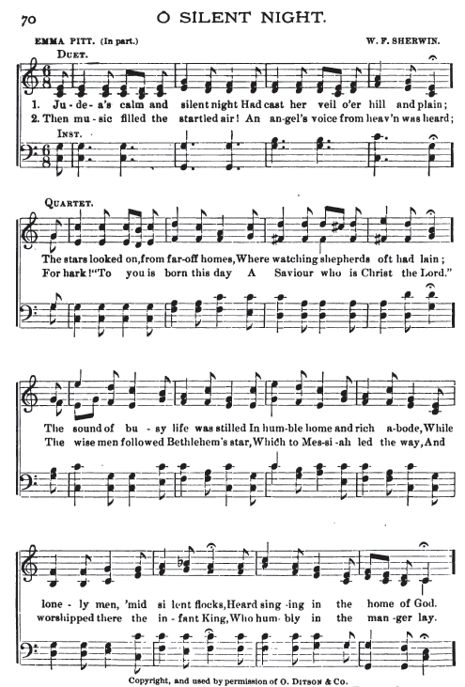
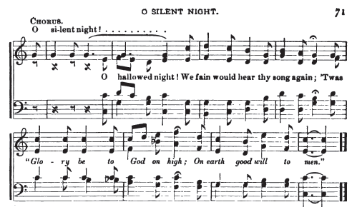

Christmas
First Line: Hail we now the time of gladness.
P. 88



